

**Technology Park Malaysia**

**APP004-4-2-JP-L-3**

**Java Programming**

**TEAM: Group 8**

**INTAKE: UCDF2208ICT(SE)**

|  |  |  |
| --- | --- | --- |
| Group Member | | |
| *No.* | Name | TP Number |
| 1 | LEW WEI HOW | TP071331 |
| 2 | TAN PO YEH | TP070780 |
| 3 | TONG JIA CHUEN | TP070484 |

Table of Contents

1.0 Introduction 4

2.0 Sample Output and explanation of the Output 5

2.1 User Credentials 5

2.2 Admin Features 8

2.2.1 Manage Patient Account 9

2.2.2 Manage Doctor Account 18

2.2.3 Manage Walk-In Appointments 25

2.2.4 Track Patient Medical Record 30

2.2.5 Manage Medicine 32

2.2.6 Manage Payment 37

2.2 Doctor Features 45

2.3 Patient Features 66

2.3.1 Patient Authentication 66

2.3.2 Dashboard - View Available Timeslot 68

2.3.3 Appointment - Make Appointment 71

2.3.3 Upcoming - Cancel Appointment 73

2.3.4 Medical Record - Track Personal Medical Record 76

2.3.5 History Review - Track Personal Historical Appointment 77

2.3.6 Log Out 78

3.0 Object Oriented Concepts 79

3.1 Class and Object 79

3.2 Encapsulation 81

3.3 Inheritance 83

3.4 Polymorphism 85

4.0 Java Features 87

5.0 Additional features 92

5.1 Forget Password 92

5.2 Hashing Password 97

5.3 Generate Payment Receipt 98

5.4 Generate Sales Report 100

5.5 Searching Table Data 103

6.0 Conclusion 106

7.0 References 108

8.0 Workload Matrix 109

# 1.0 Introduction

Our Group has been tasked to create a simple Clinic management system program which includes a system feature “sign in” and “sign up” page using Java programming languages such as Graphic User Interface for designed, object-oriented programing, and different functionality. The target users of this system mainly focus on admin, doctor and patient. The system is expected to perform some important operations such as user registration, appointment management, medical record management and payment collection. Furthermore, the data created by using an object-oriented software solution must be stored in text file. The first target user system is the role of Admin. The admin role should be able to manage the user registration, manage patients’ walk-in-appointments, track patient’s medical record, track doctor daily appointment and collect patient payment. Secondly, is the role of doctor. The doctor’s role should be able to upload their daily schedule, track their own individual appointment, cancel the appointment, track patients’ medical record and add patients’ medical record. Last but not least, is the role of patients. The Patients role should be able to view their available timeslot, make an appointment, cancel their appointment, track their own personal medical record and track their own personal historical appointment.

# 2.0 Sample Output and explanation of the Output

## 2.1 User Credentials

This the distributed login page, user can click on the specific role login button to redirect to the login page.

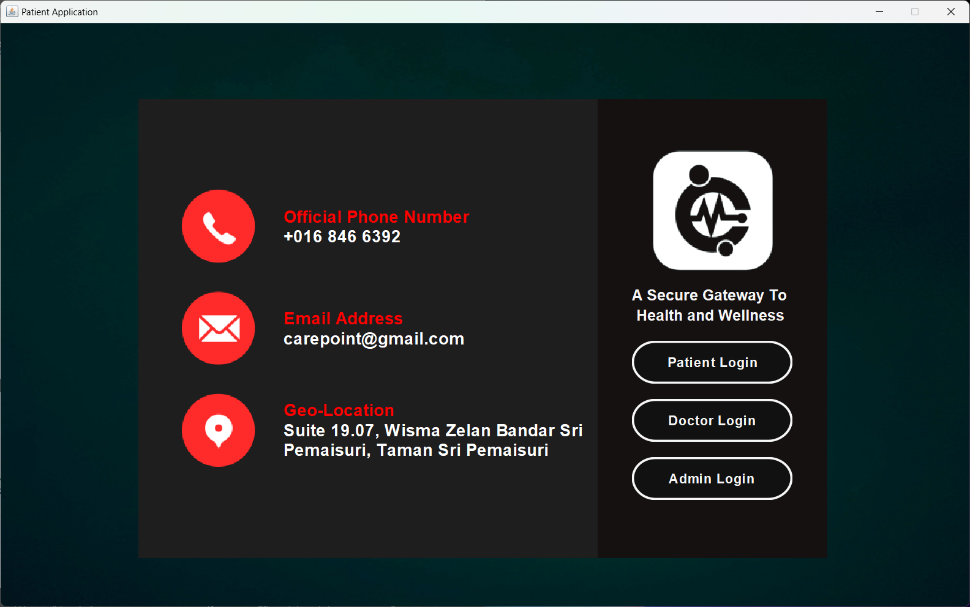

Figure 1 Main Page

Once users pass the authentication, they are allowed to access to specific role of main page. If user input wrong username (IC Number) or password, the system will show “Login Failed” message to the user.

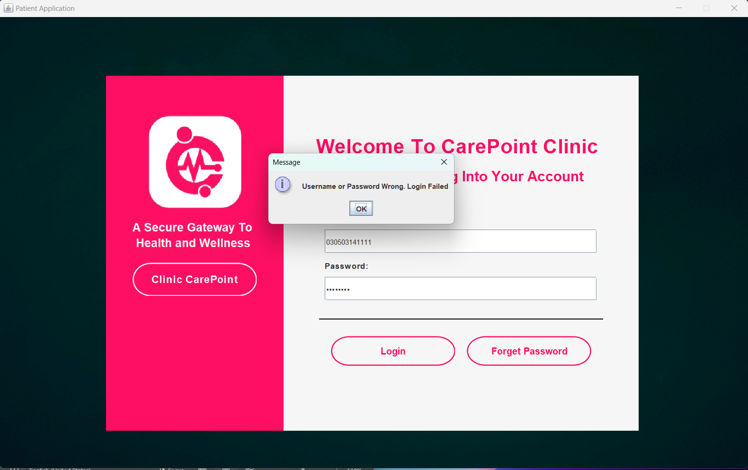

Figure 2 Login page

Users can change their password by clicking on the *Forget Password* button. A Forget Password box will pop up. Users need to key in their IC number and contact number to the account. After that, typing new password and confirm password, then click on the *Reset Password* button to change the password. “Password changed successfully” message will be displayed once the password changed.

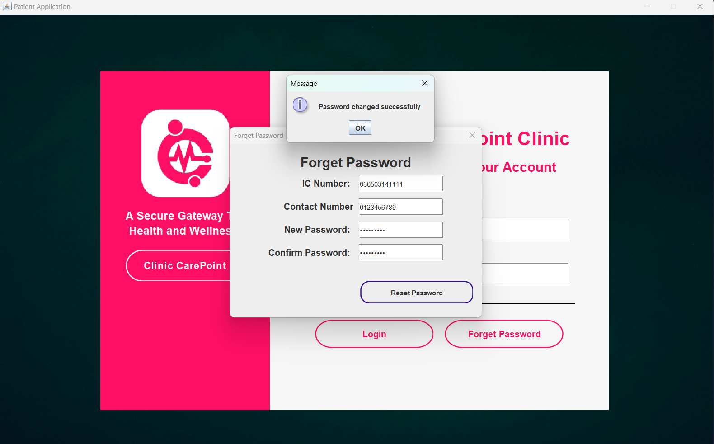

Figure 3 Forget Password Page

## 2.2 Admin Features

Admin can access the admin main page after authentication passed. The center of this page contains some button that can navigate admin to function page. The bottom of the page shows Upcoming Appointment for current date. Admin can click on the *Refresh* button to refresh the upcoming appointment table.

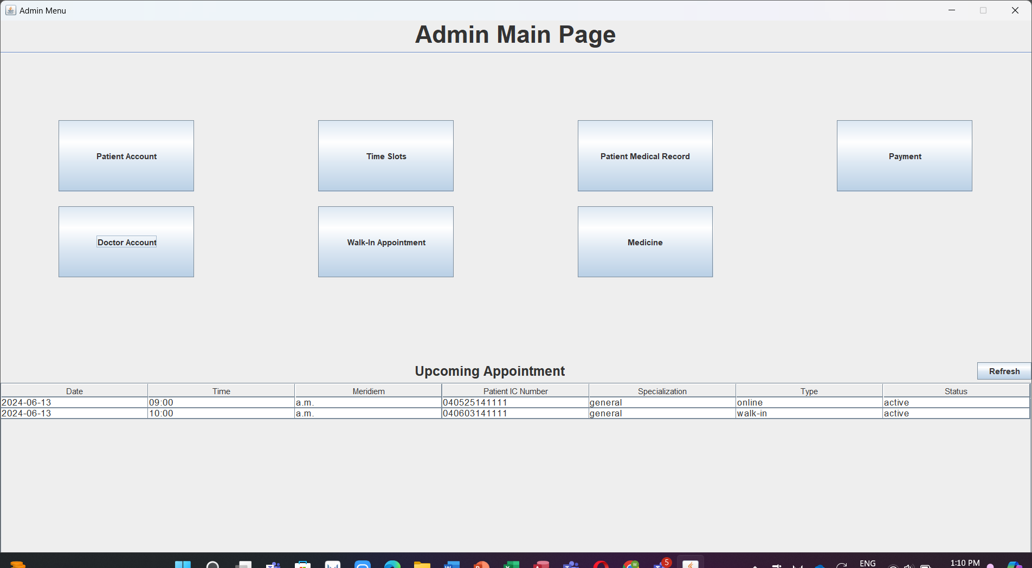

Figure 4 Before refreshing

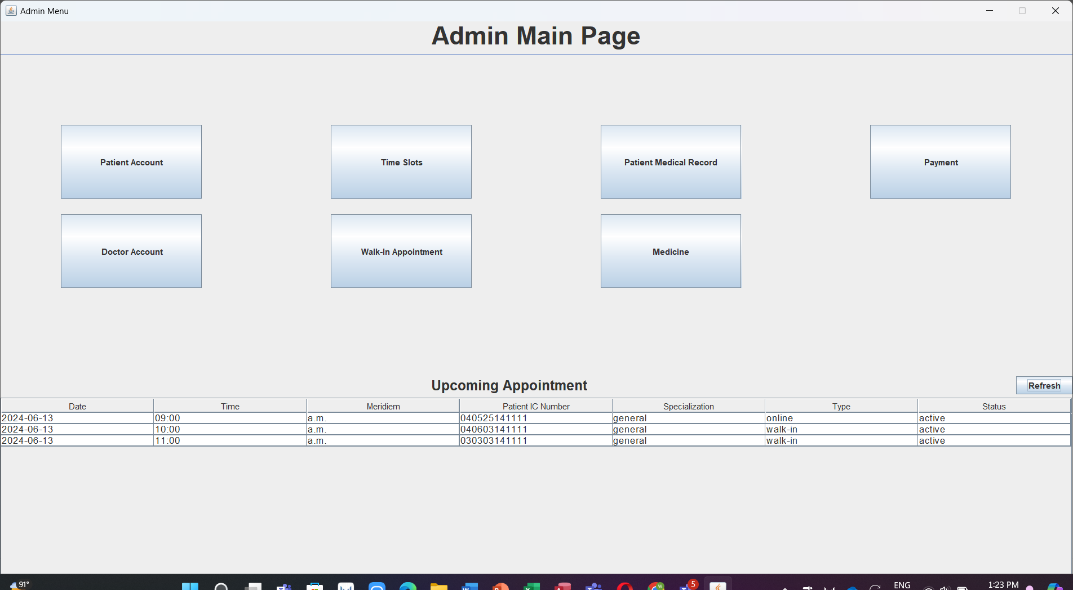

Figure 5 After refreshing

### 2.2.1 Manage Patient Account

Admin is able to manage patient accounts. Admin will be required to select patient information and click on the Edit button to modify patient accounts.

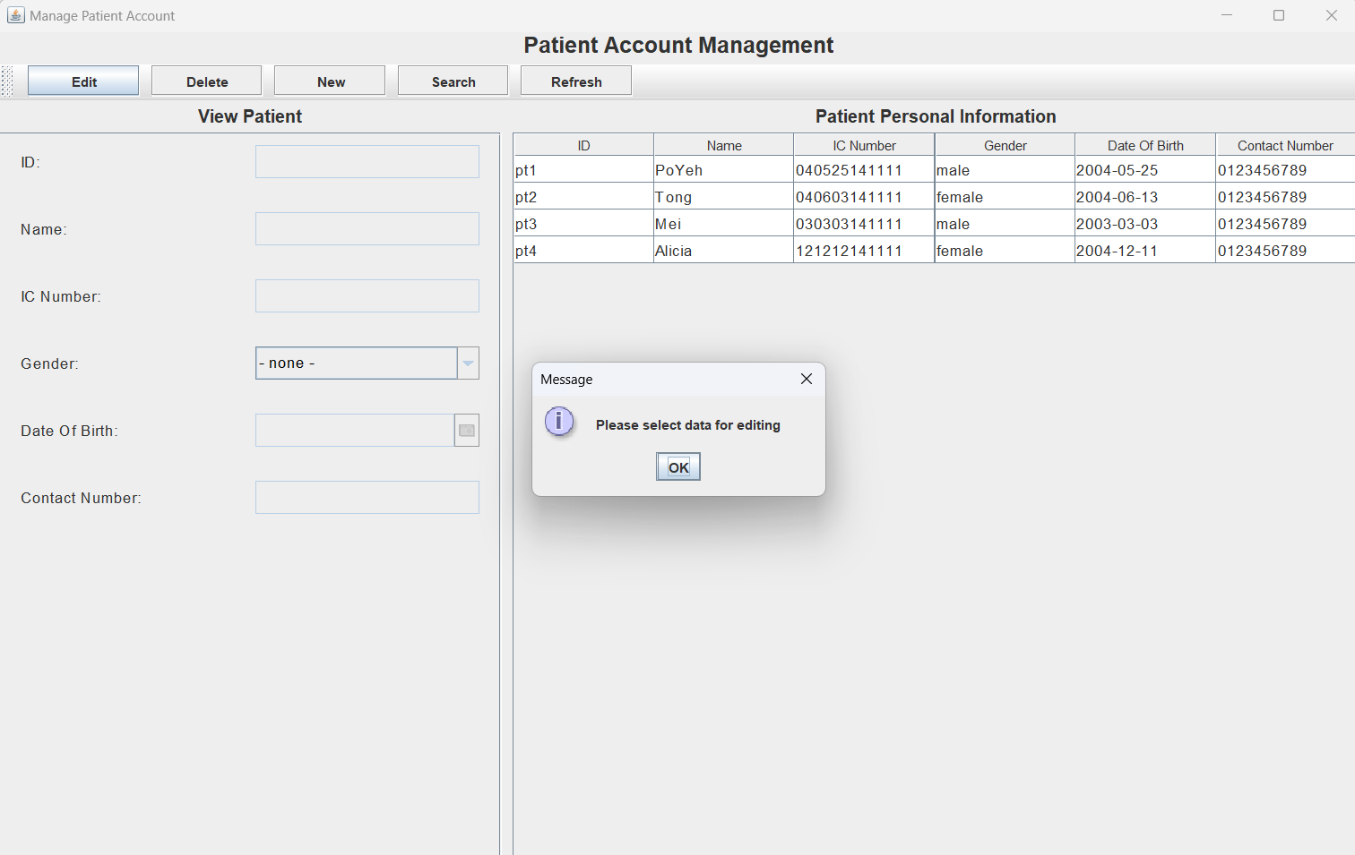

Figure 6 Click on the Edit button before selecting data will show "Please select data for editing" message

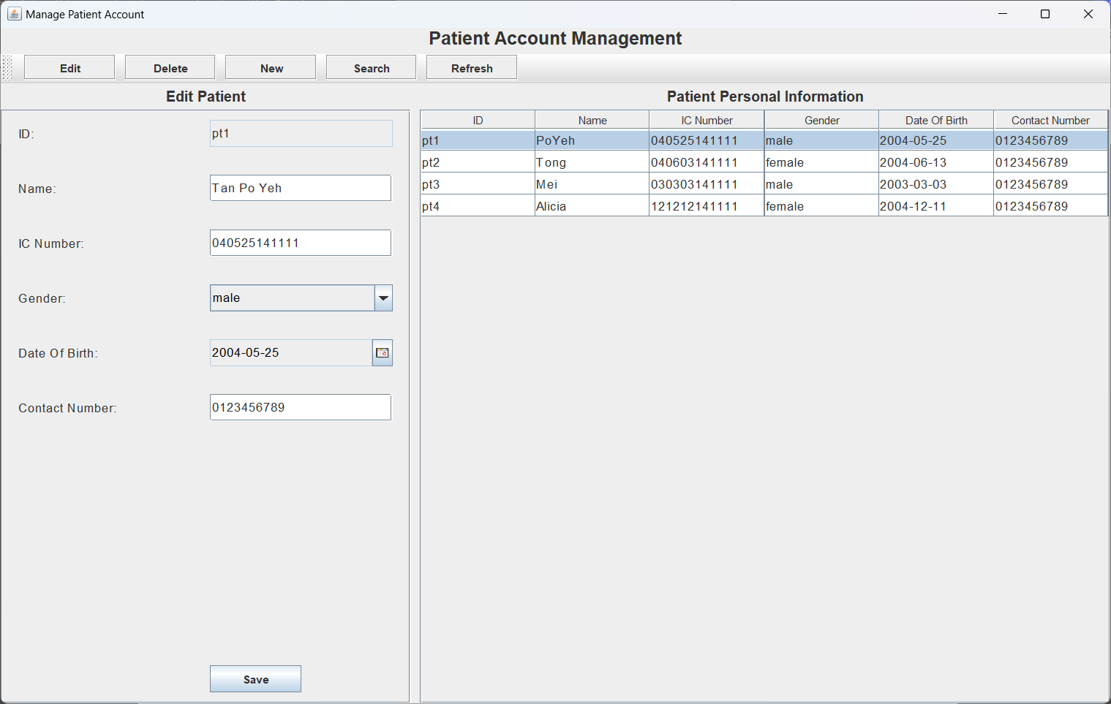

Figure 7 Input Field on left side is editable for admin to modify patient information. For example, the patient name changed to Tan Po Yeh from PoYeh

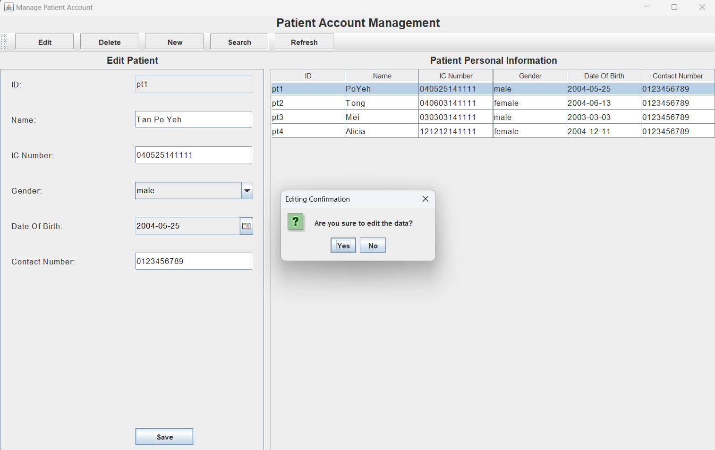

Figure 8 After that, admin can click on the Save button to save the modification. The system will prompt editing comfimation message to admin.

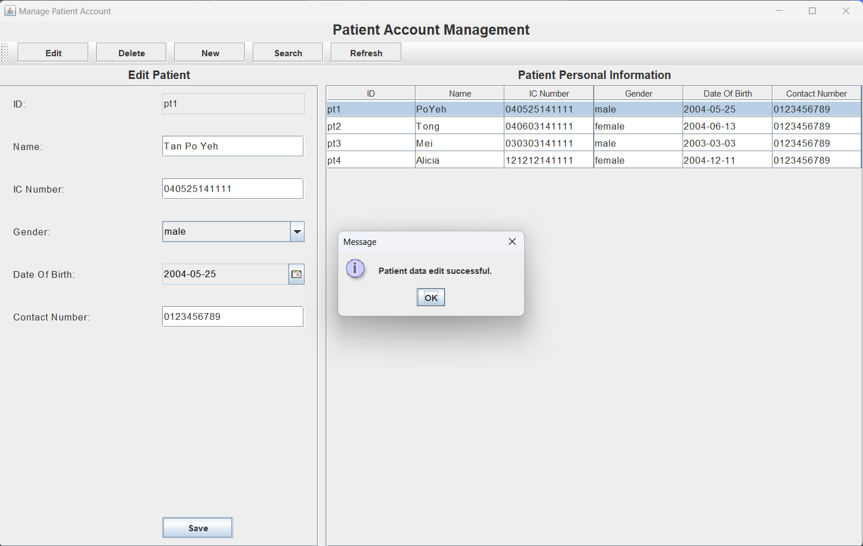

Figure 9 After clicking on Yes, the system saves the modification record into storage and show a message for the process.

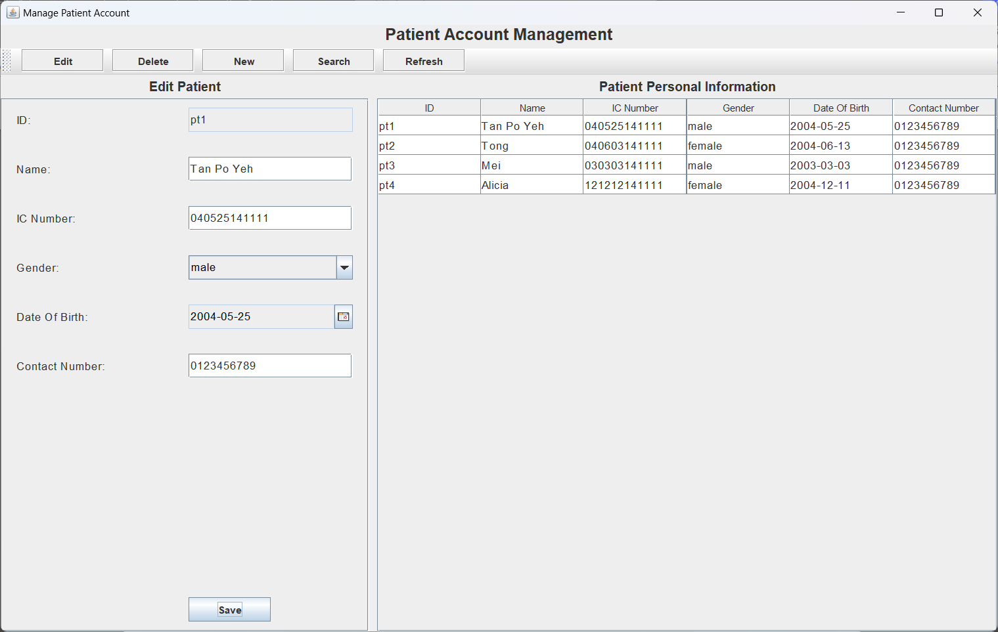

Figure 10 Name of patient pt1 have changed to Tan Po Yeh

Admin also can create new patient accounts. Click on the *New* button, the input field on left side of the screen will be clear to enable admin input new patient information.

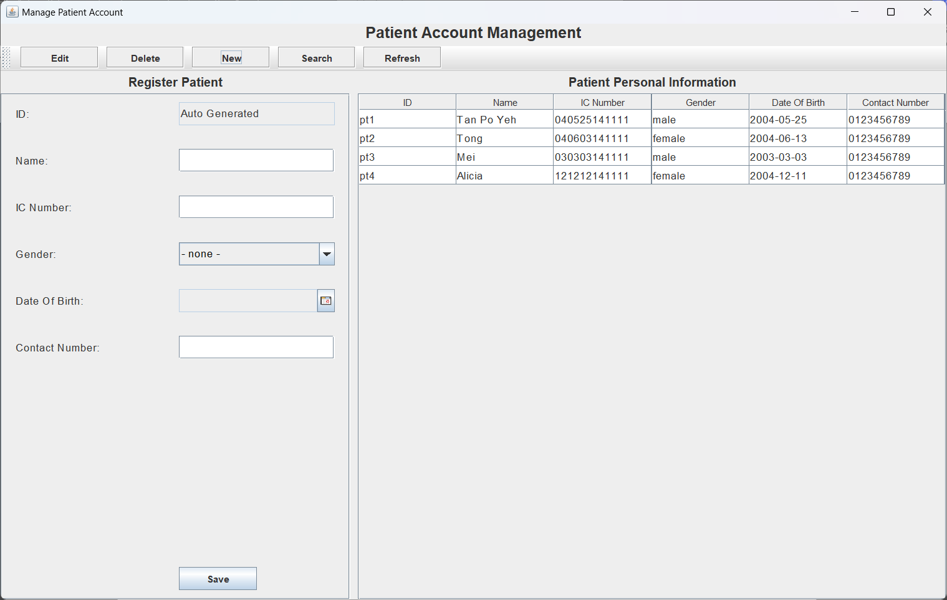

Figure 11 After clicking on New button

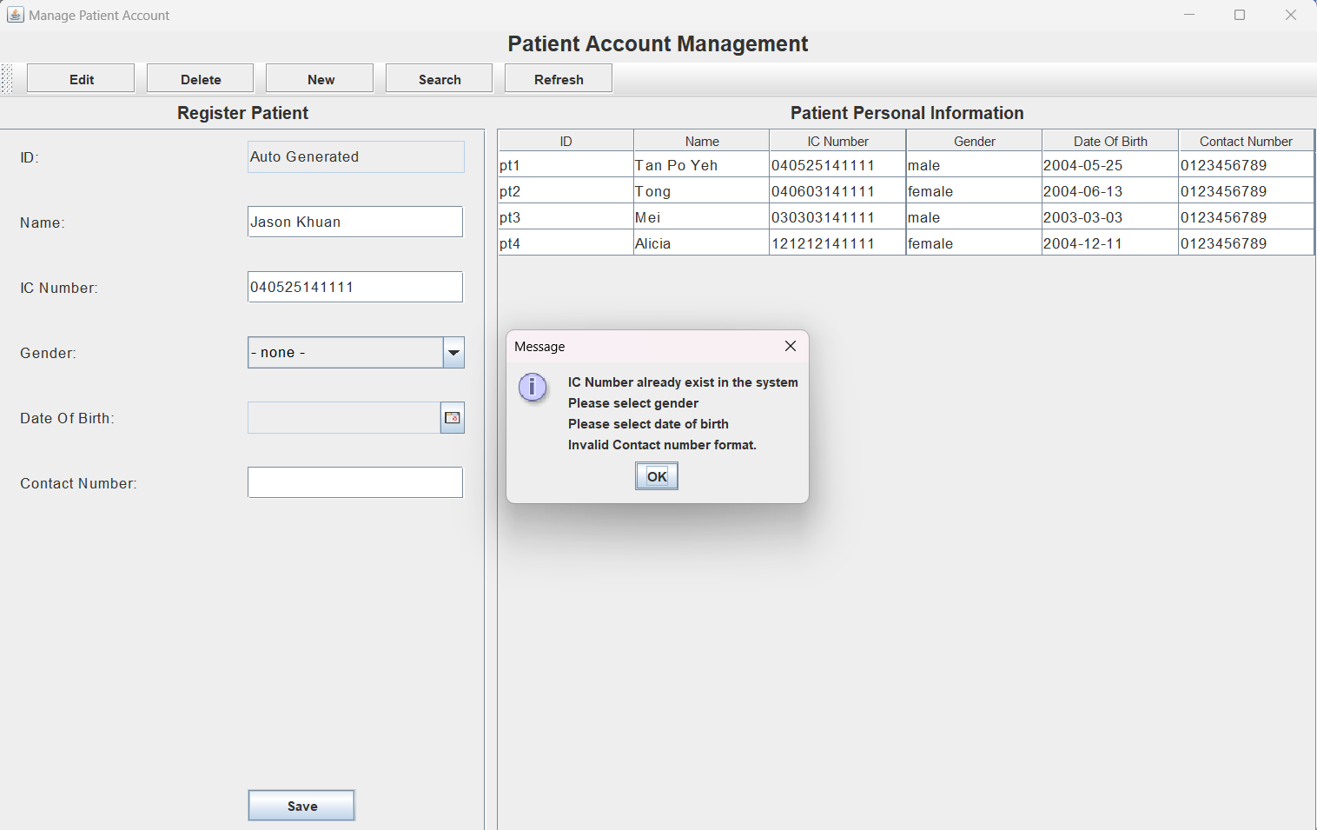

Figure 12 Input Validation

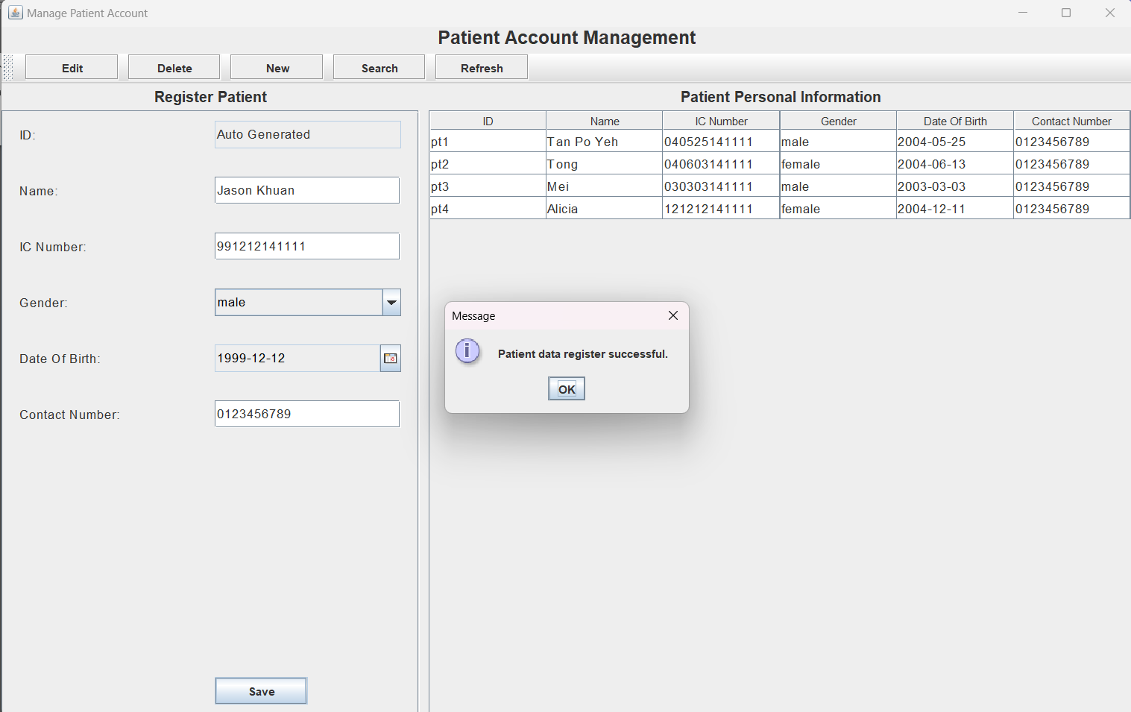

Figure 13 Click on Save button to create new patient account. When the input for the new patient information is valid, the system display registration success message

Deletion of accounts can provide better management to the system. Admin can perform this function to delete existing patient accounts.

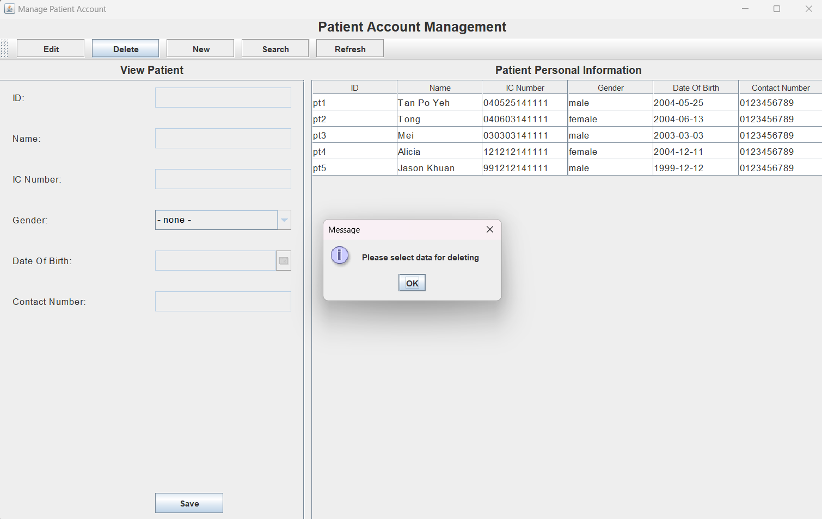

Figure 14 Before selecting patient account

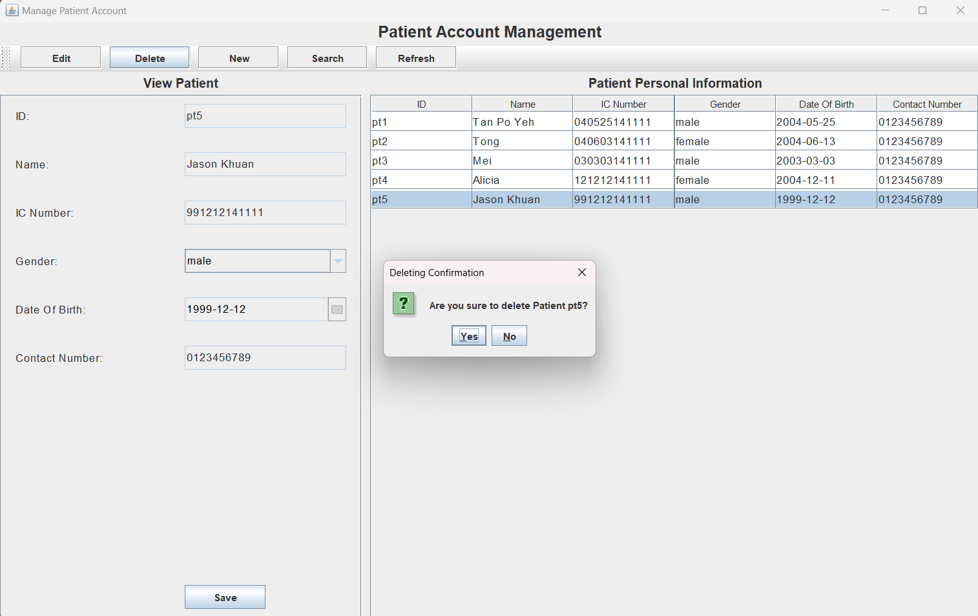

Figure 15 After selecting a patient account, admin can click on the Delete button. Following it, the system prompt admin to confirm the deleting process.

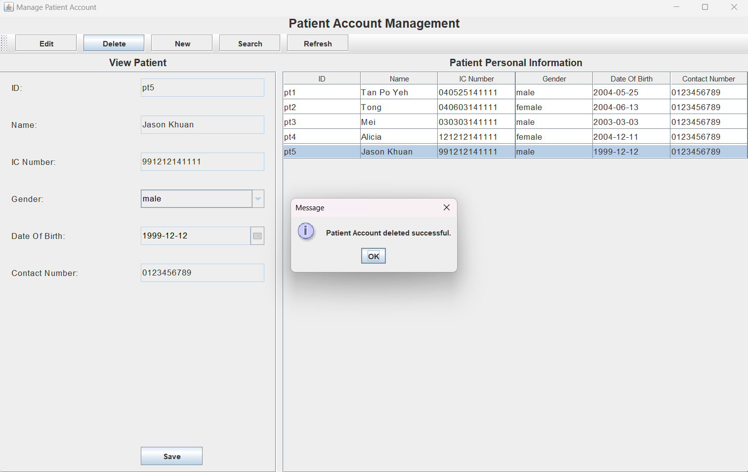

Figure 16 Upon clicking on Yes button, the system removes the patient account from storage and display a message

Admin can also query specific patient information from the system. Click on the *Search* button to access search mode.

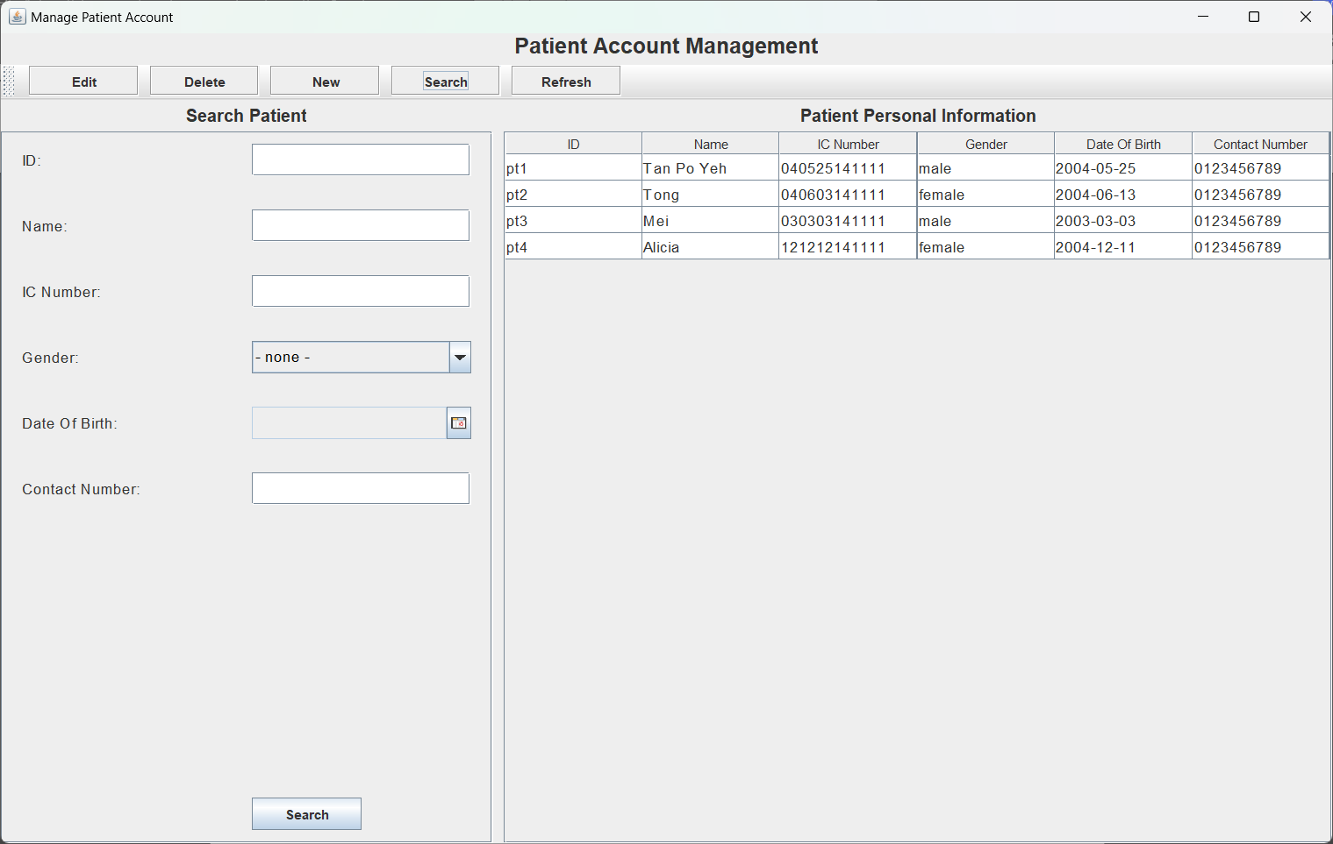

Figure 17 Search Patient

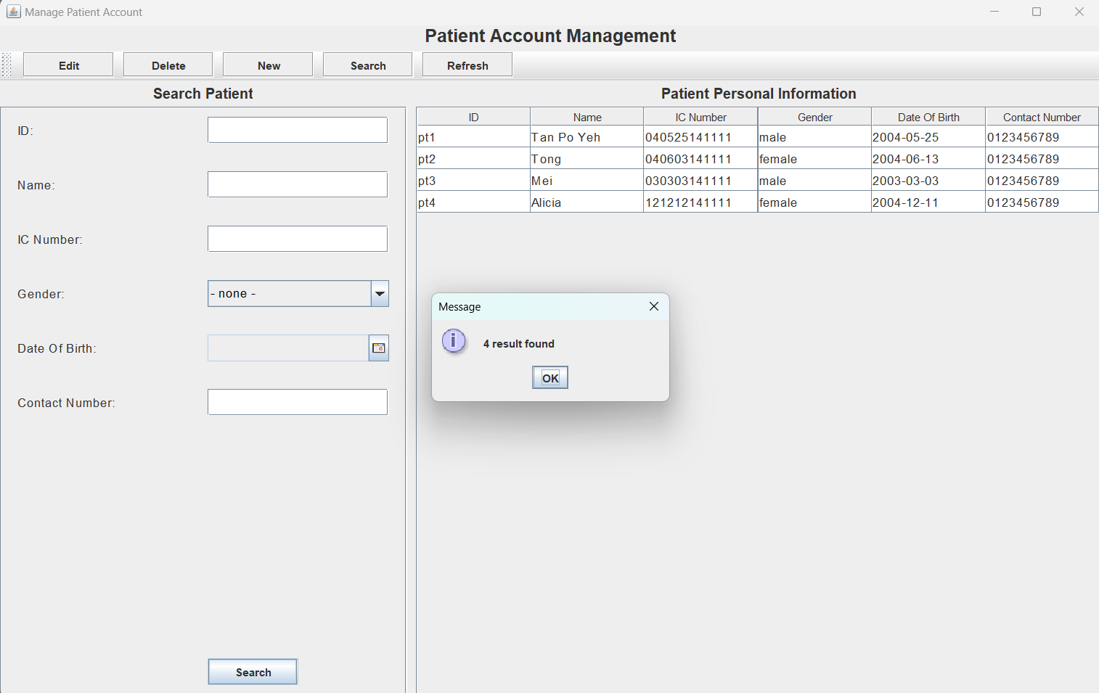

Figure 18 The searching input field left empty represent retrieving any record for this type of information. Therefore, all result will be showed.

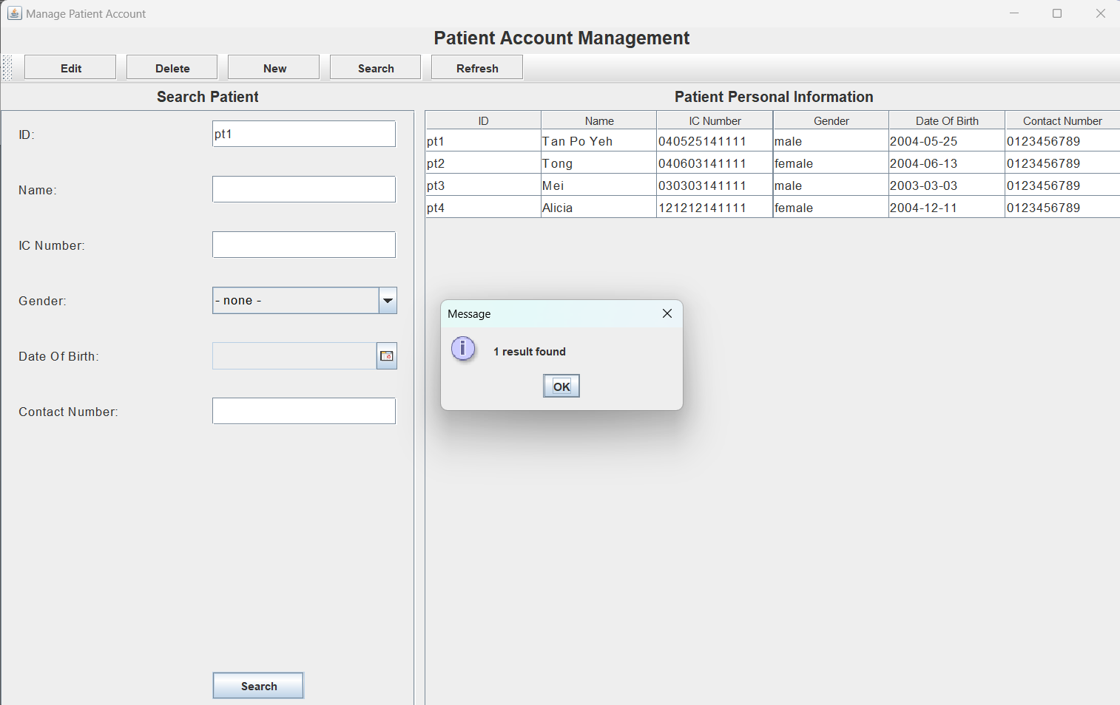

Figure 19 For example, admin input pt1 in ID input field. The system display one result found.

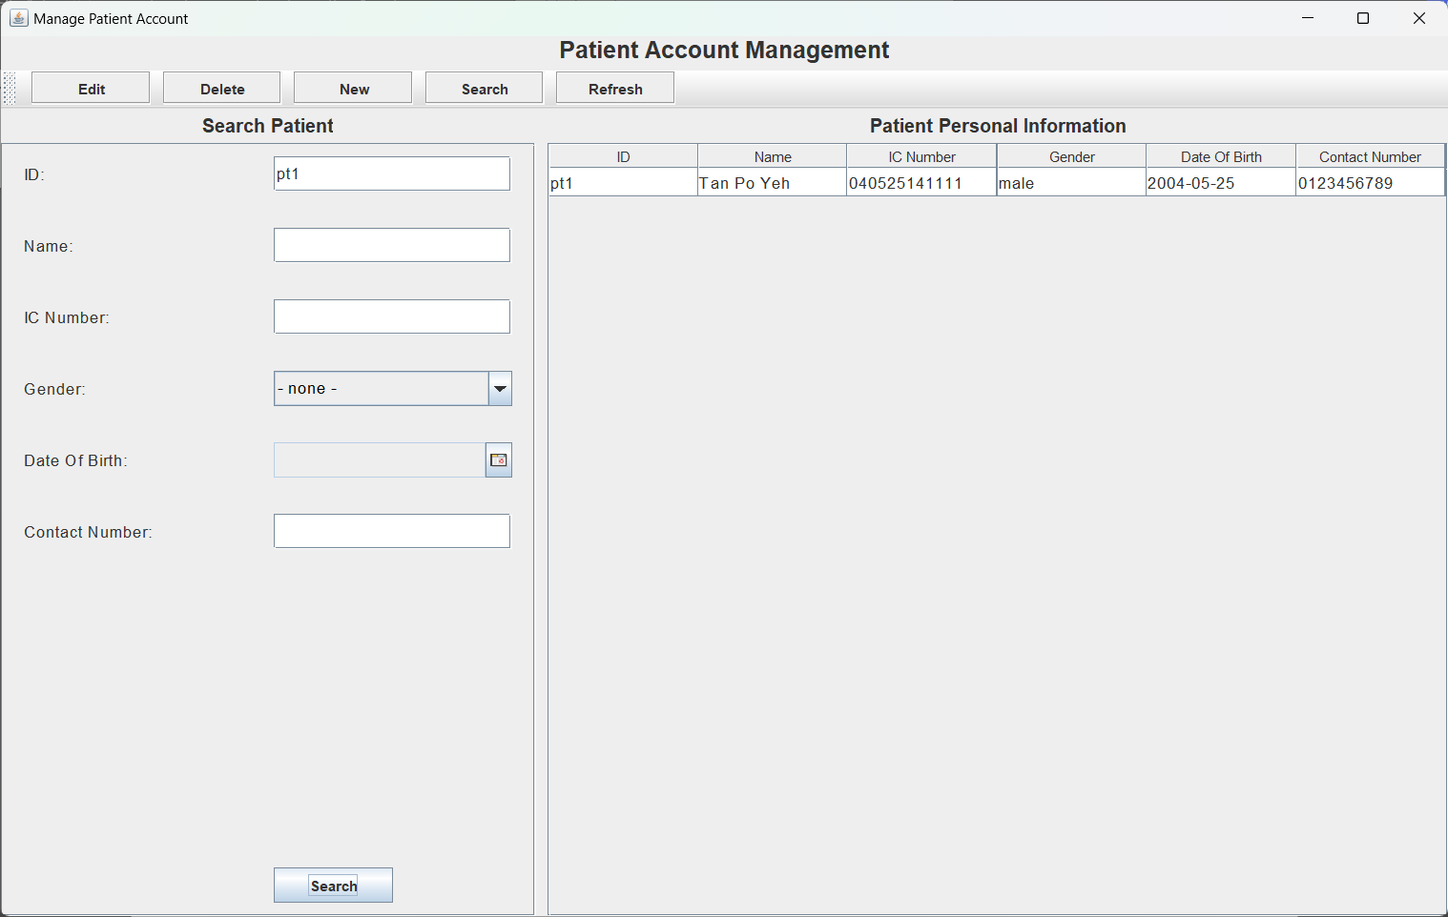

Figure 20 Only patient which contain pt1 ID is displayed in the table

Functions such as Doctor Account management, Walk-In Appointment management, Medicine management, Patient Medical Record Tracking and Payment management also have the features of Create, Read, Update and Delete (CRUD). The operation of CRUD includes input validation and data redundancy detection to ensure the consistency and accuracy of data. However, admin has view-only authorization for available time slots.

### 2.2.2 Manage Doctor Account

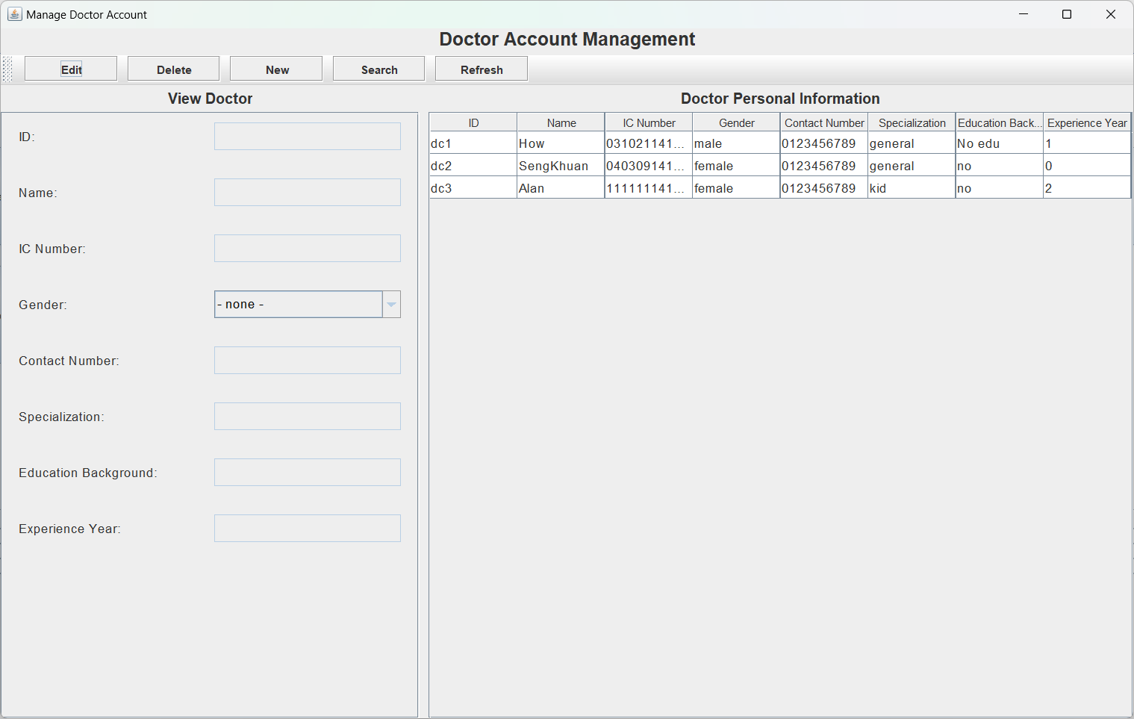

Figure 21 Doctor Account Management page

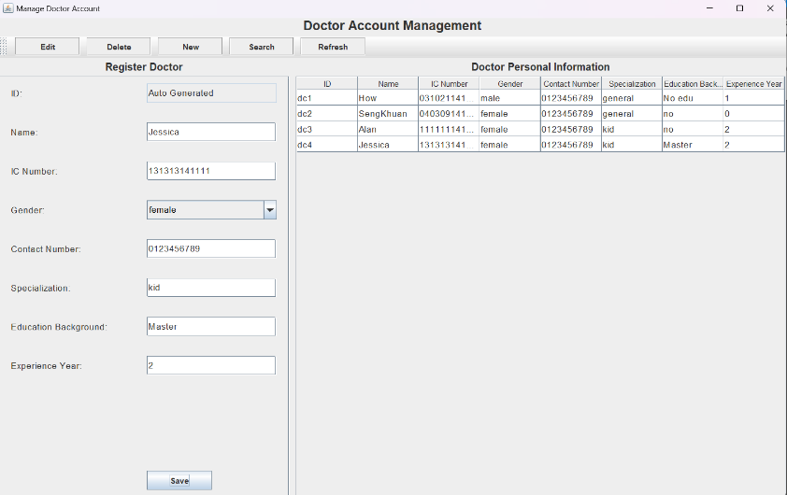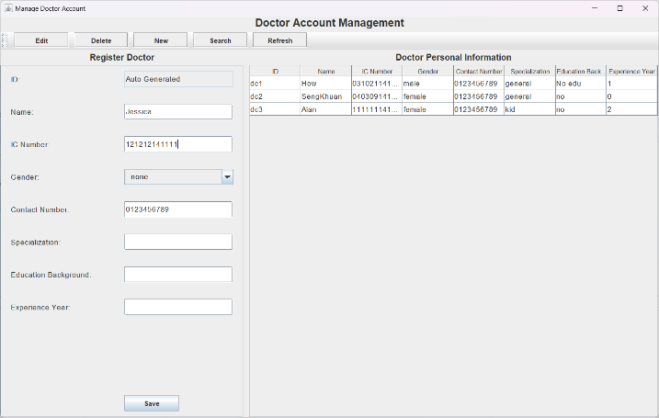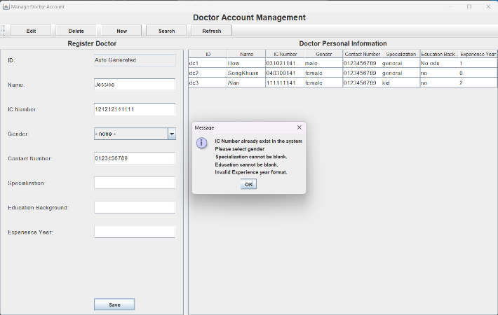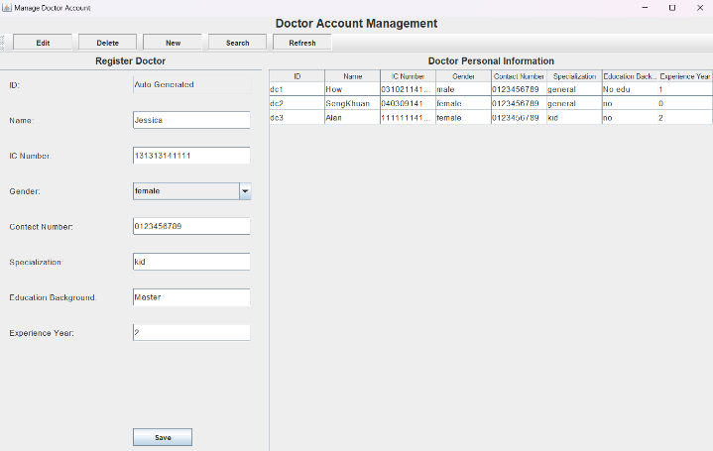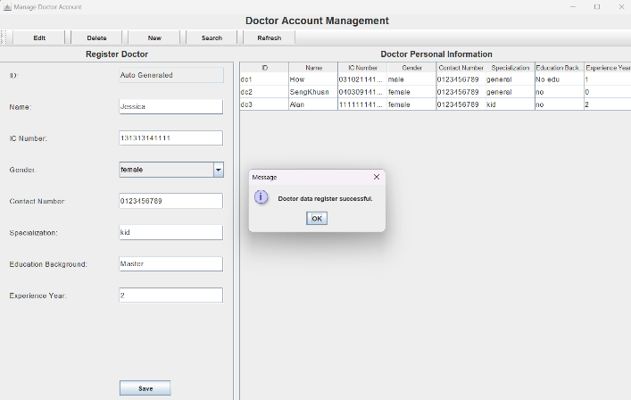

Figure 22 create new doctor account

Figure 23 Edit doctor's account

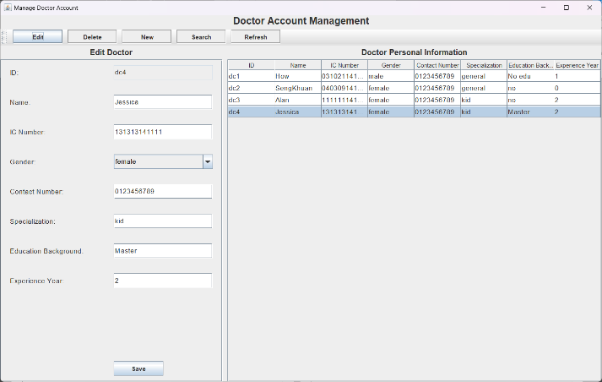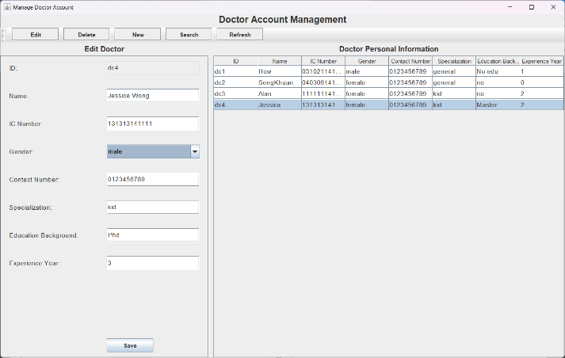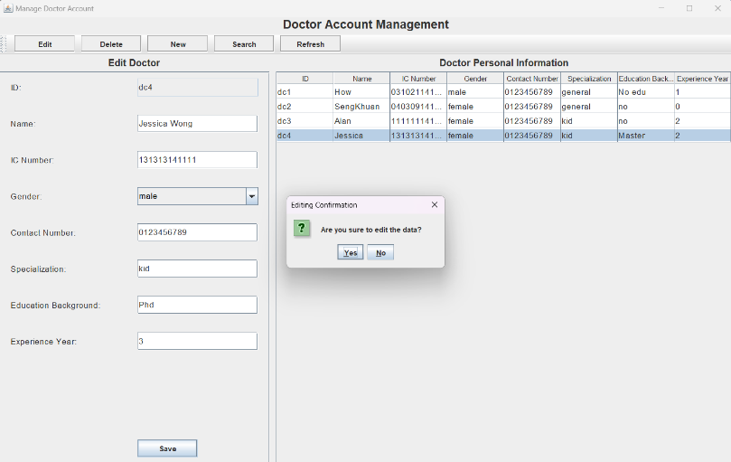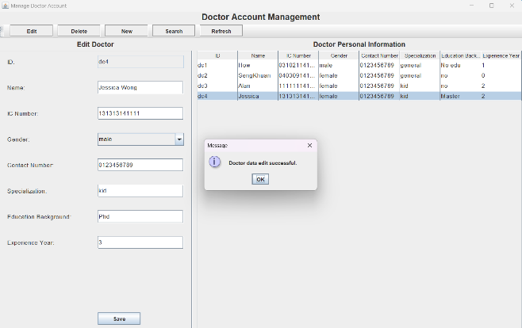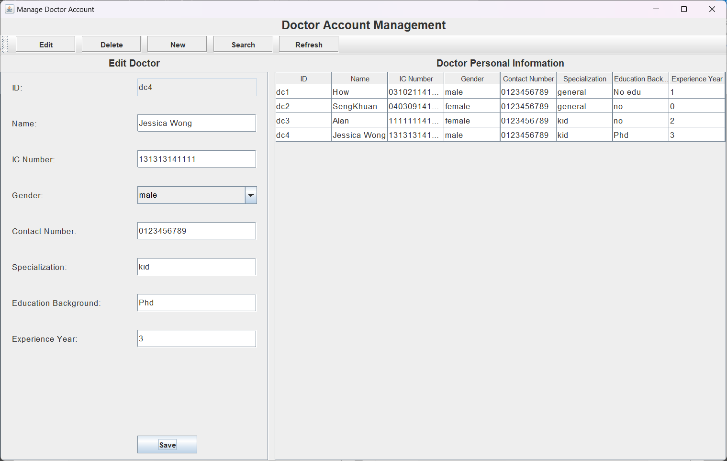

Figure 24 Delete doctor's account

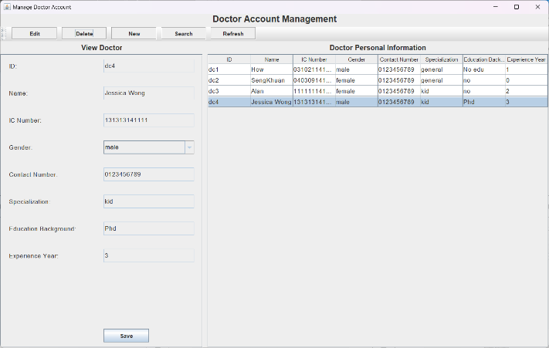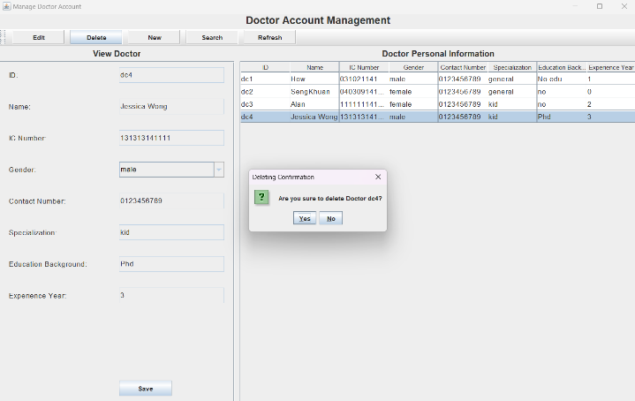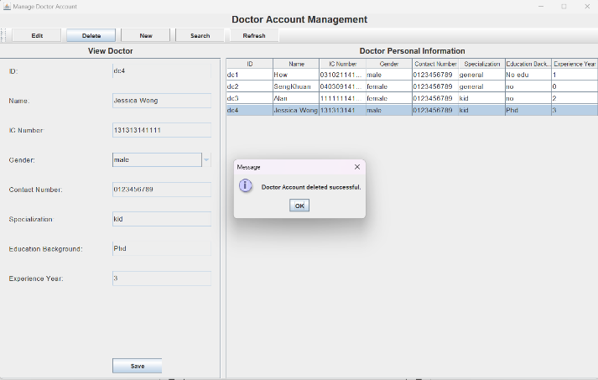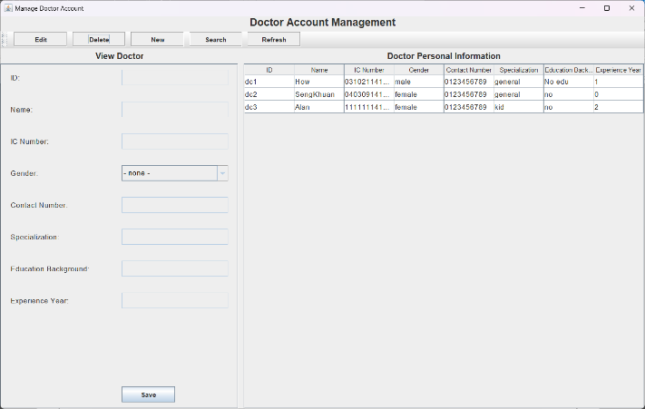

Figure 25 Search Doctor's account

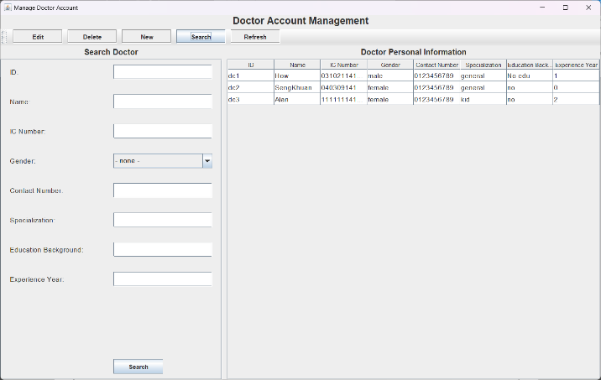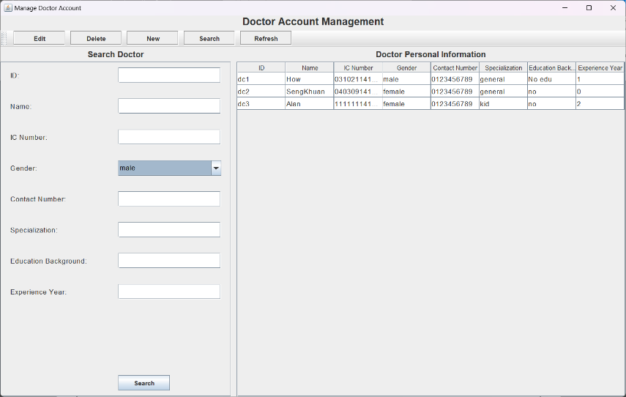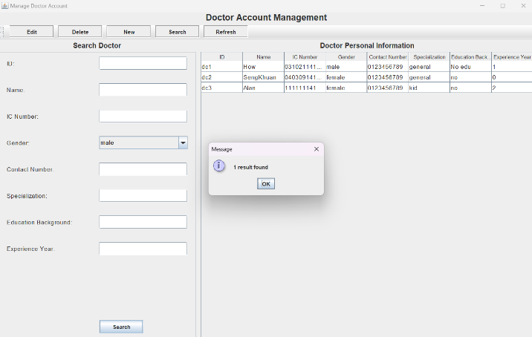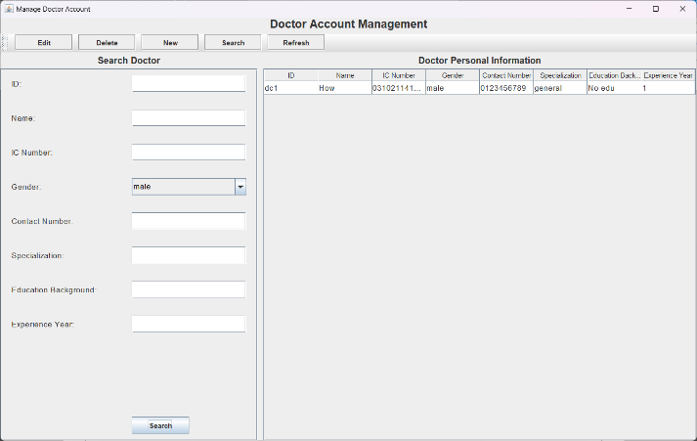

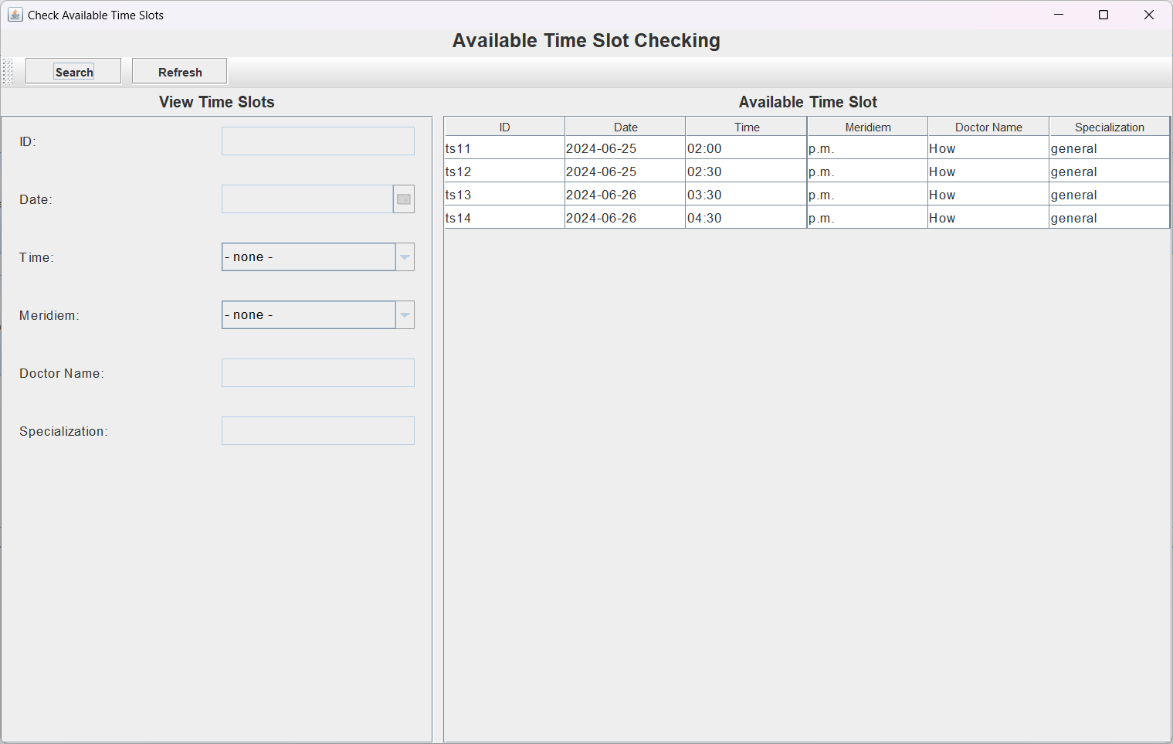

Figure 26 Available Time Slot Page

Figure 27 Search available time slots

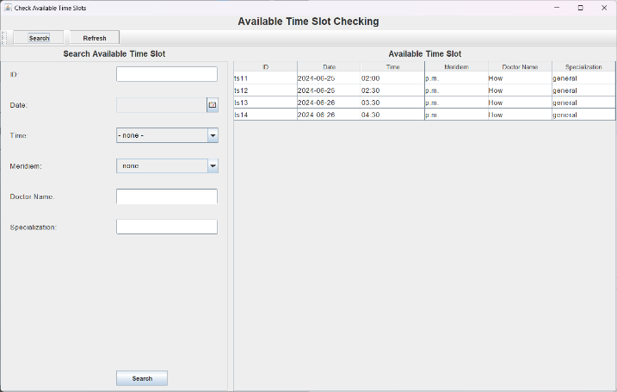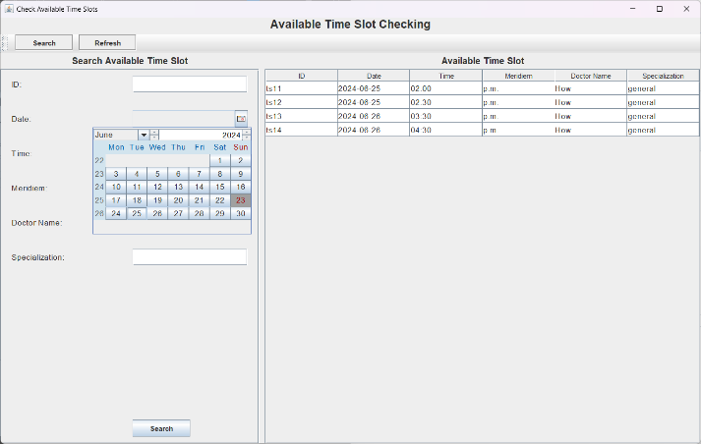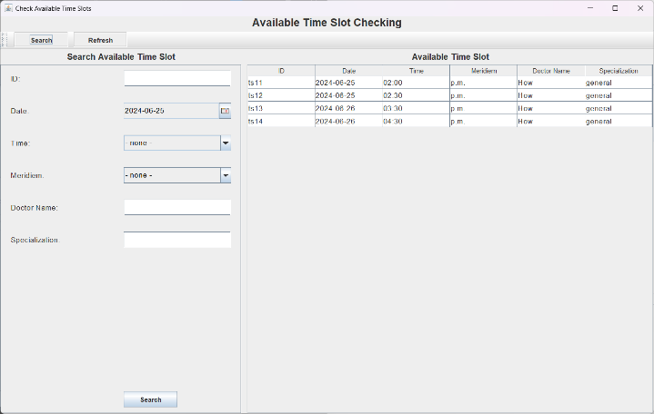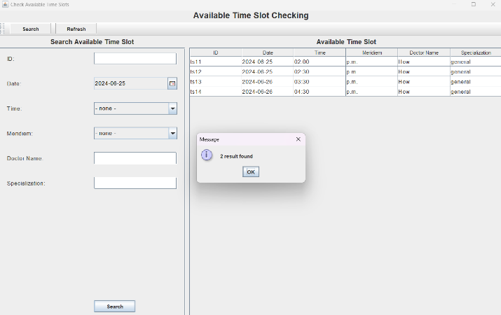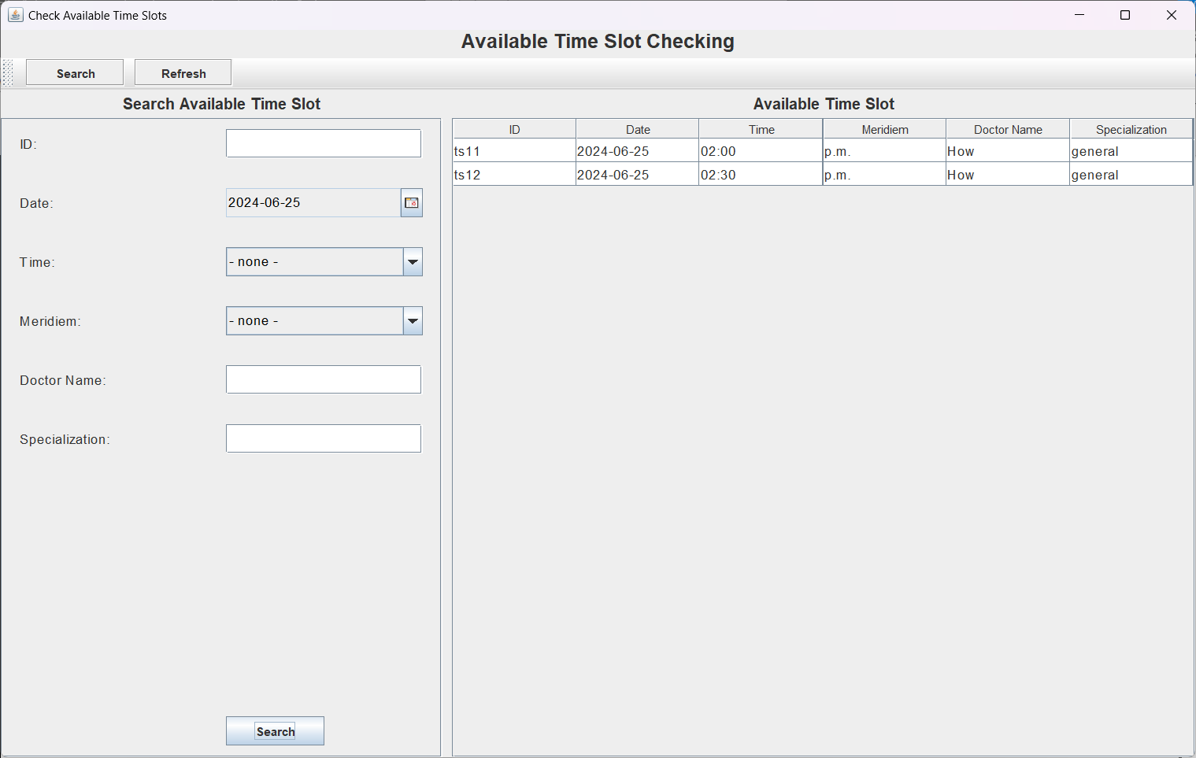

### 2.2.3 Manage Walk-In Appointments

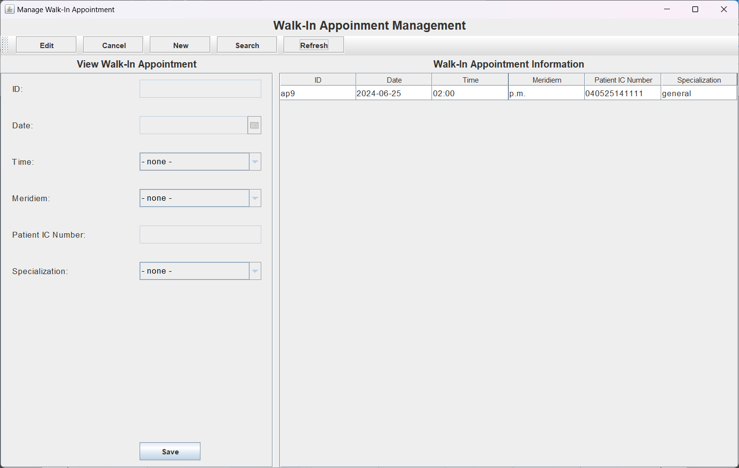

Figure 28 Walk-In Appointment Page

Figure 29 Make new walk-in appointment

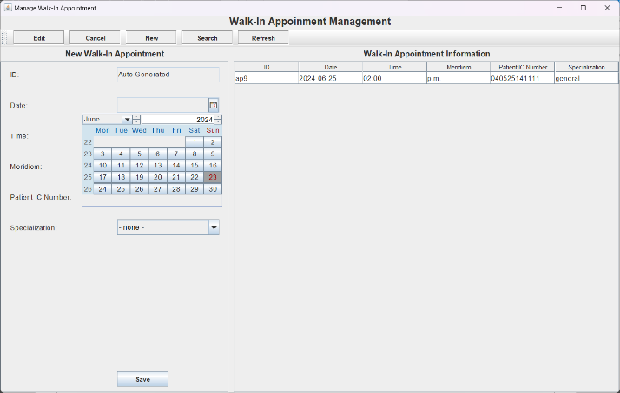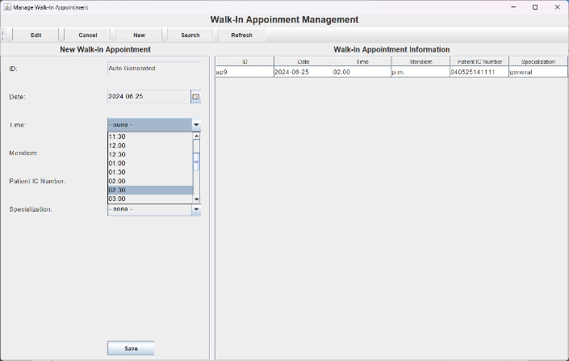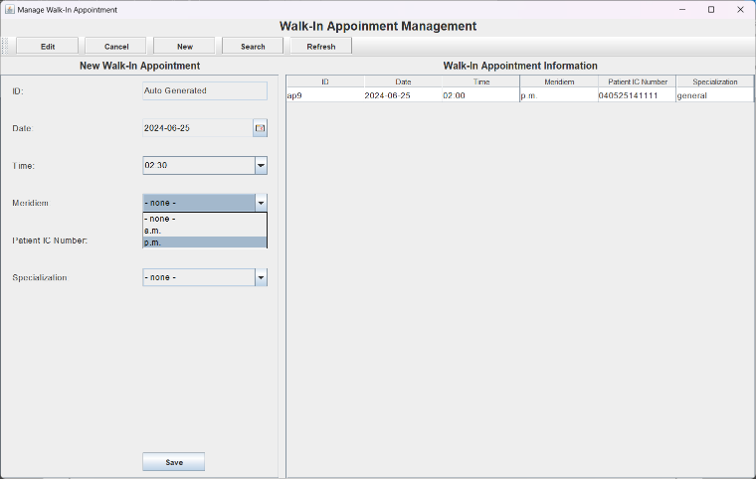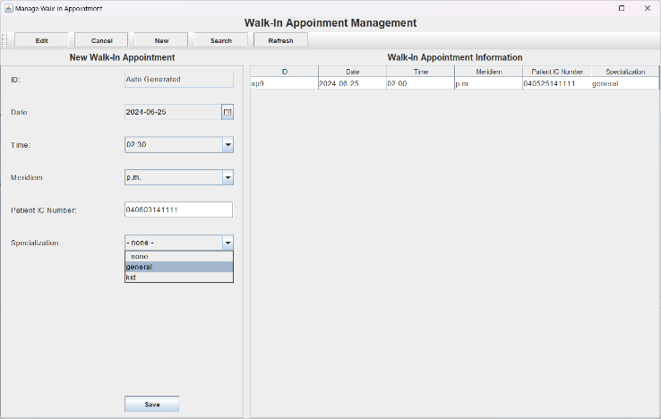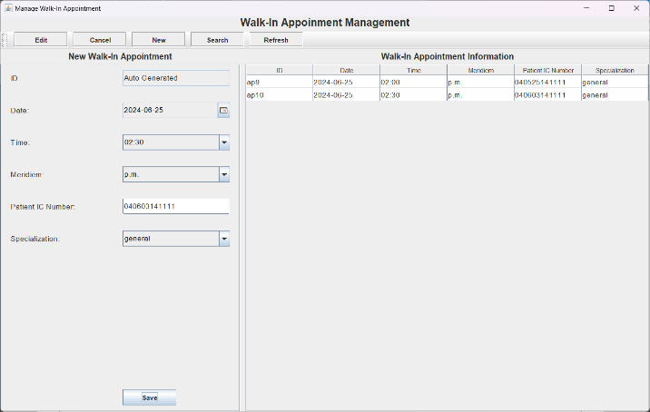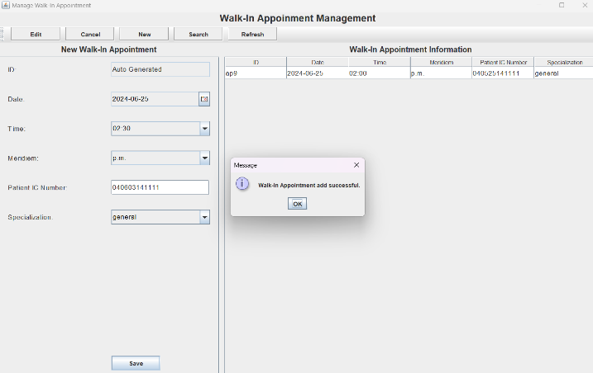

Figure 30 Edit walk-in appointment

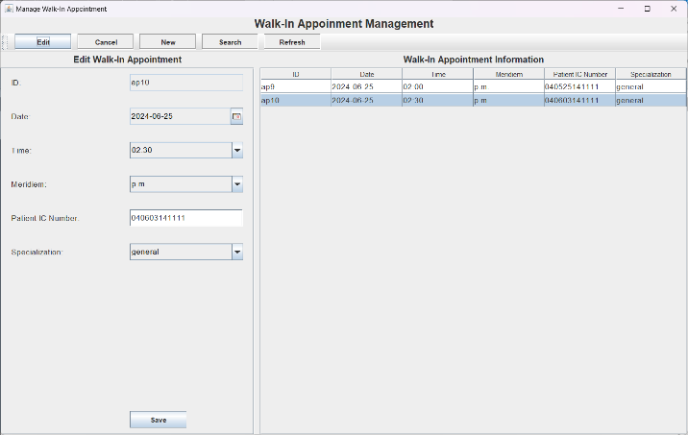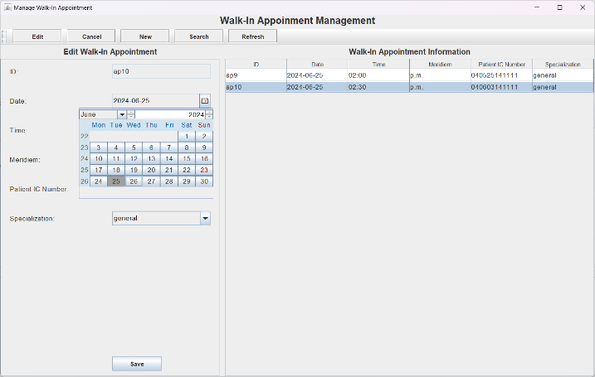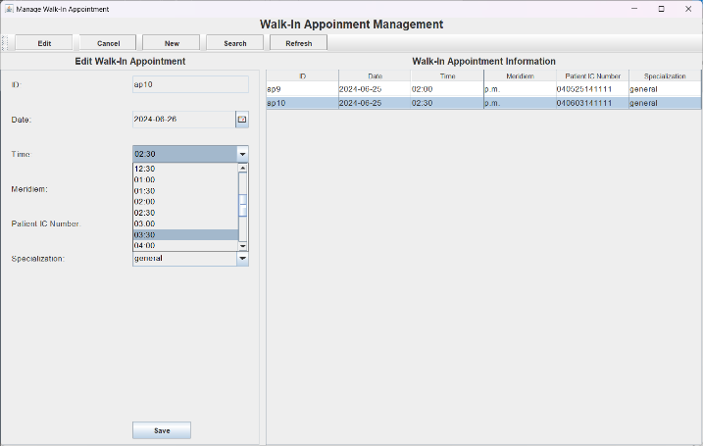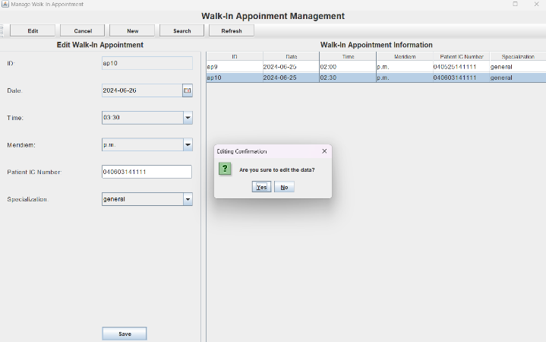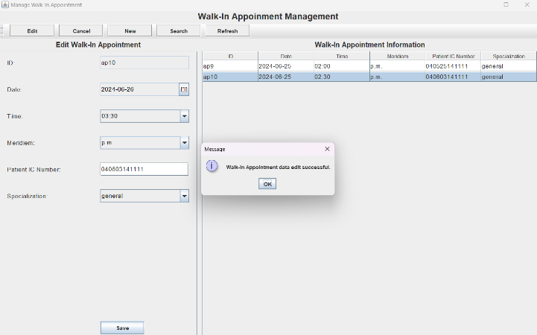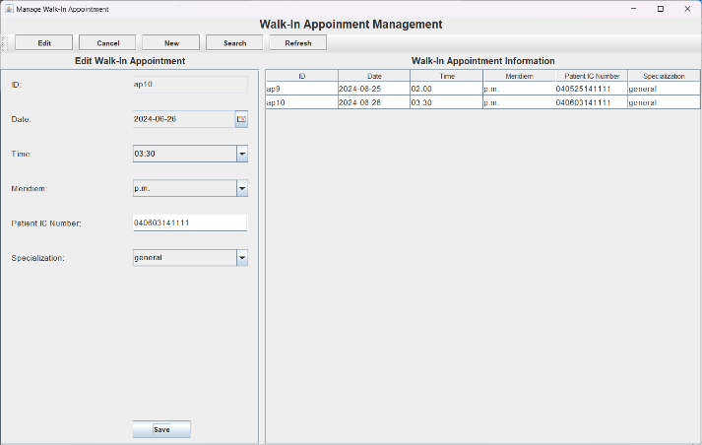

Figure 31 Cancel walk-in appointment

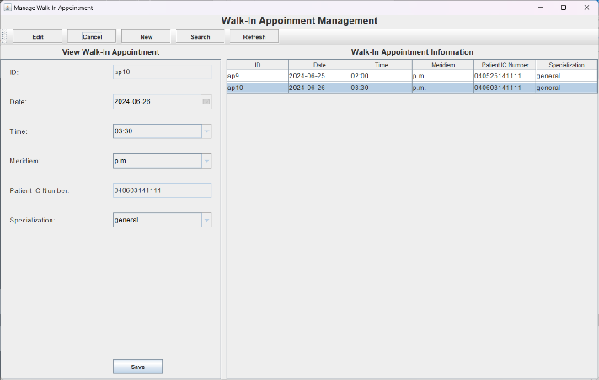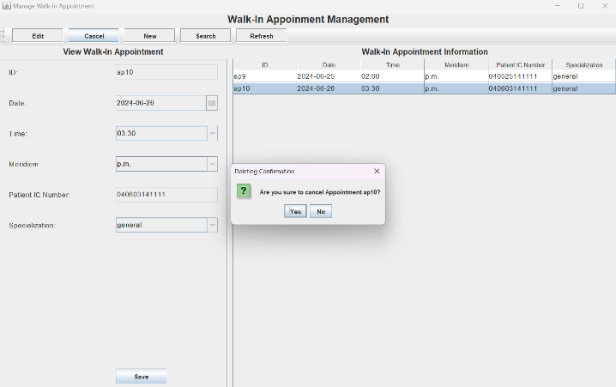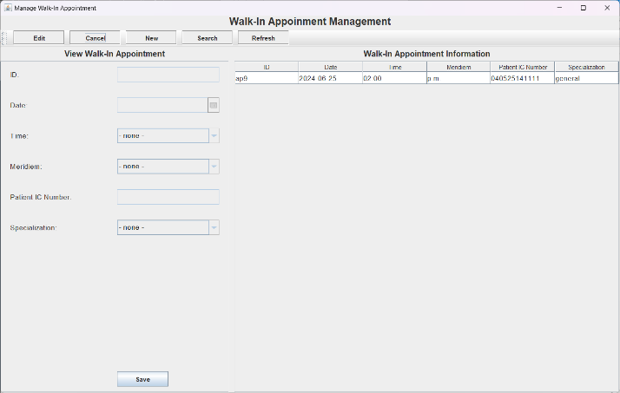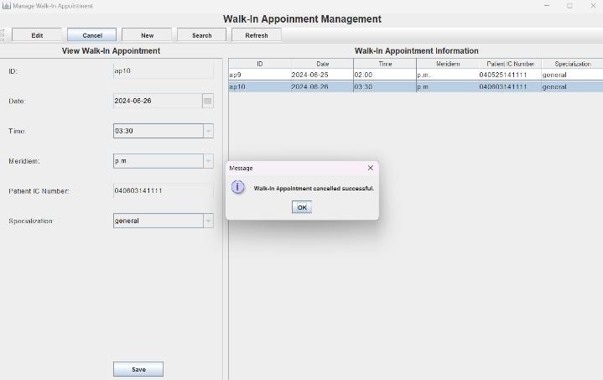

Figure 32 Search walk-in appointment

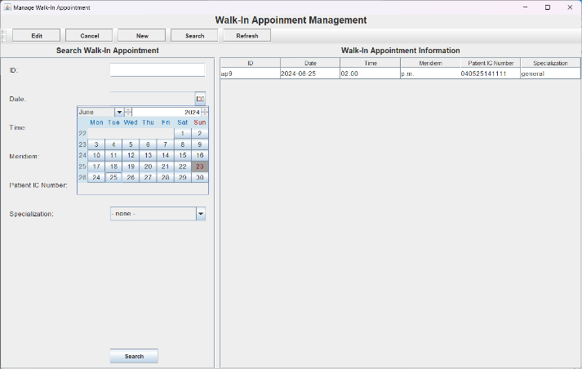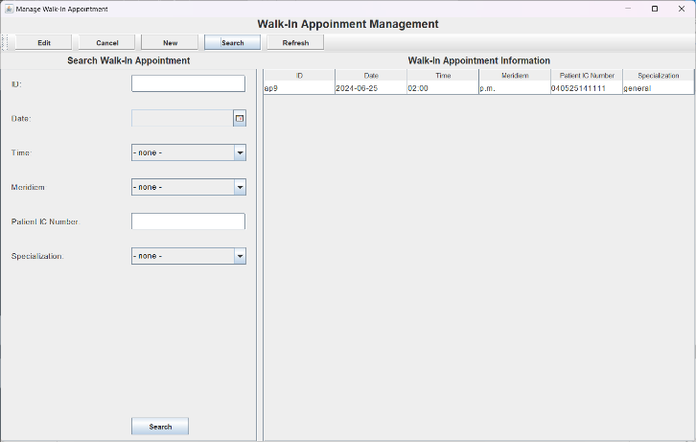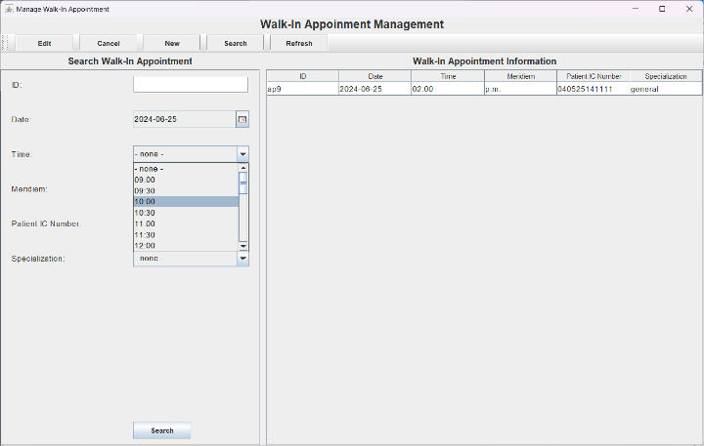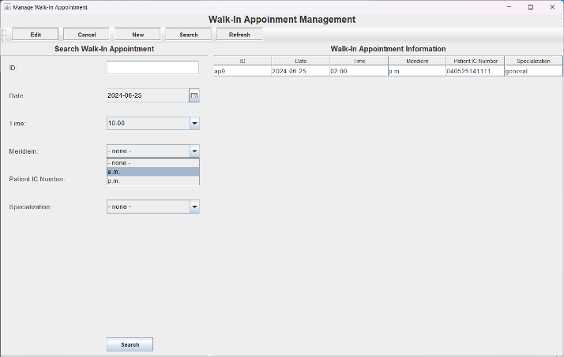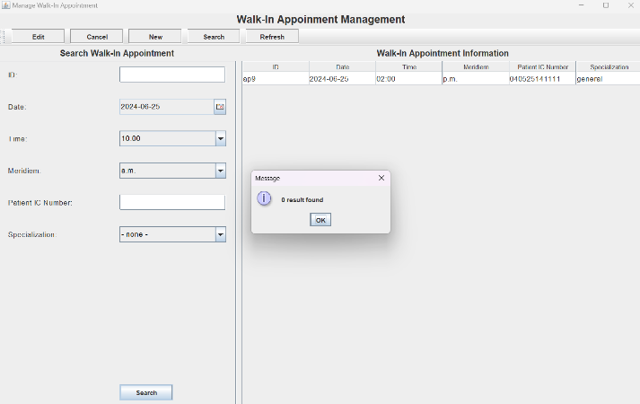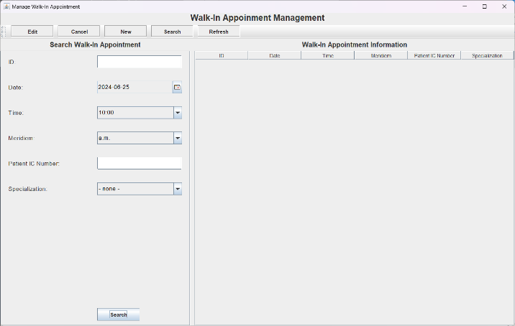

### 2.2.4 Track Patient Medical Record

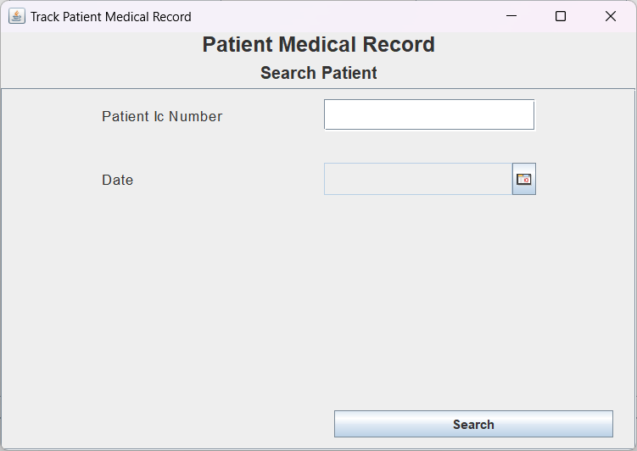

Figure 33 Patient Medical Record Tracking Page

Figure 34 Track patient medical record

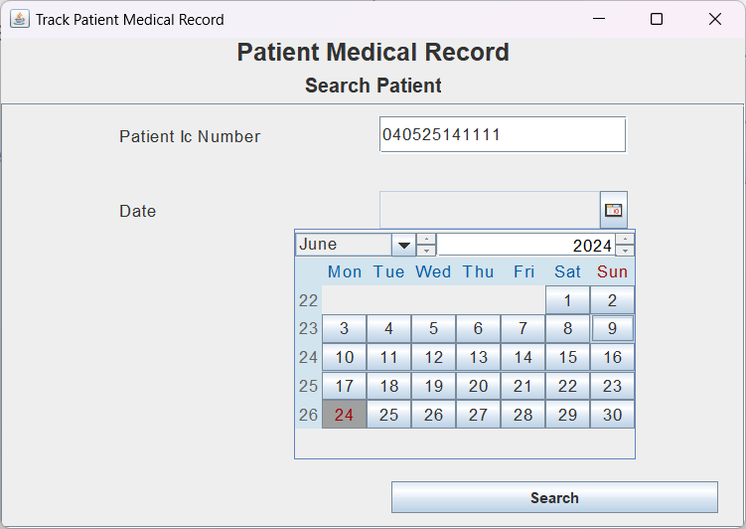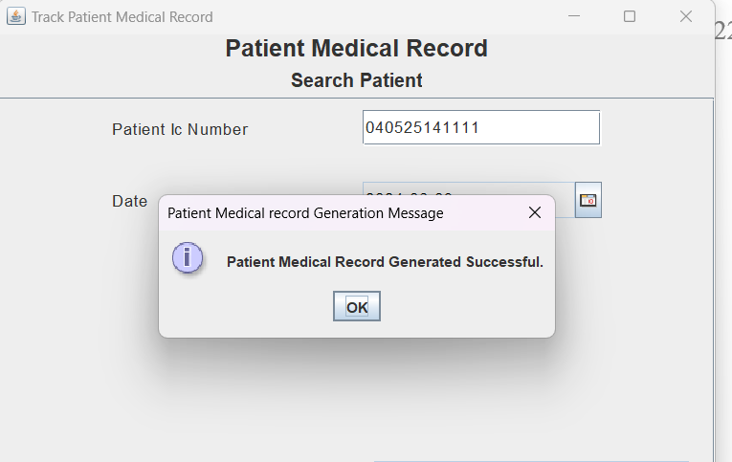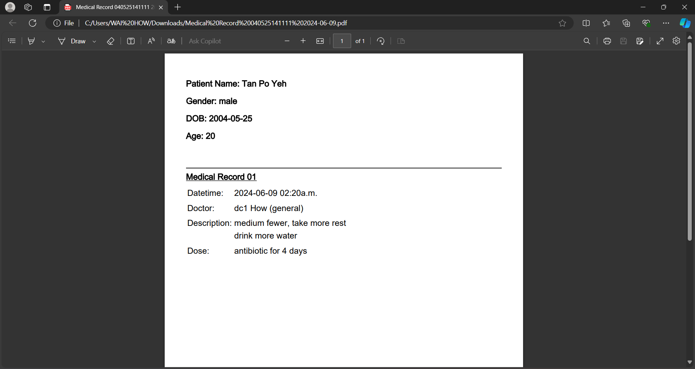

### 2.2.5 Manage Medicine

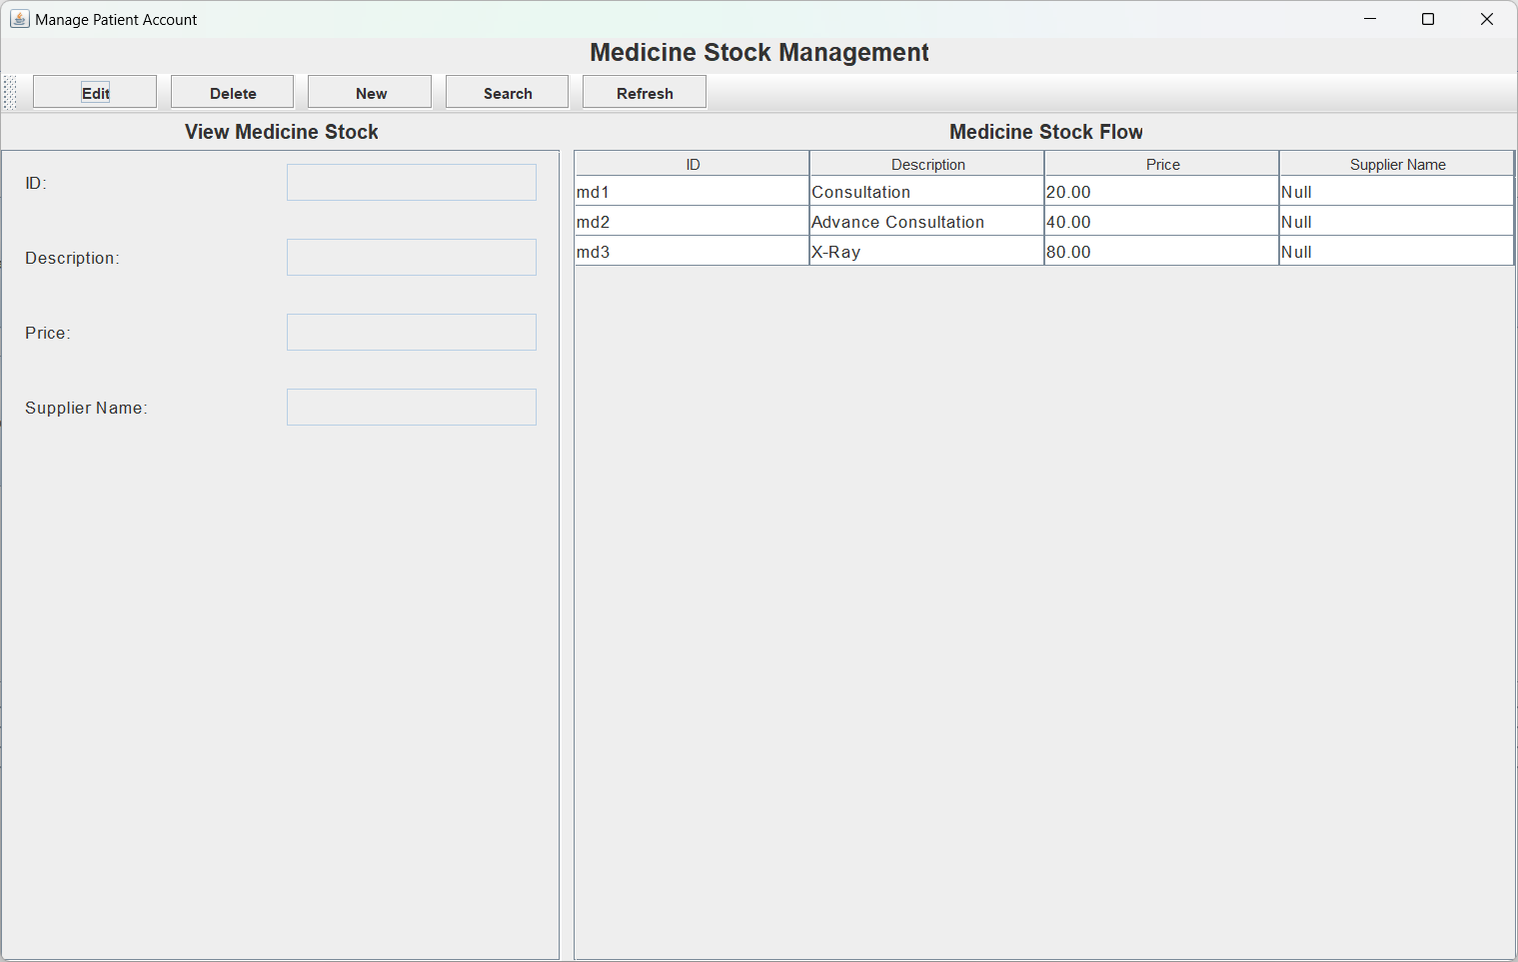

Figure 35 Medicine Management page

Figure 36 Add new medicine

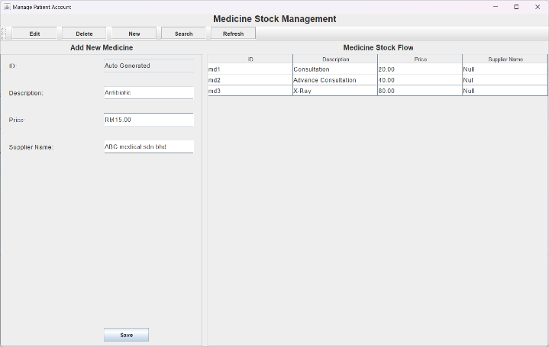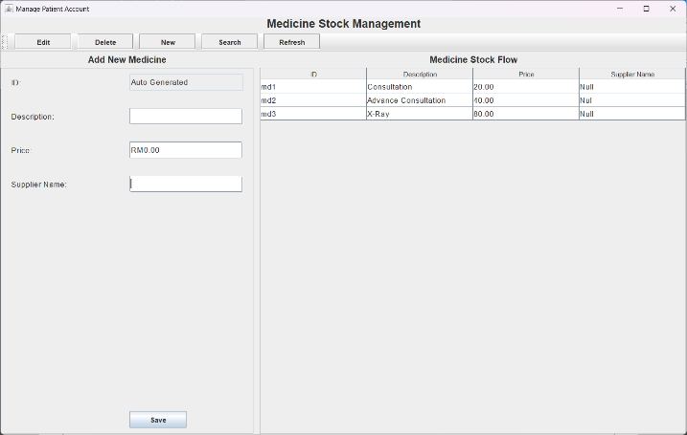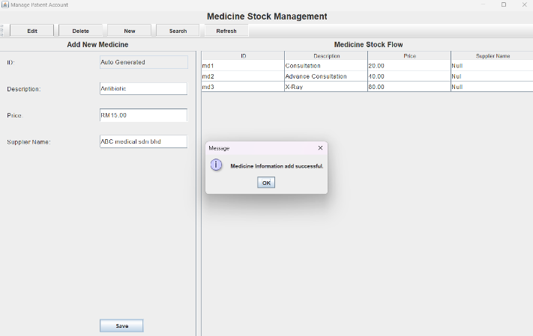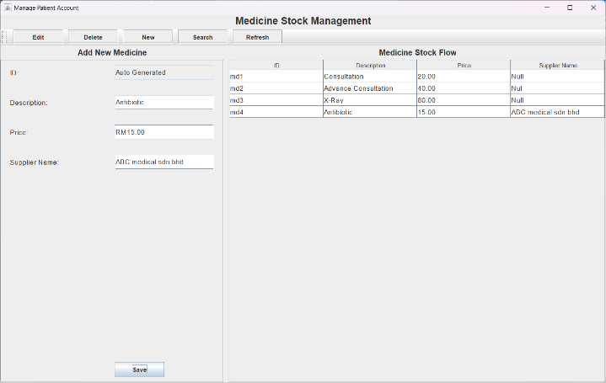

Figure 37 Edit medicine

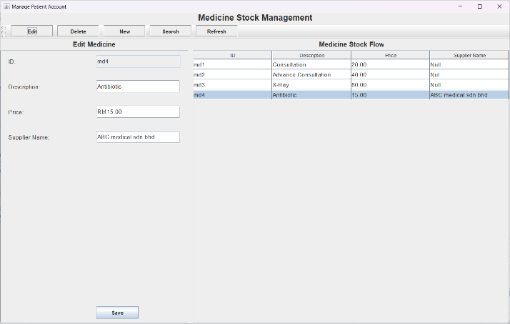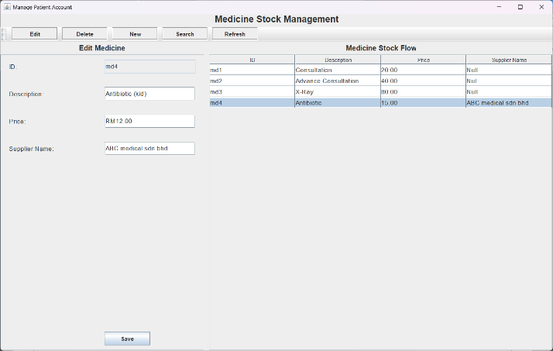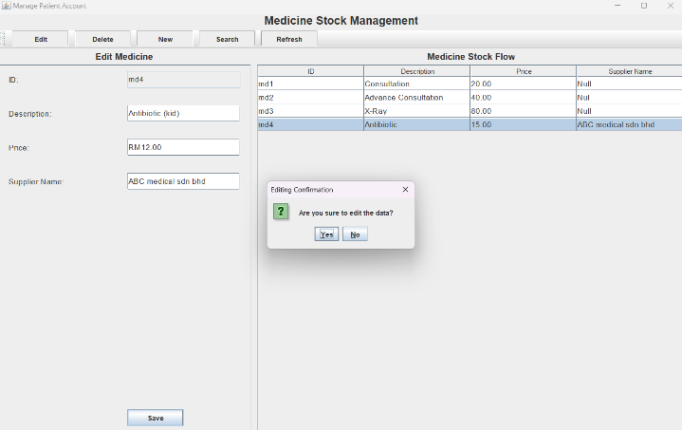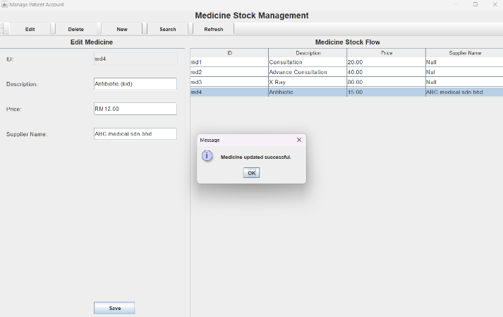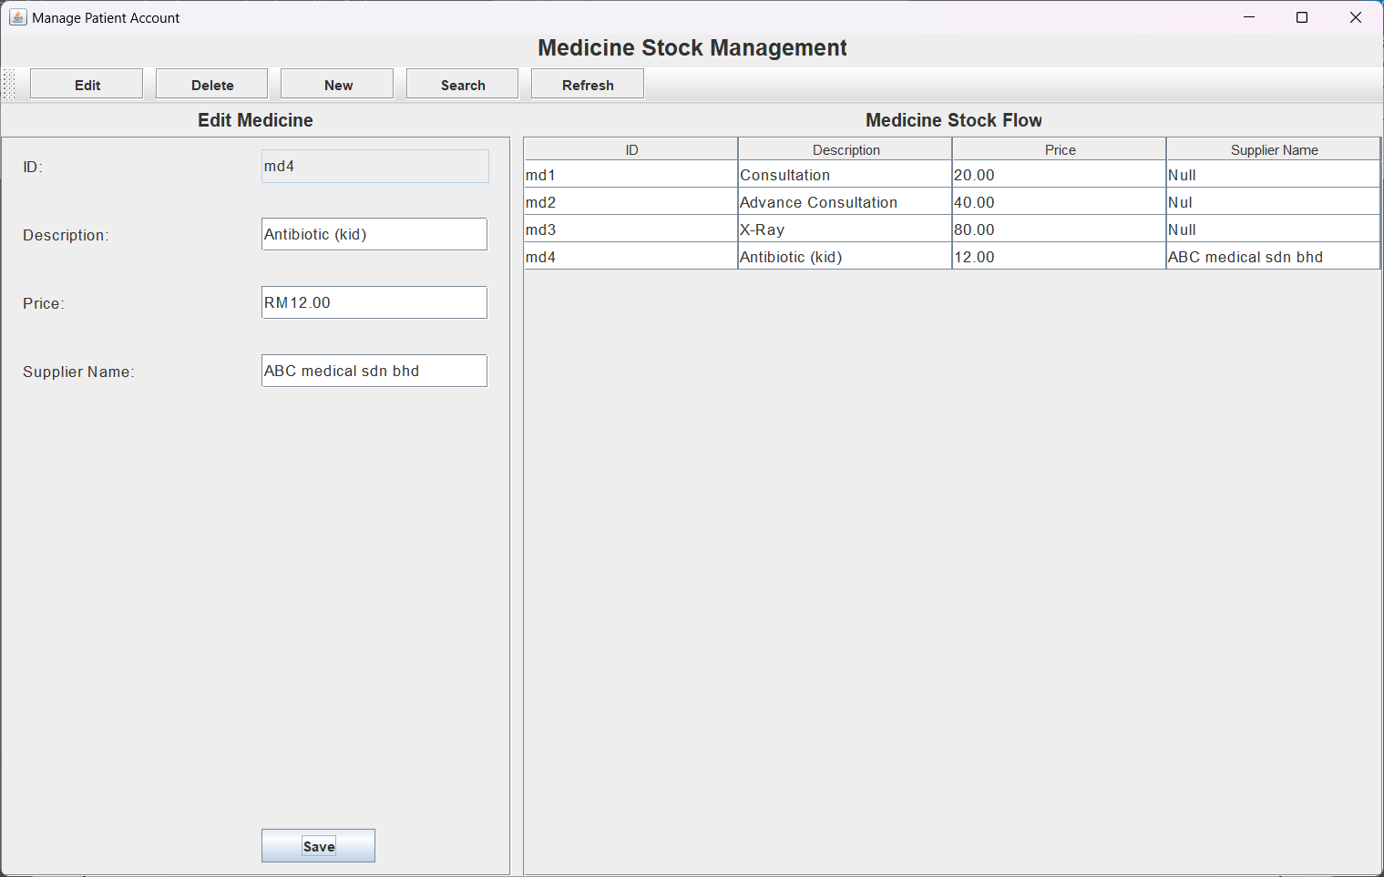

Figure 38 Delete medicine

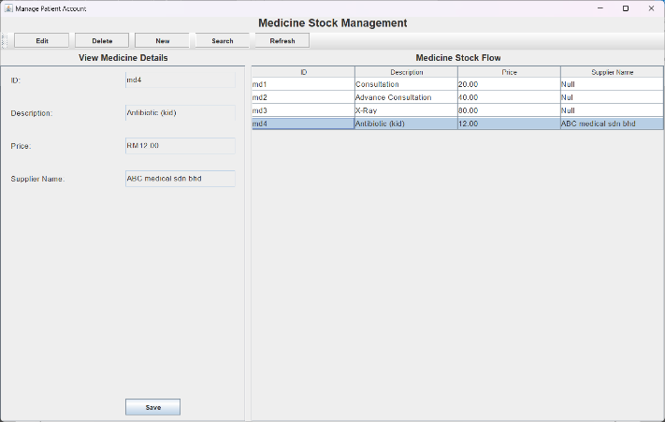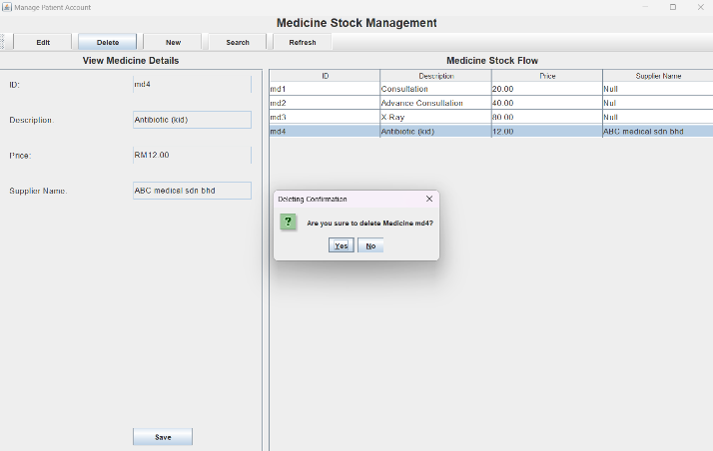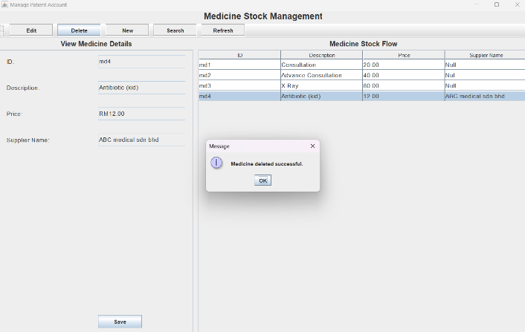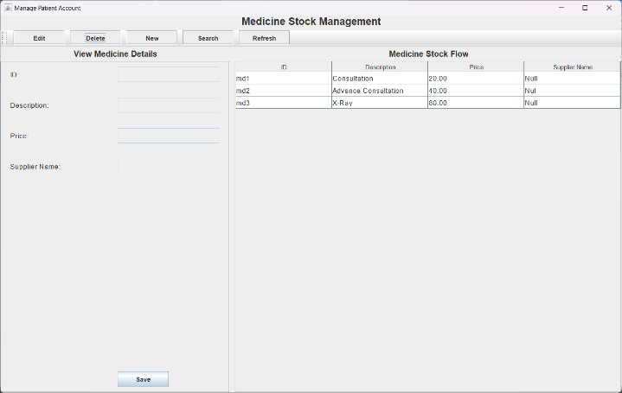

Figure 39 Search medicine

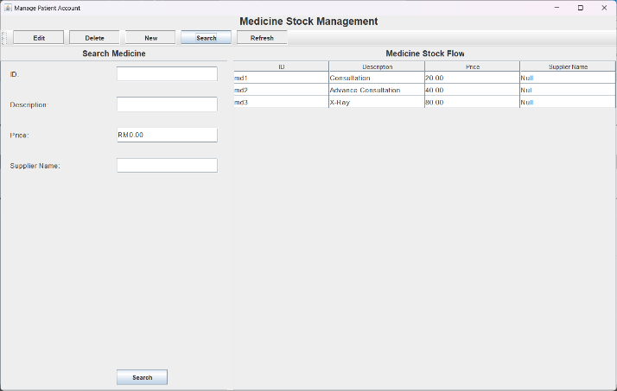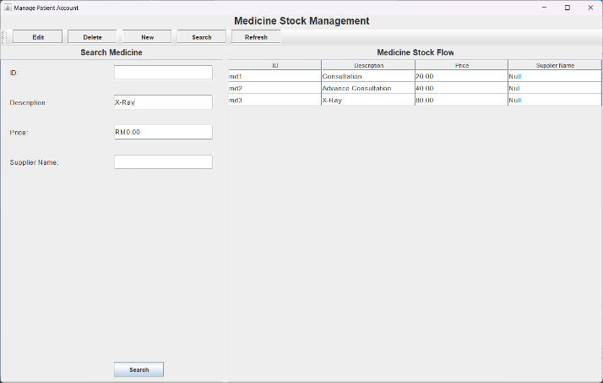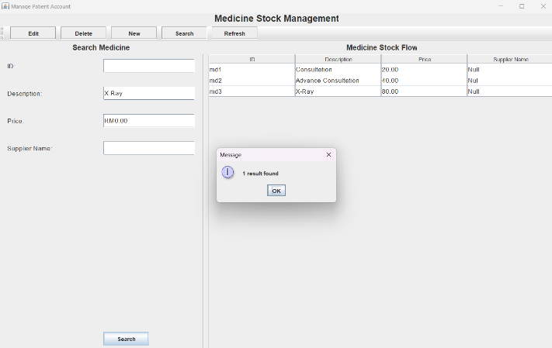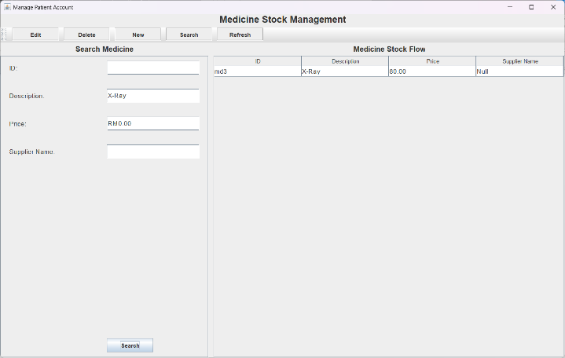

### 2.2.6 Manage Payment

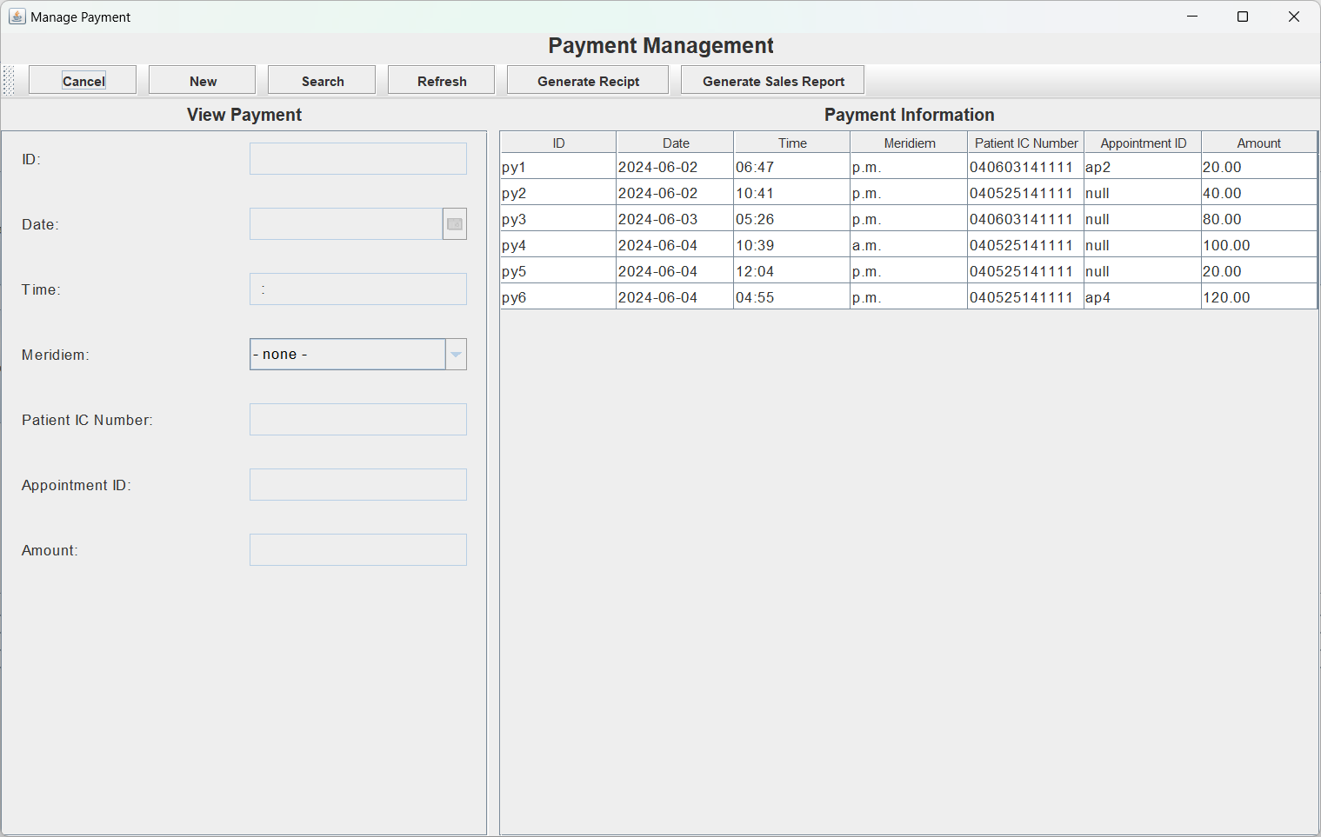

Figure 40 Payment Management page

We integrate some features of Point of Sales system into the payment process:

1. **Enter Payer's IC Number**: Admins need to input the payer's identification number.
2. **Select Appointment**: Choose the appropriate appointment linked to the payment.
3. **Select Items**: Admins can select up to five medicines or items to include in the payment.
4. **Generate Invoice**: Click the *Generate Invoice* button to preview the payment details.
5. **Confirm Payment**: Click *Confirm* button to confirm the preview payment detail.
6. **Enter Paid Amount**: Enter the amount of the payer paid.

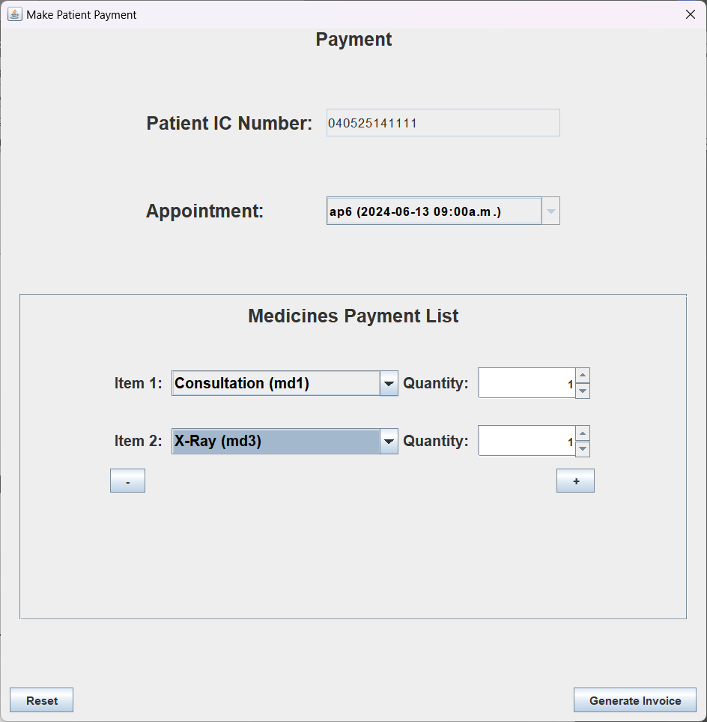

Figure 41 Make new payment

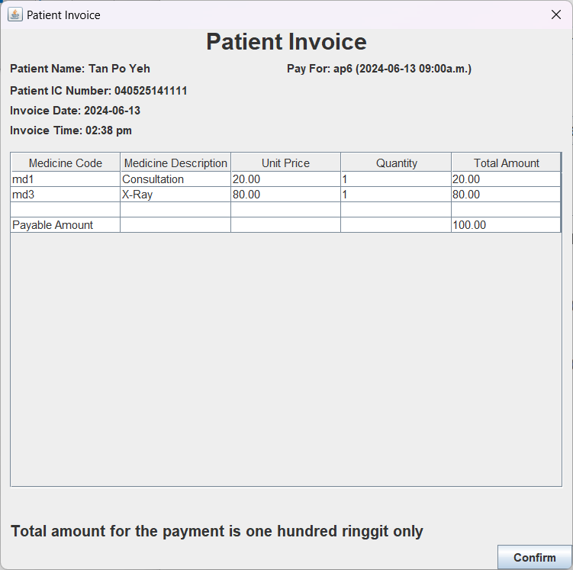

Figure 42 Preview payment details

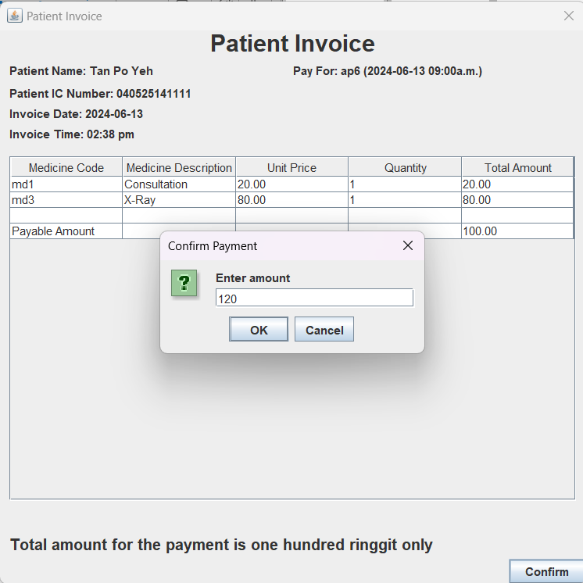

Figure 43 Enter paid amount

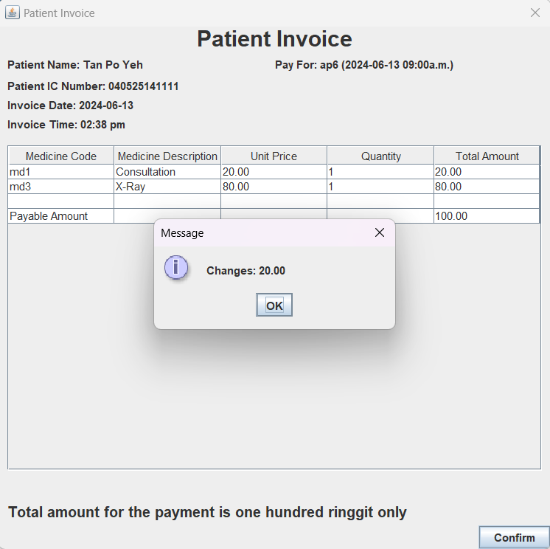

Figure 44 The system display change for the payment

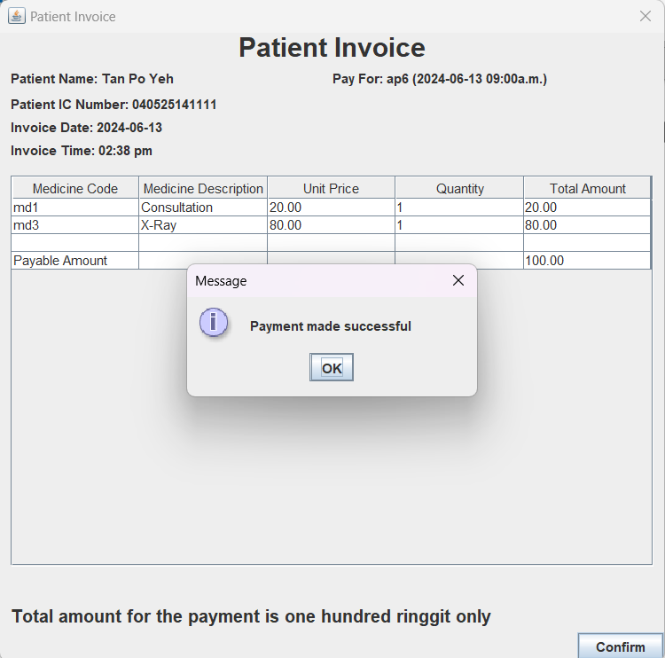

Figure 45 Payment made successfu

Figure 46 Cancel Payment

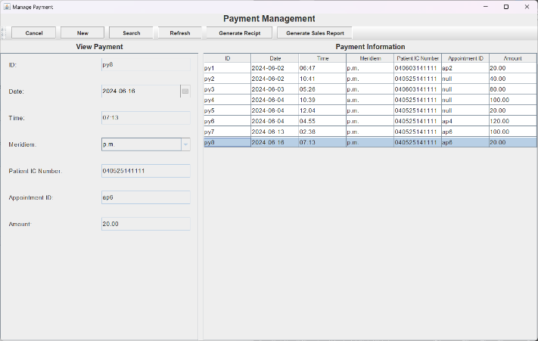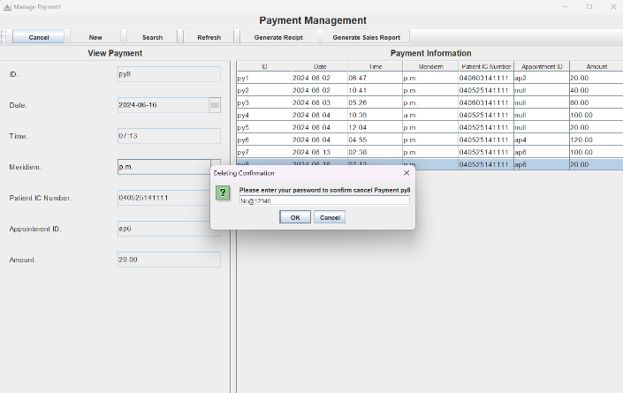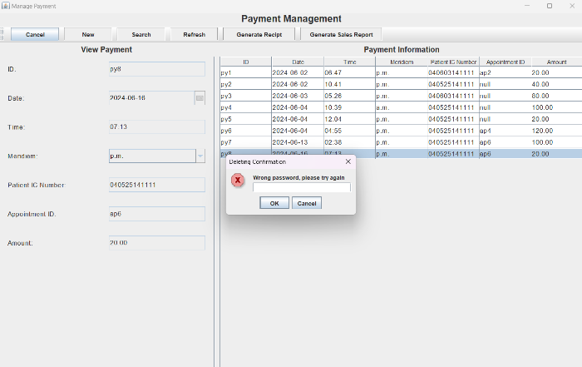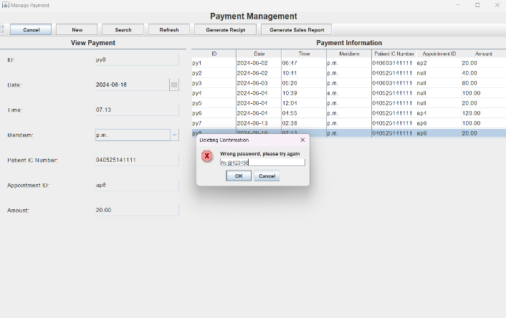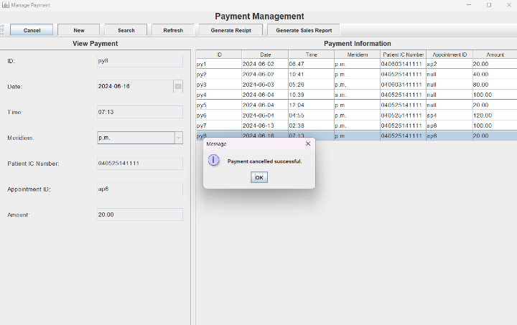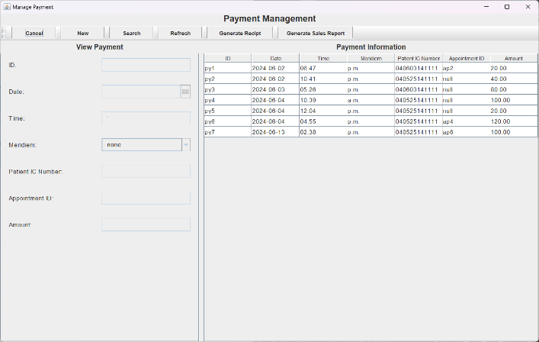

Figure 47 Search payment

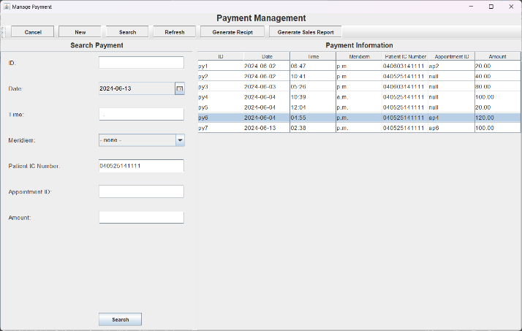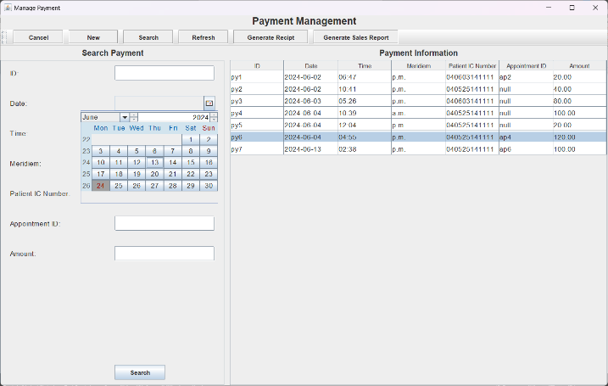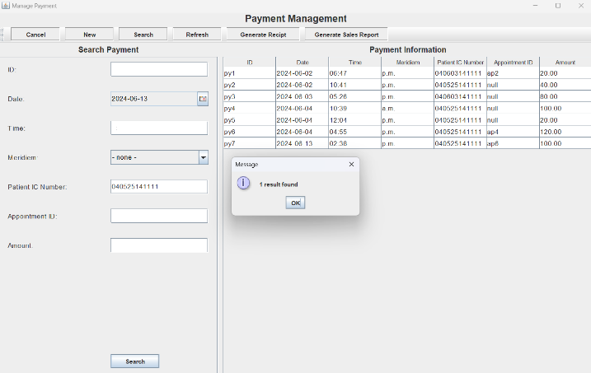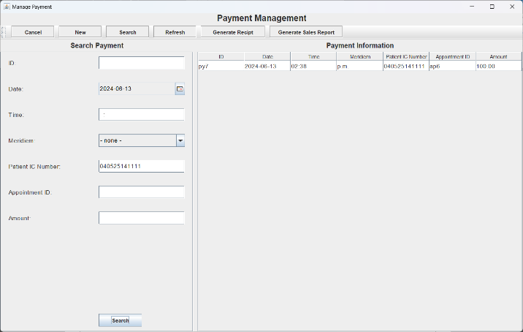

Figure 48 Generate payment receipt

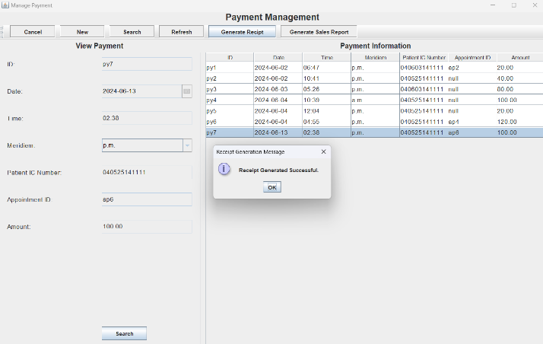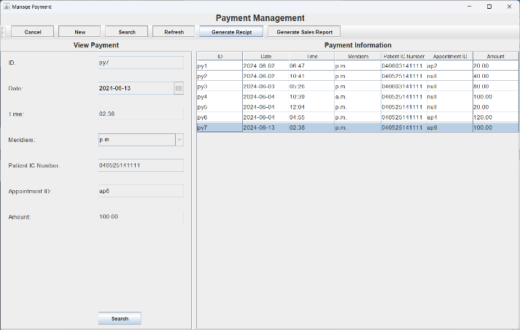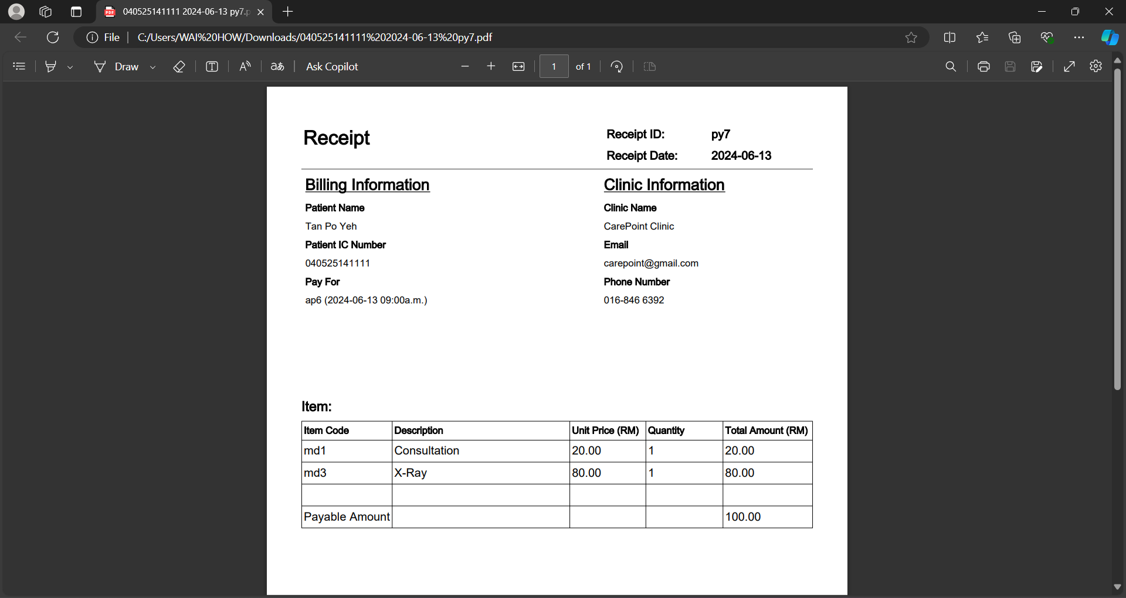

Figure 49 Generate sales report

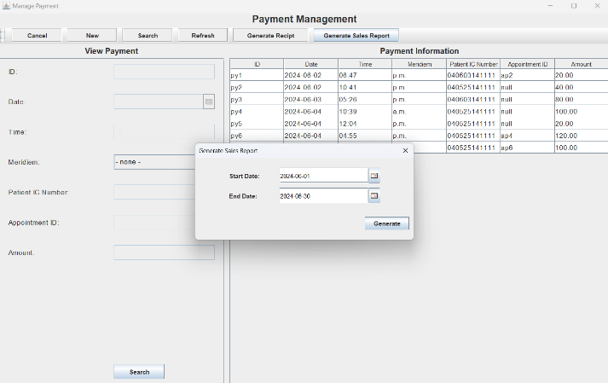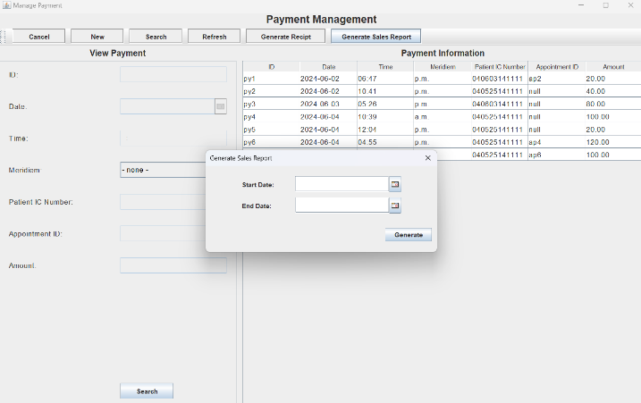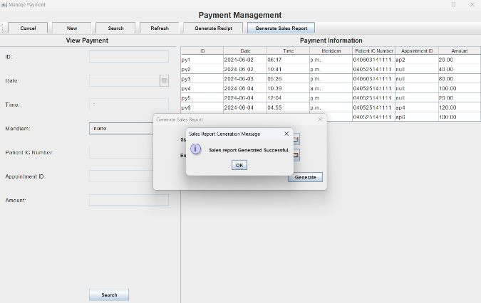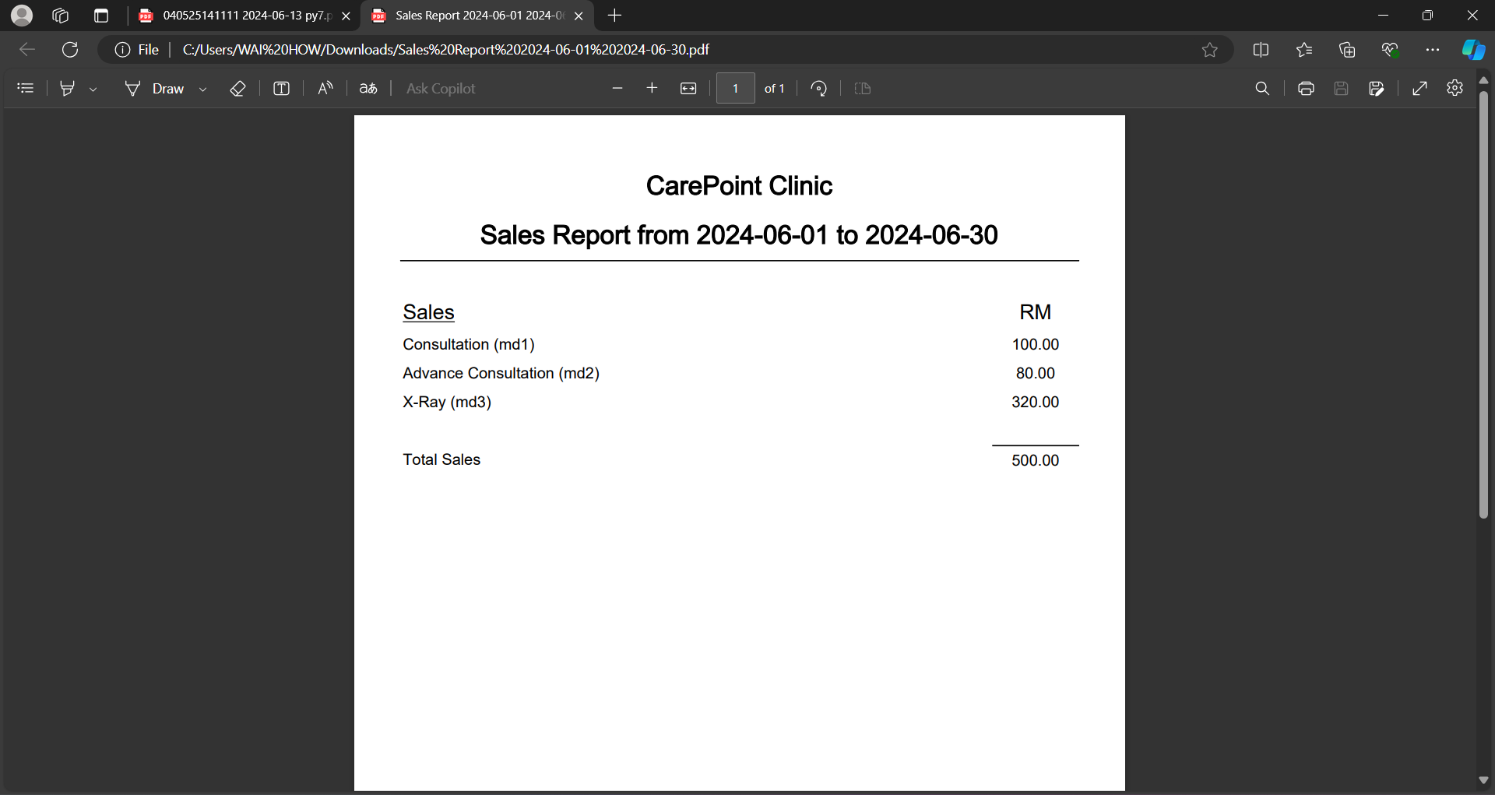

## 2.2 Doctor Features

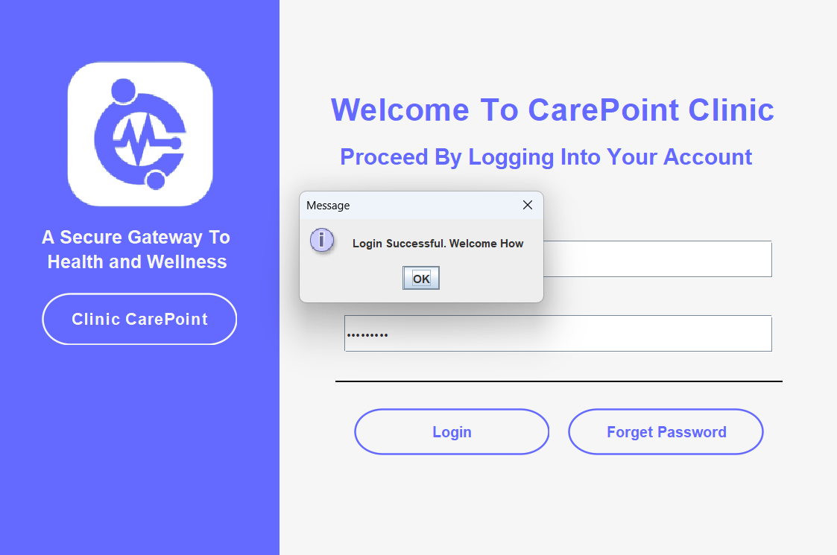

Figure 50 :Doctor sign in page

.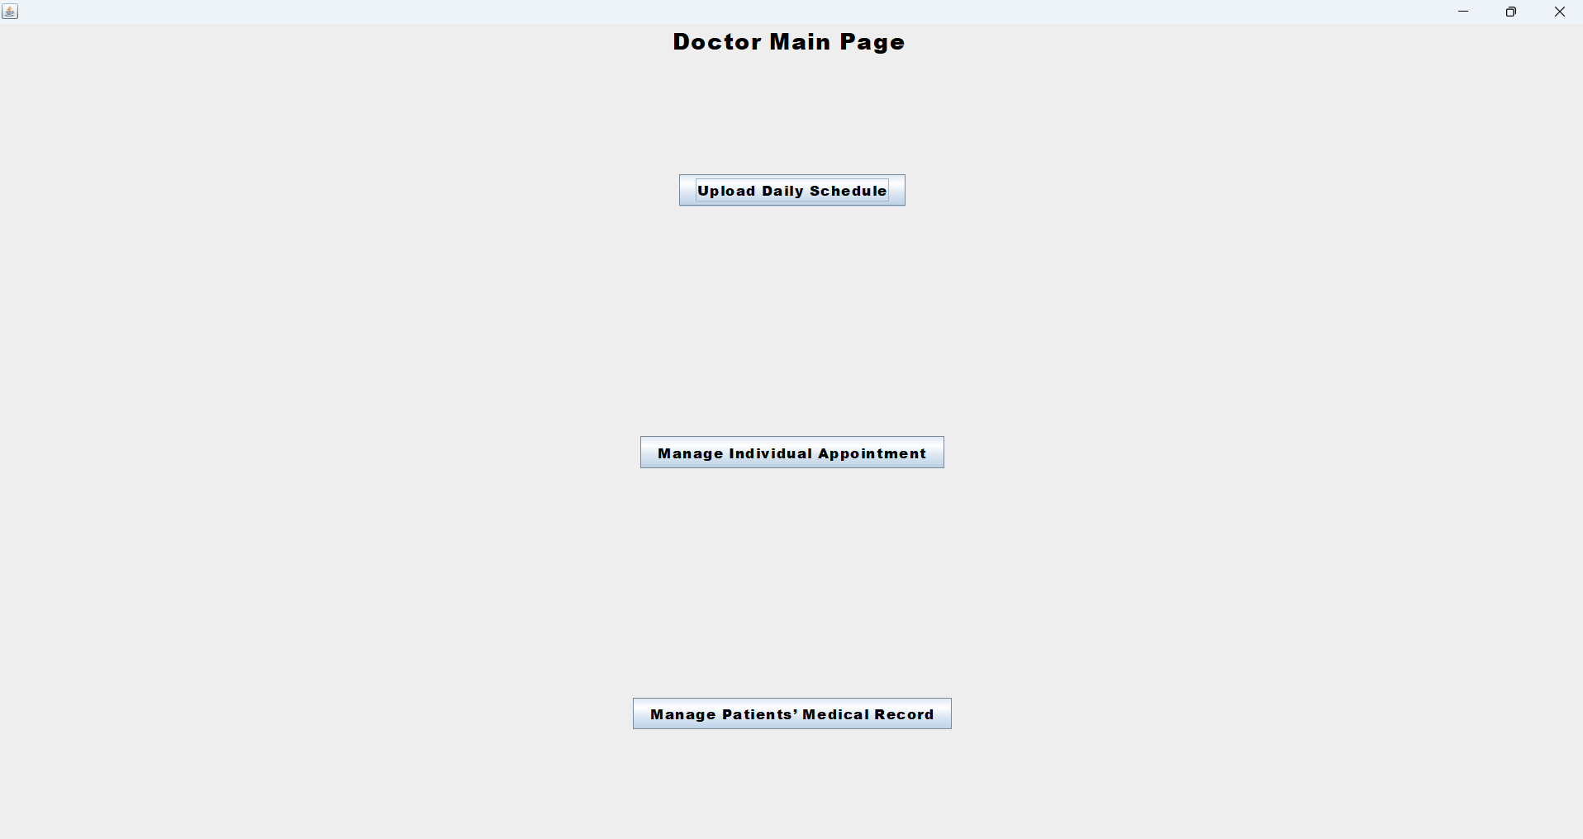

Figure 51 :Main Page for Doctor

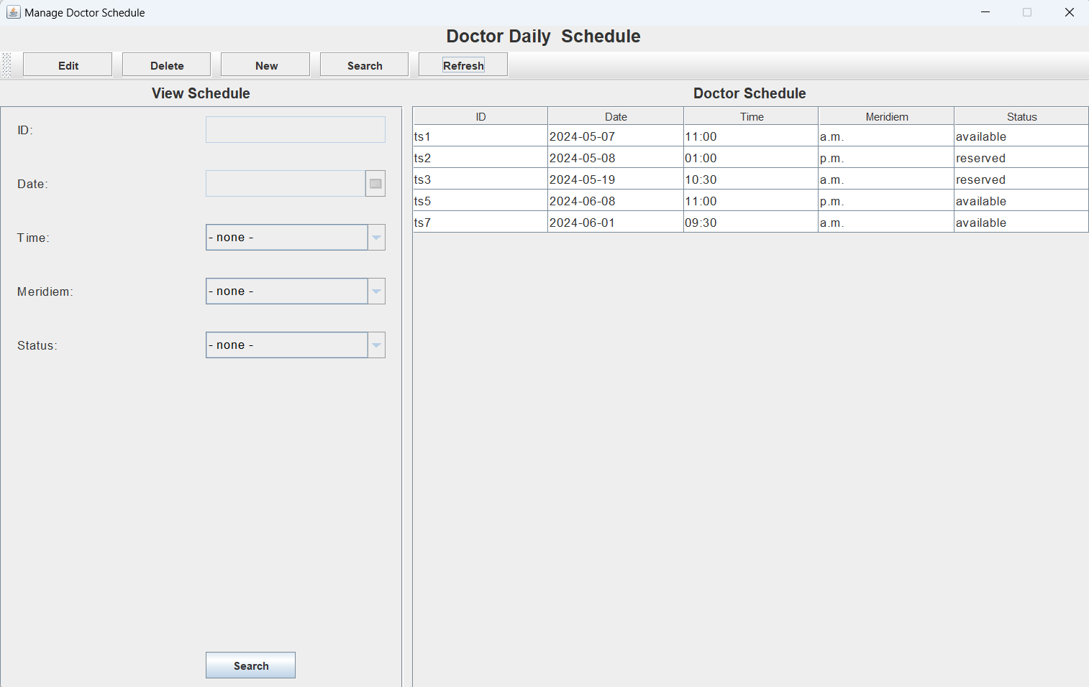

Figure 52:Update Daily Schedule for Doctor

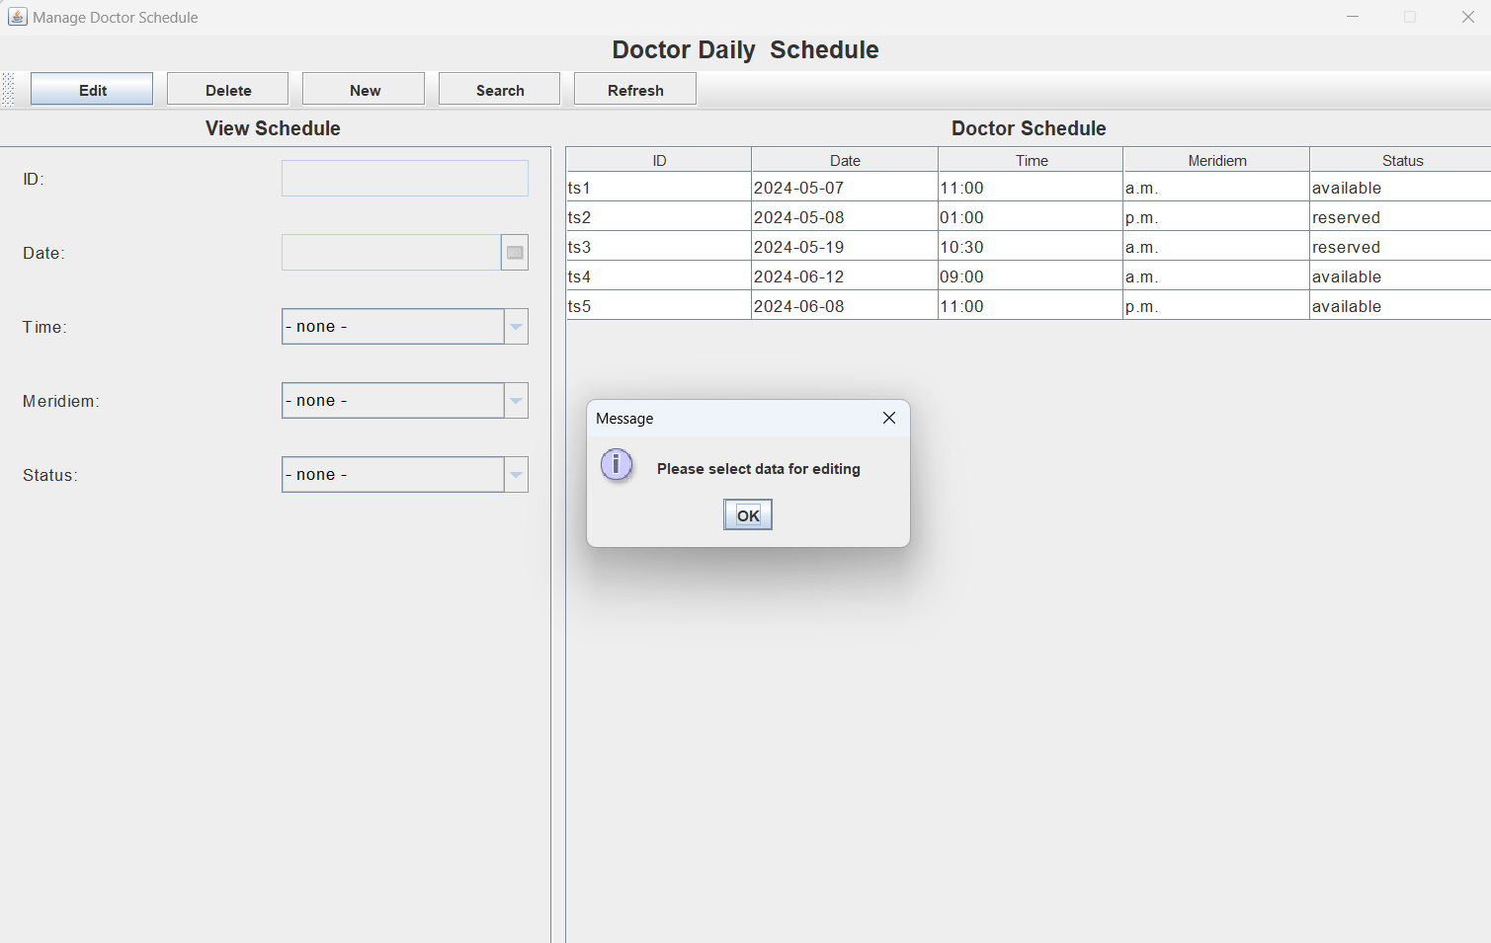

Figure 53:User must Select Data for Editing as shown above

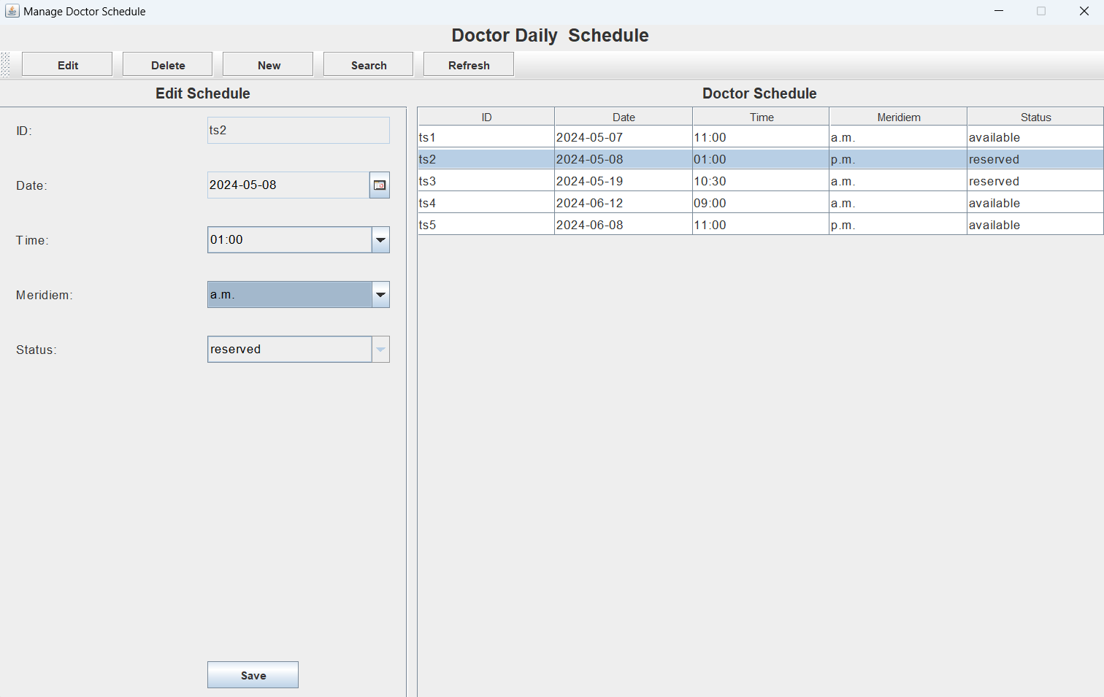

Figure 54:After selecting the data, it will then display on the left-hand side of the table

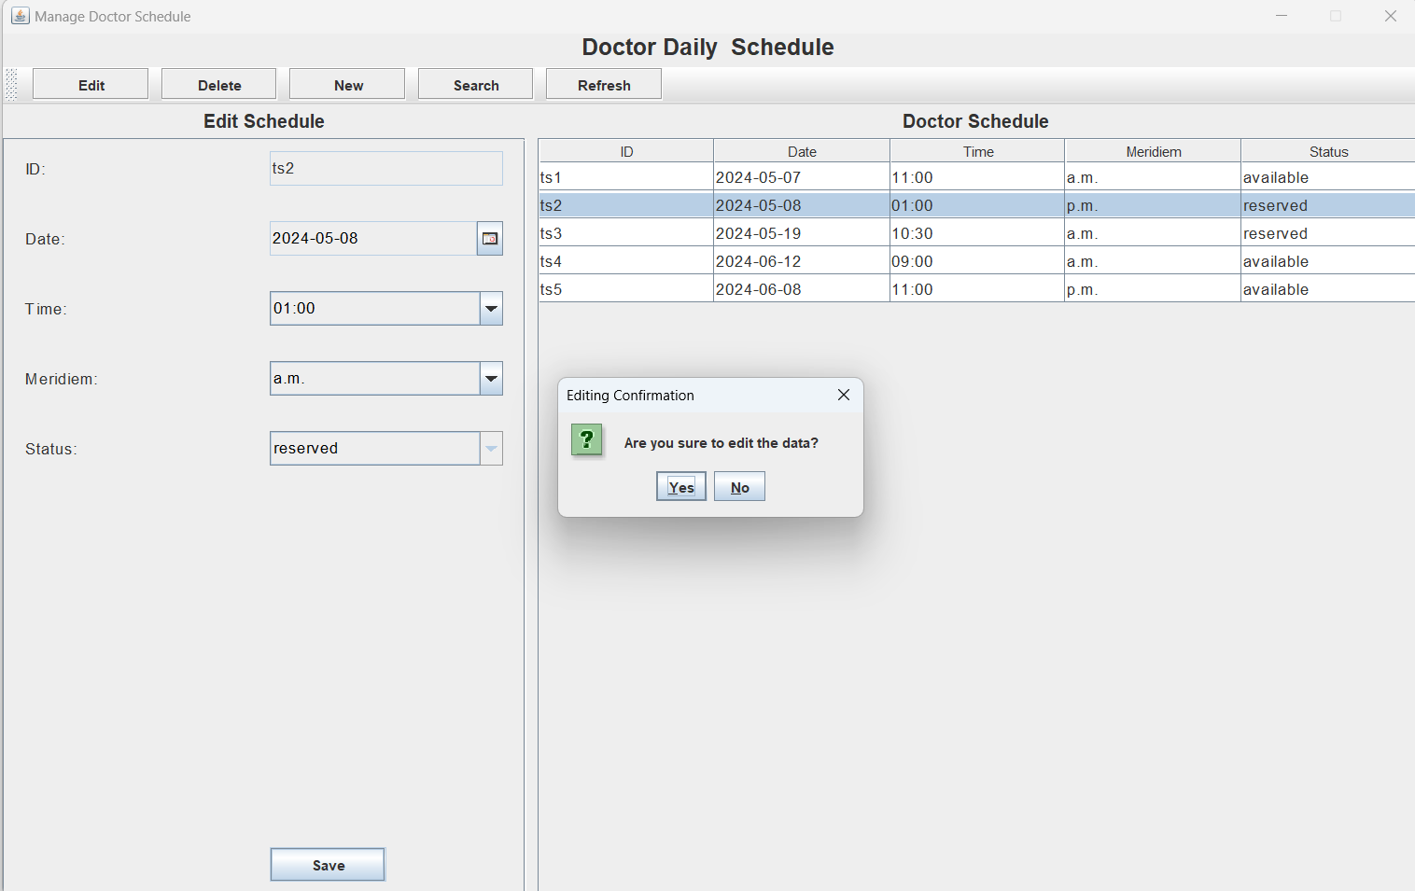

Figure 55:A pop out Message Box asking for clarification on the selected data

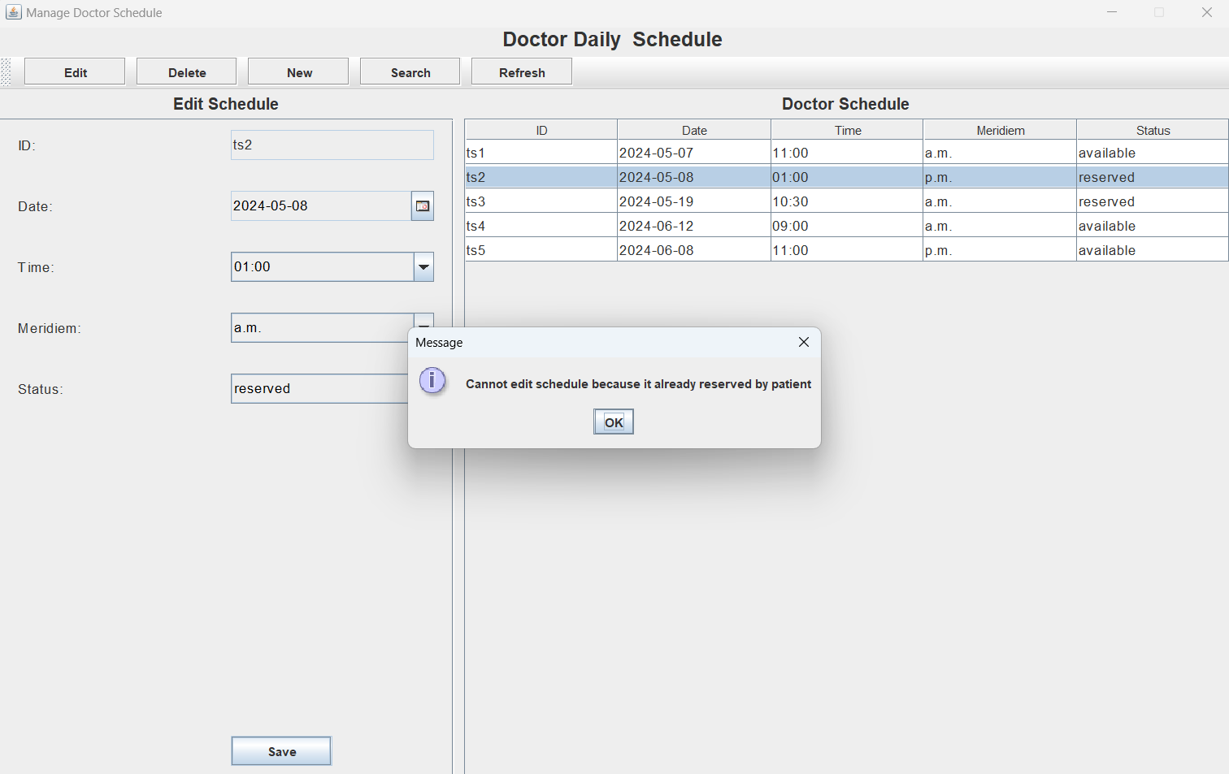

Figure 56:As u can see in the figure above, a patient who has reserved cannot be editable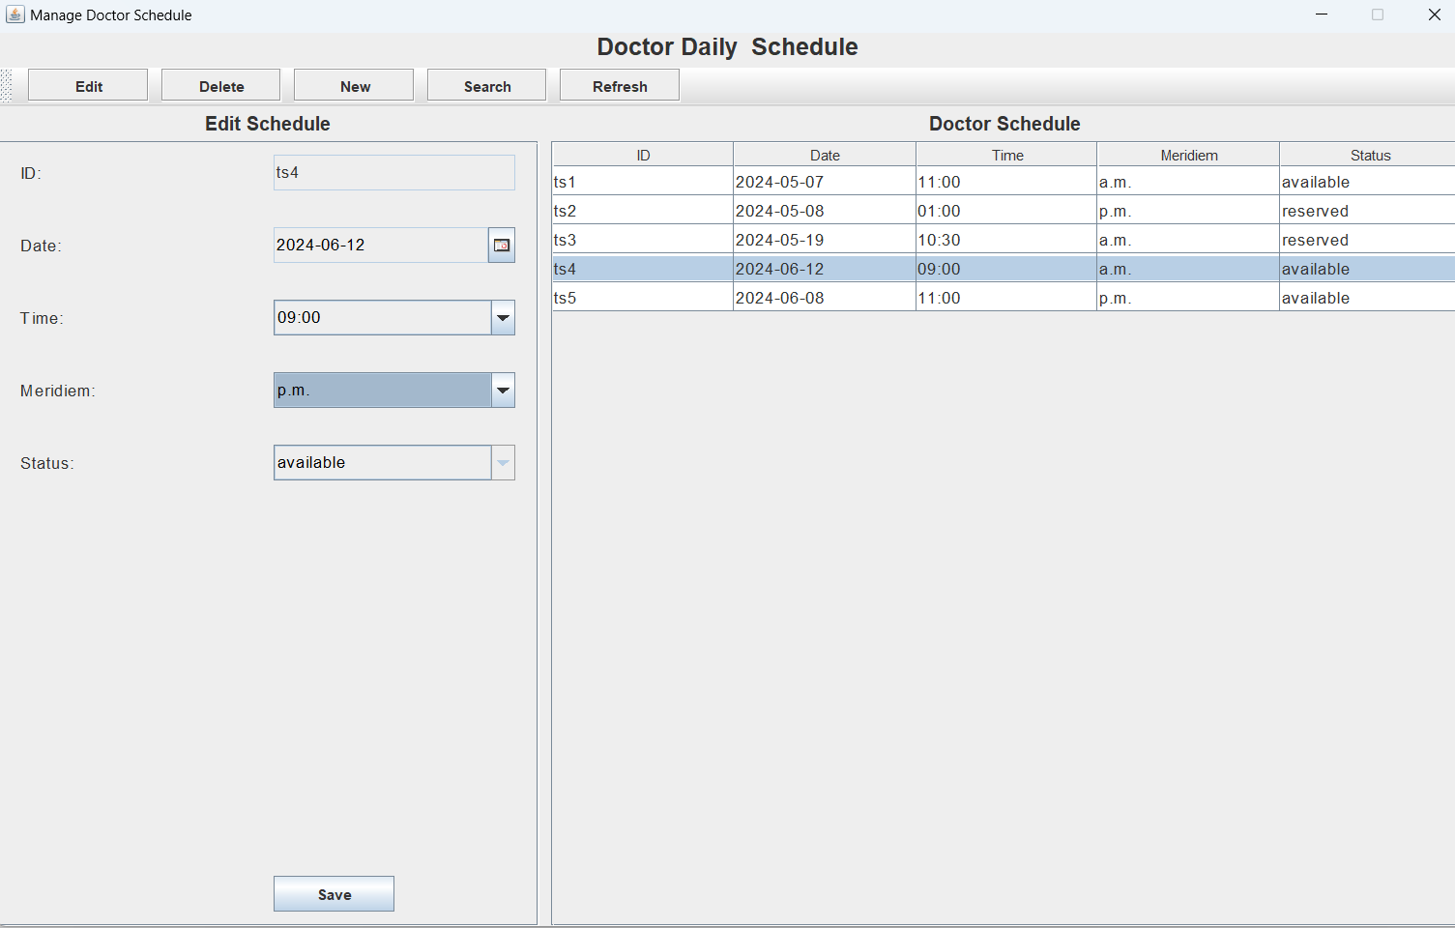

Figure 57: As u can see, the selected data which is not reserved by a patient is editable

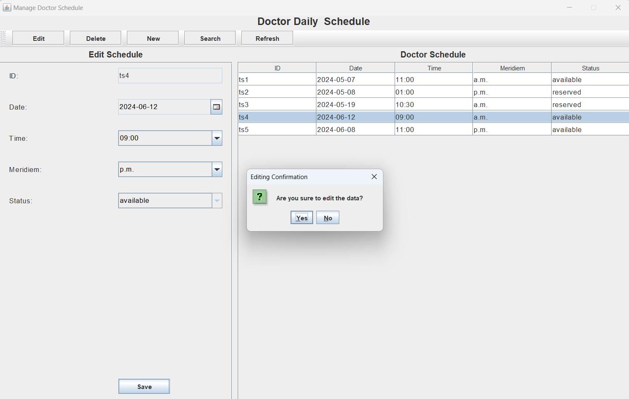

Figure 58: :A pop out Message Box asking for clarification on the selected data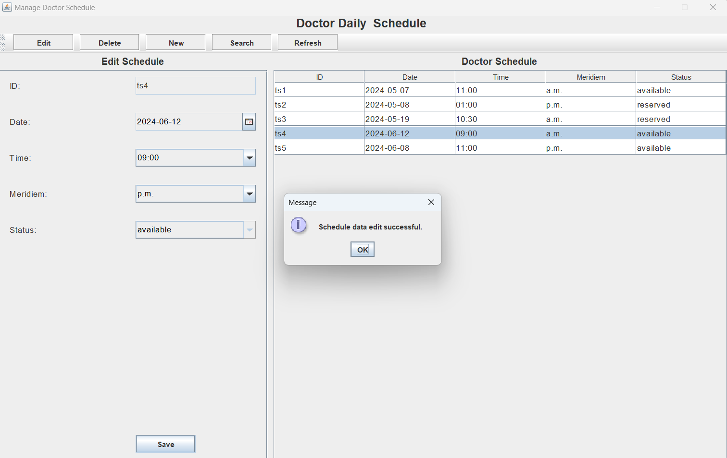

Figure 59:After selecting ok, a pop out message will appear indicating the data is edit successfully

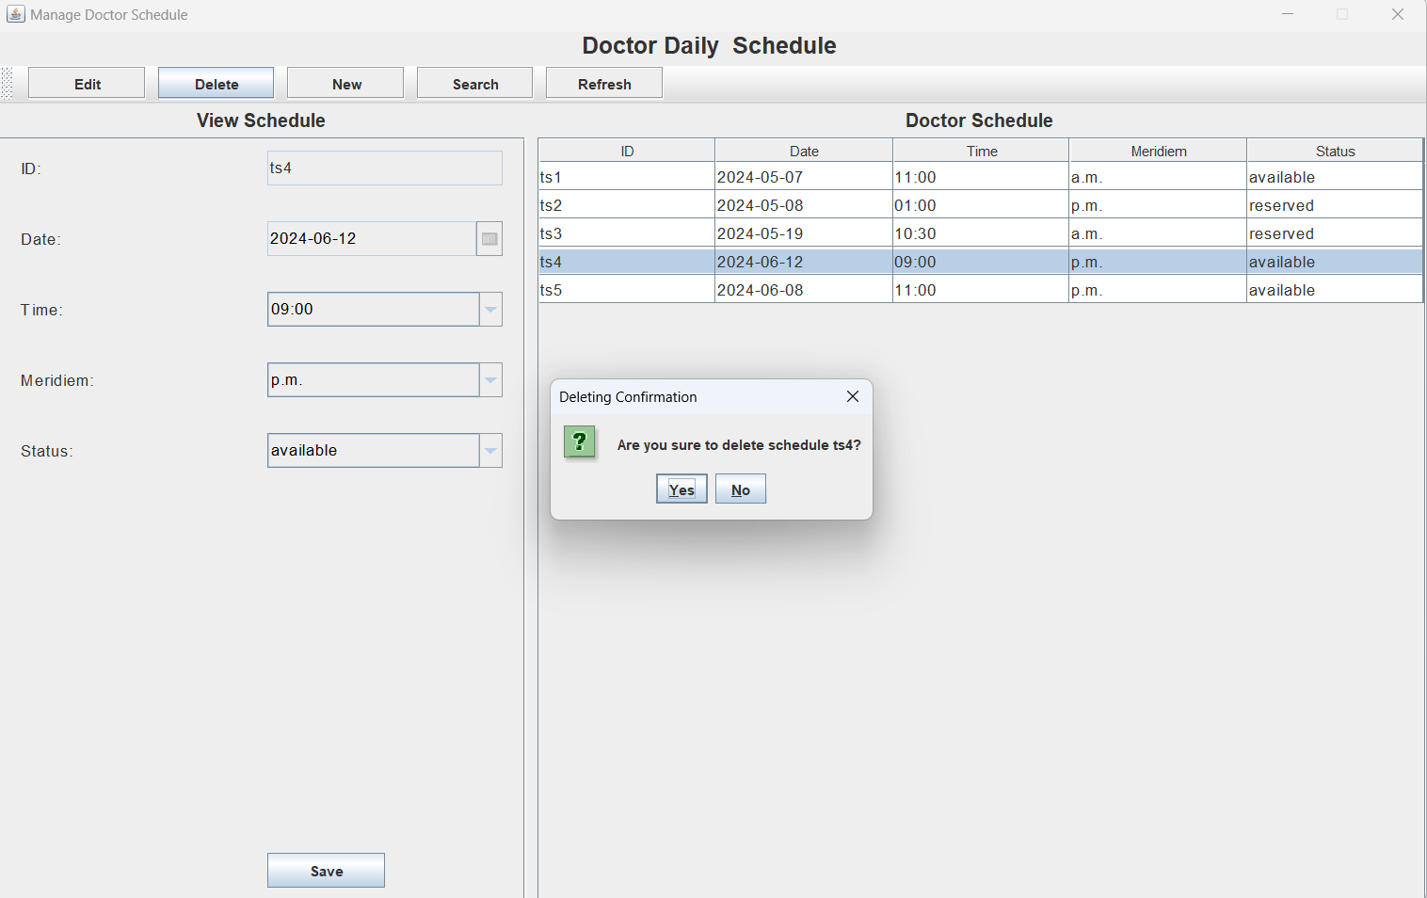

Figure 60:Delete function, the user must select a data to delete .After selecting the data a pop up message box will appear ,asking for confirmation to delete on the selected data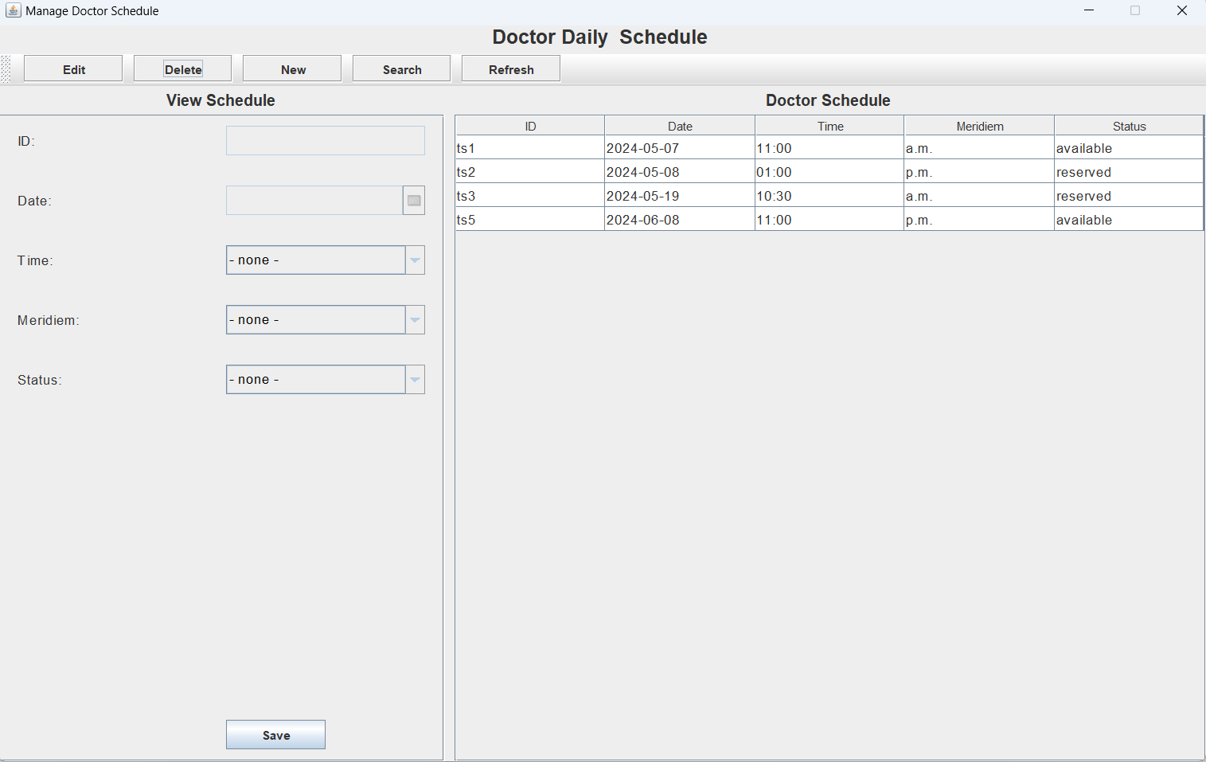

Figure 61 :The selected data by the user is deleted as shown above

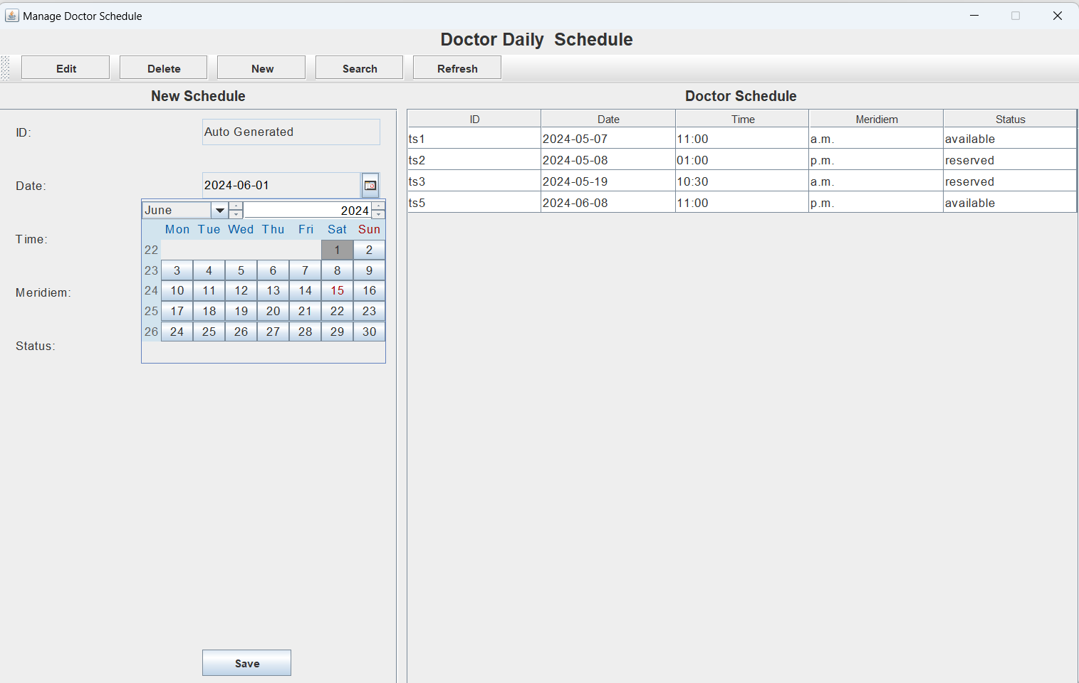

Figure 62 :If the user want to create a new Schedule ,he or she must choose a date

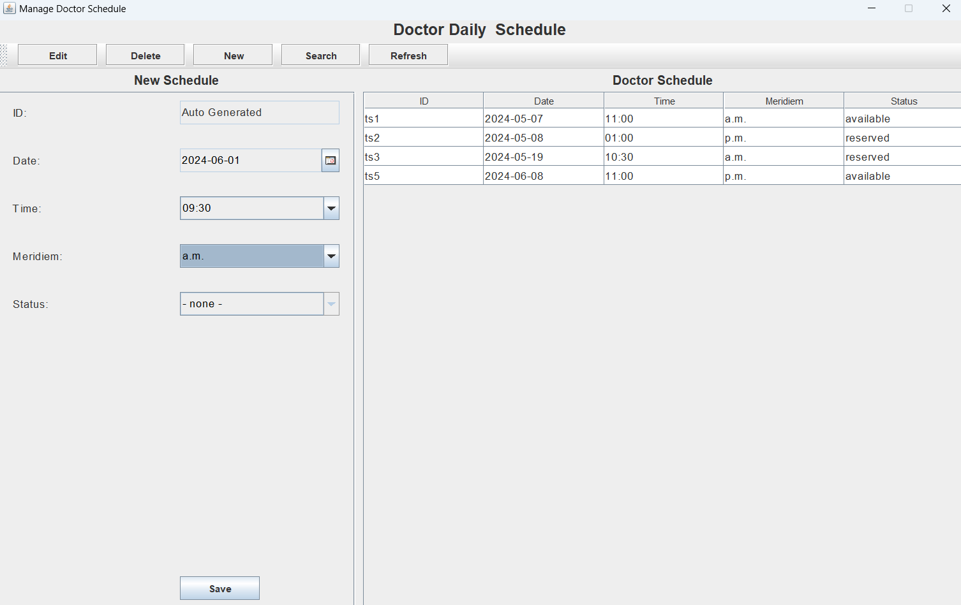

Figure 63:After user select the date and time , he or she can proceed to press the safe button

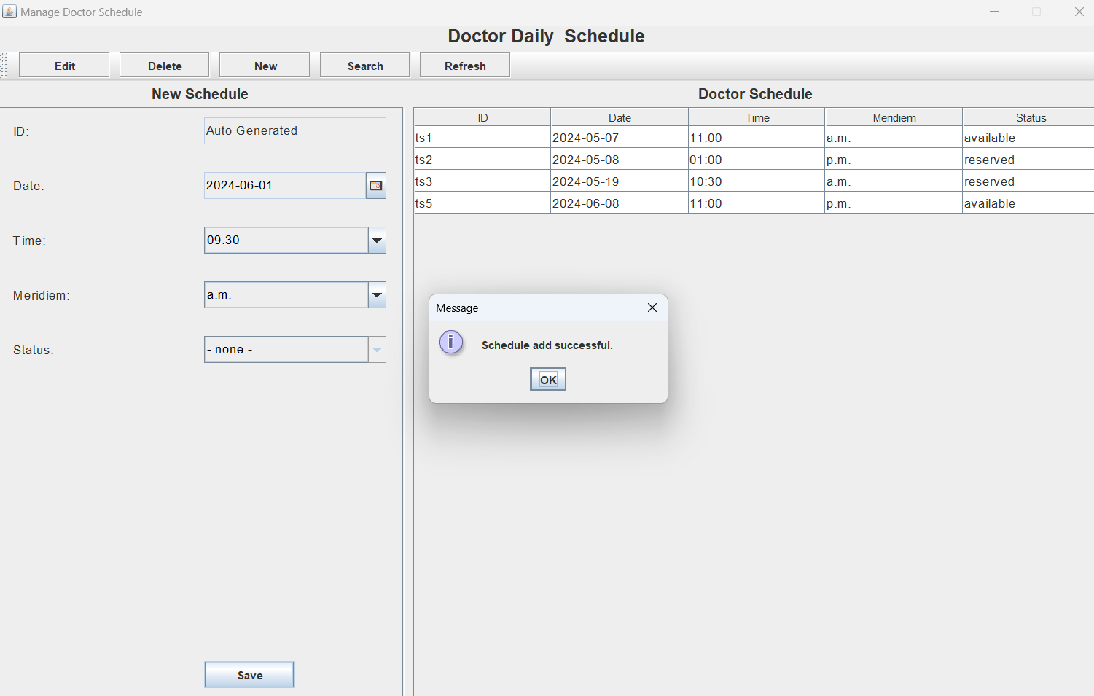

Figure 64:As shown above the schedule is added to the Doctor Schedule successfully

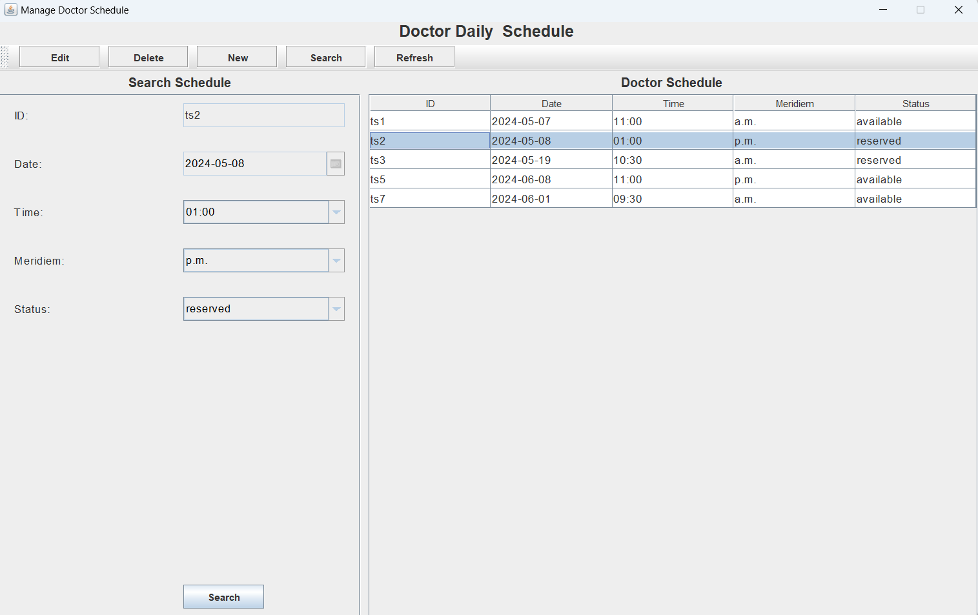

Figure 65 :If the user want to search a schedule ,he or she can press the search button

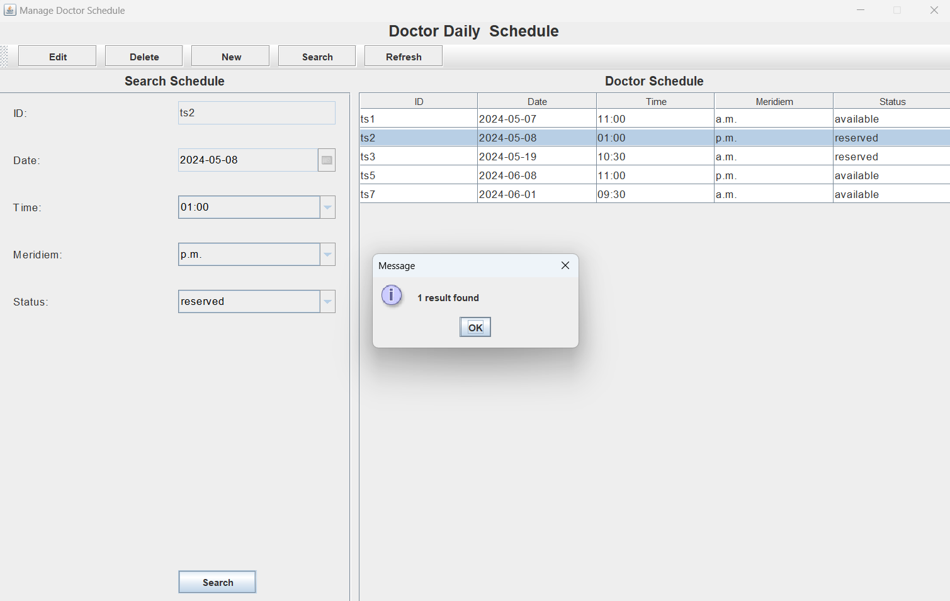

Figure 66 :As Shown above ,the user must enter the information then she want to search .After that ,it will display a pop out message box that indicating 1 result found

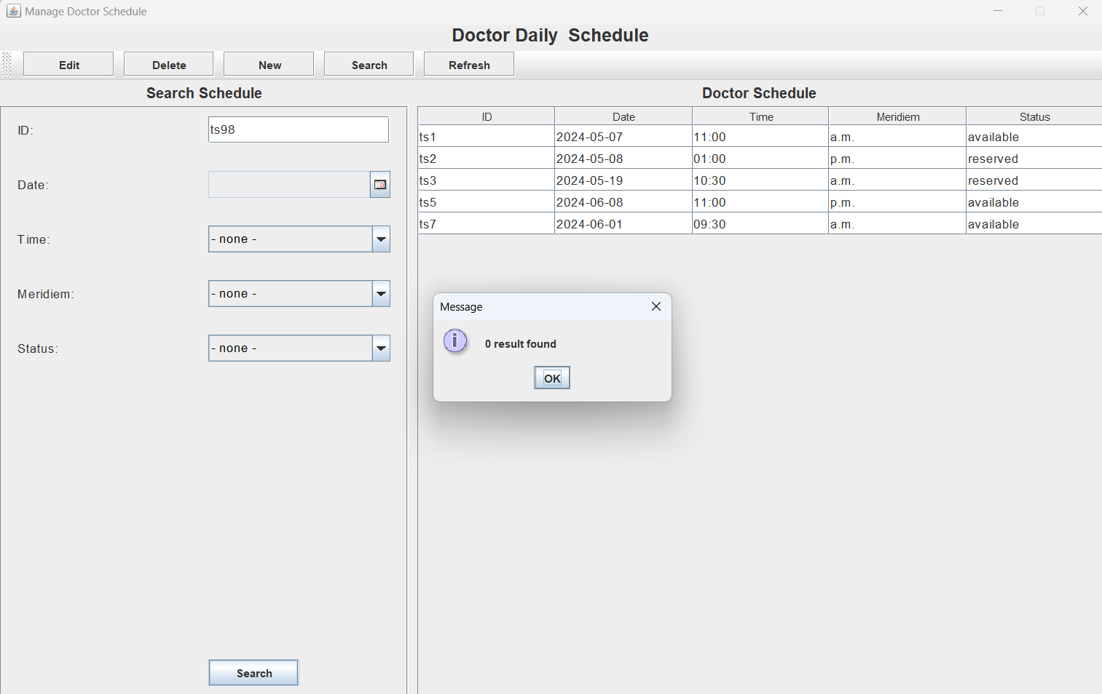

Figure 67:As Shown above , if the user did not enter the information then she or he want to search ,it will display a pop out message box that indicating 0 result found

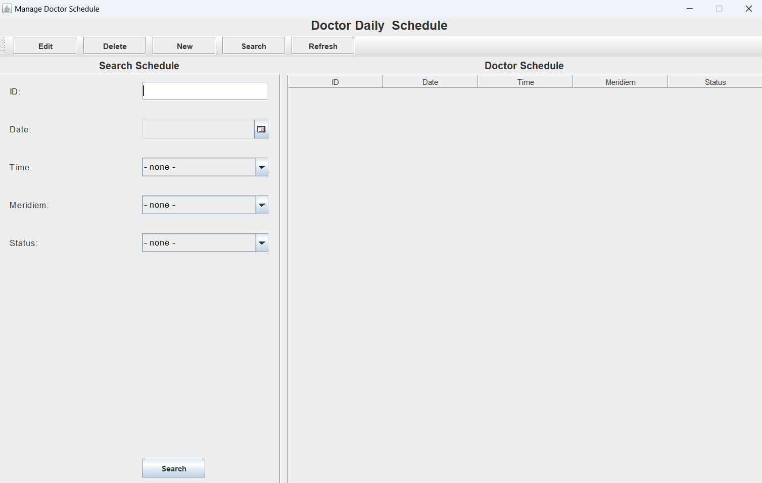

Figure 68:As Shown above , if the user want to refresh the page after adding new schedule ,he or she can press the refresh button



Figure 69:As shown above , after pressing the refresh button ,the data will show out

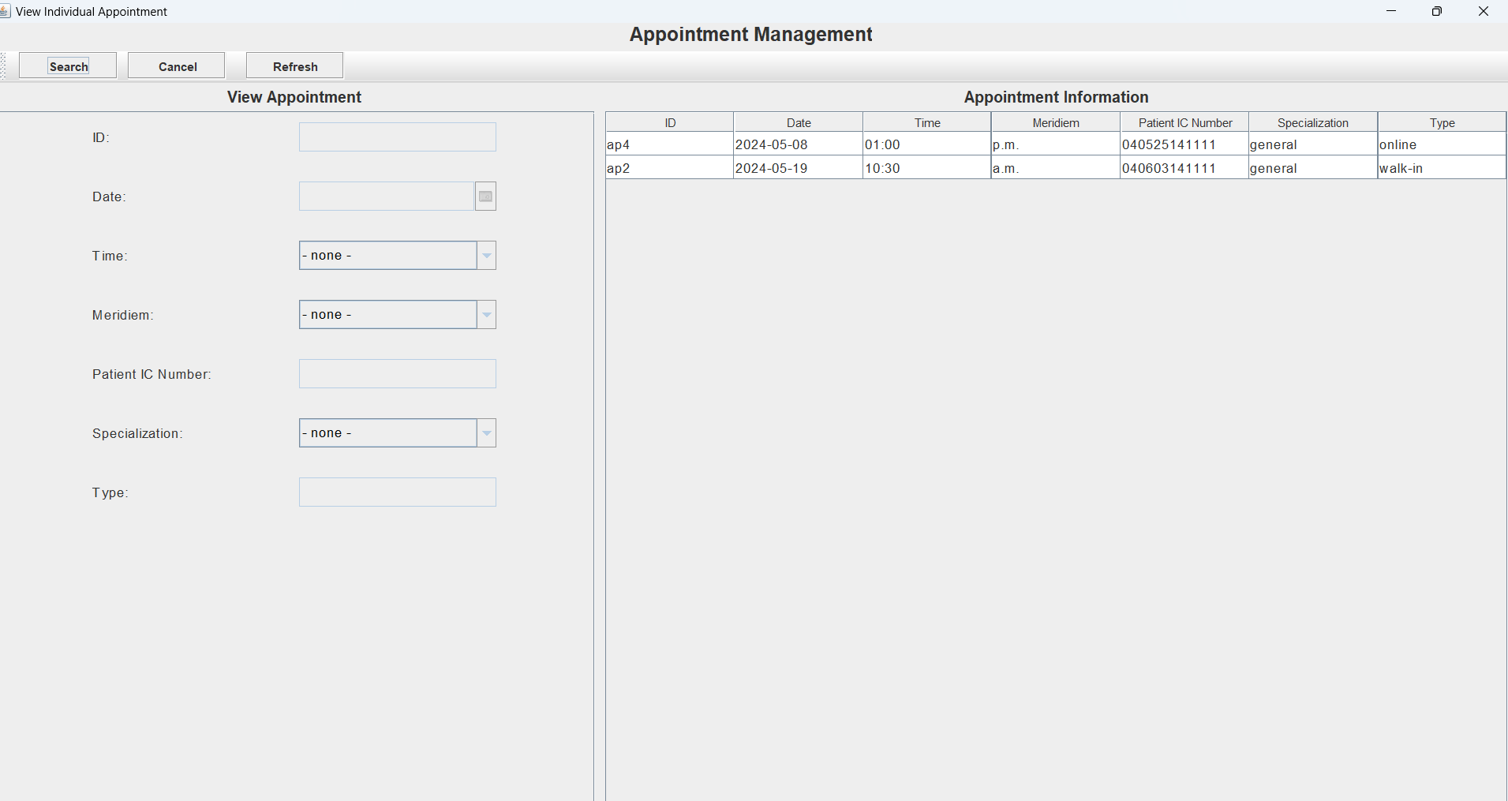

Figure 70: If the user want to search and appointment ,he or she can press the search

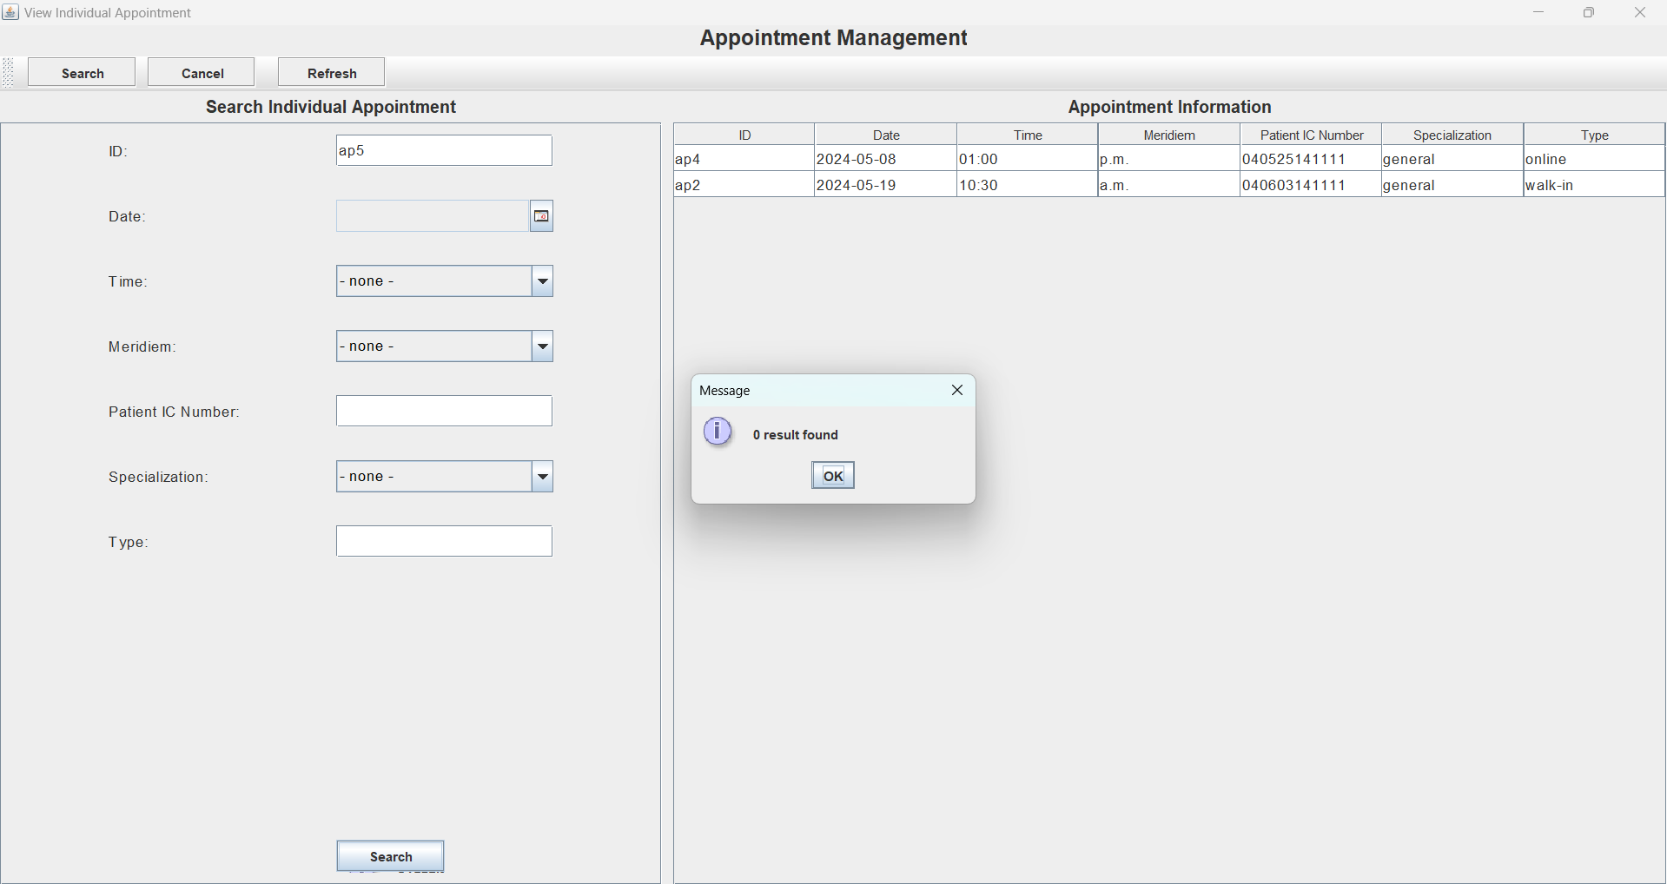

Figure 71: As shown above 0 results is found ,after the user enter the wrong ID

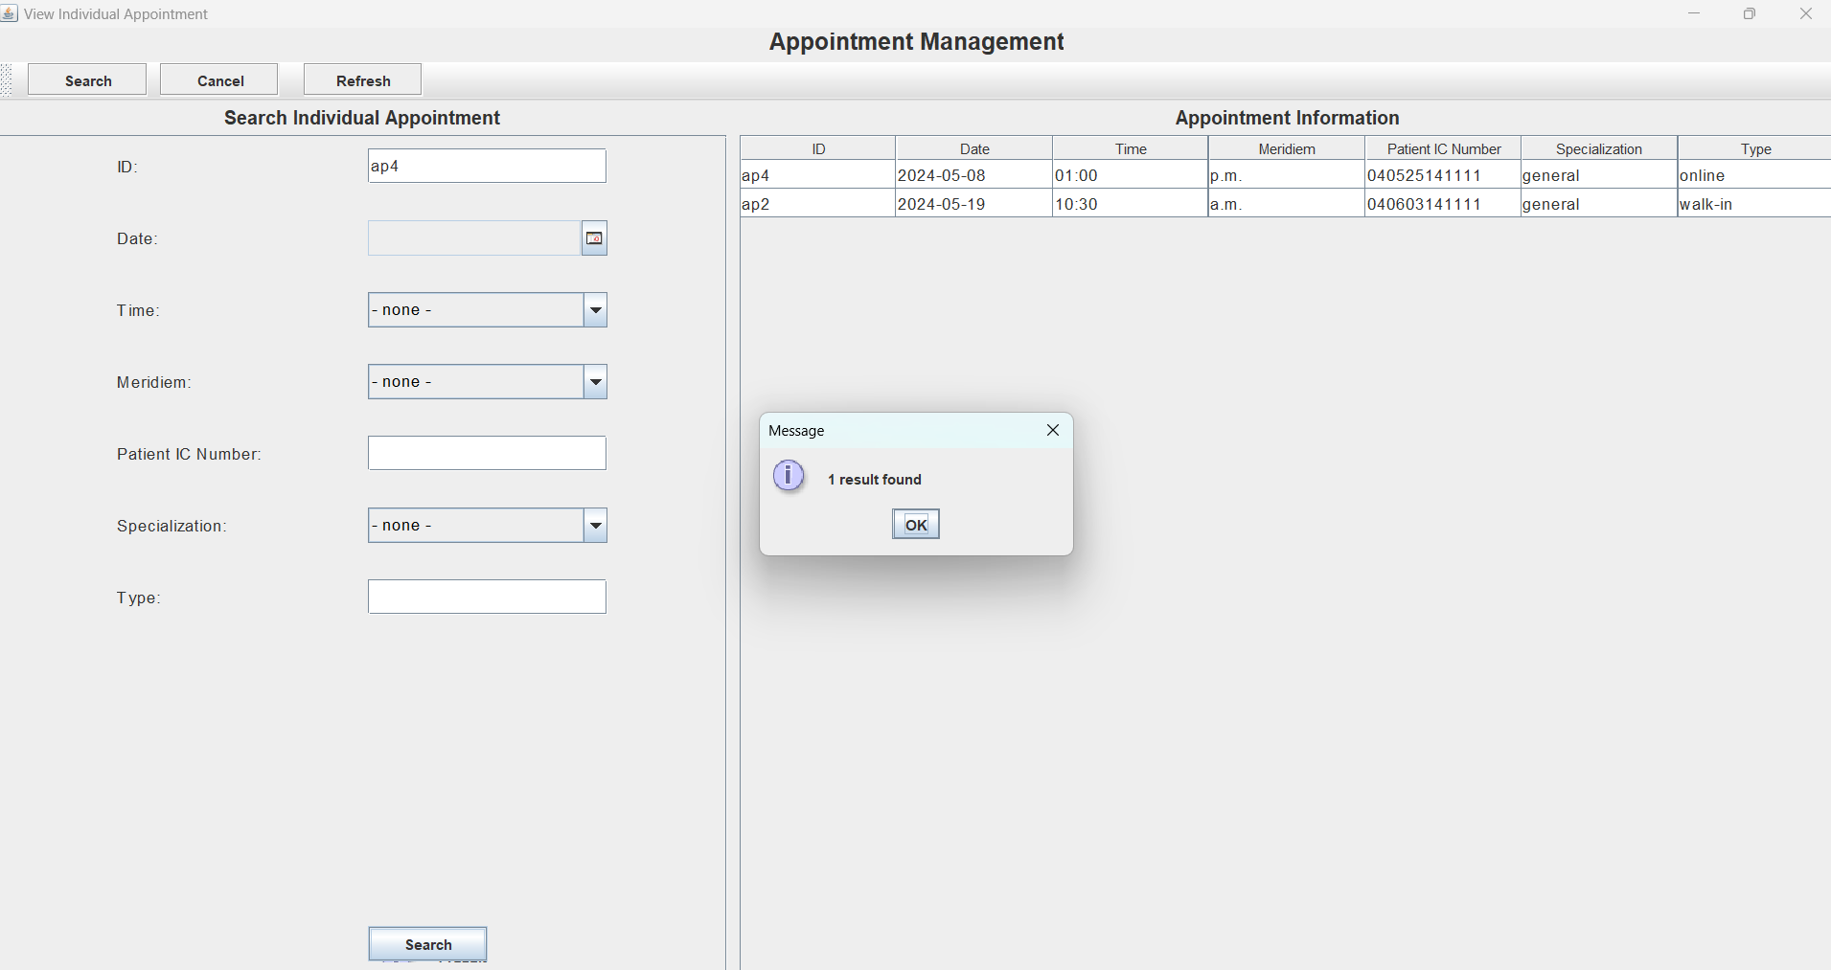

Figure 72: As shown above 1 results is found ,after the user enter correct ID

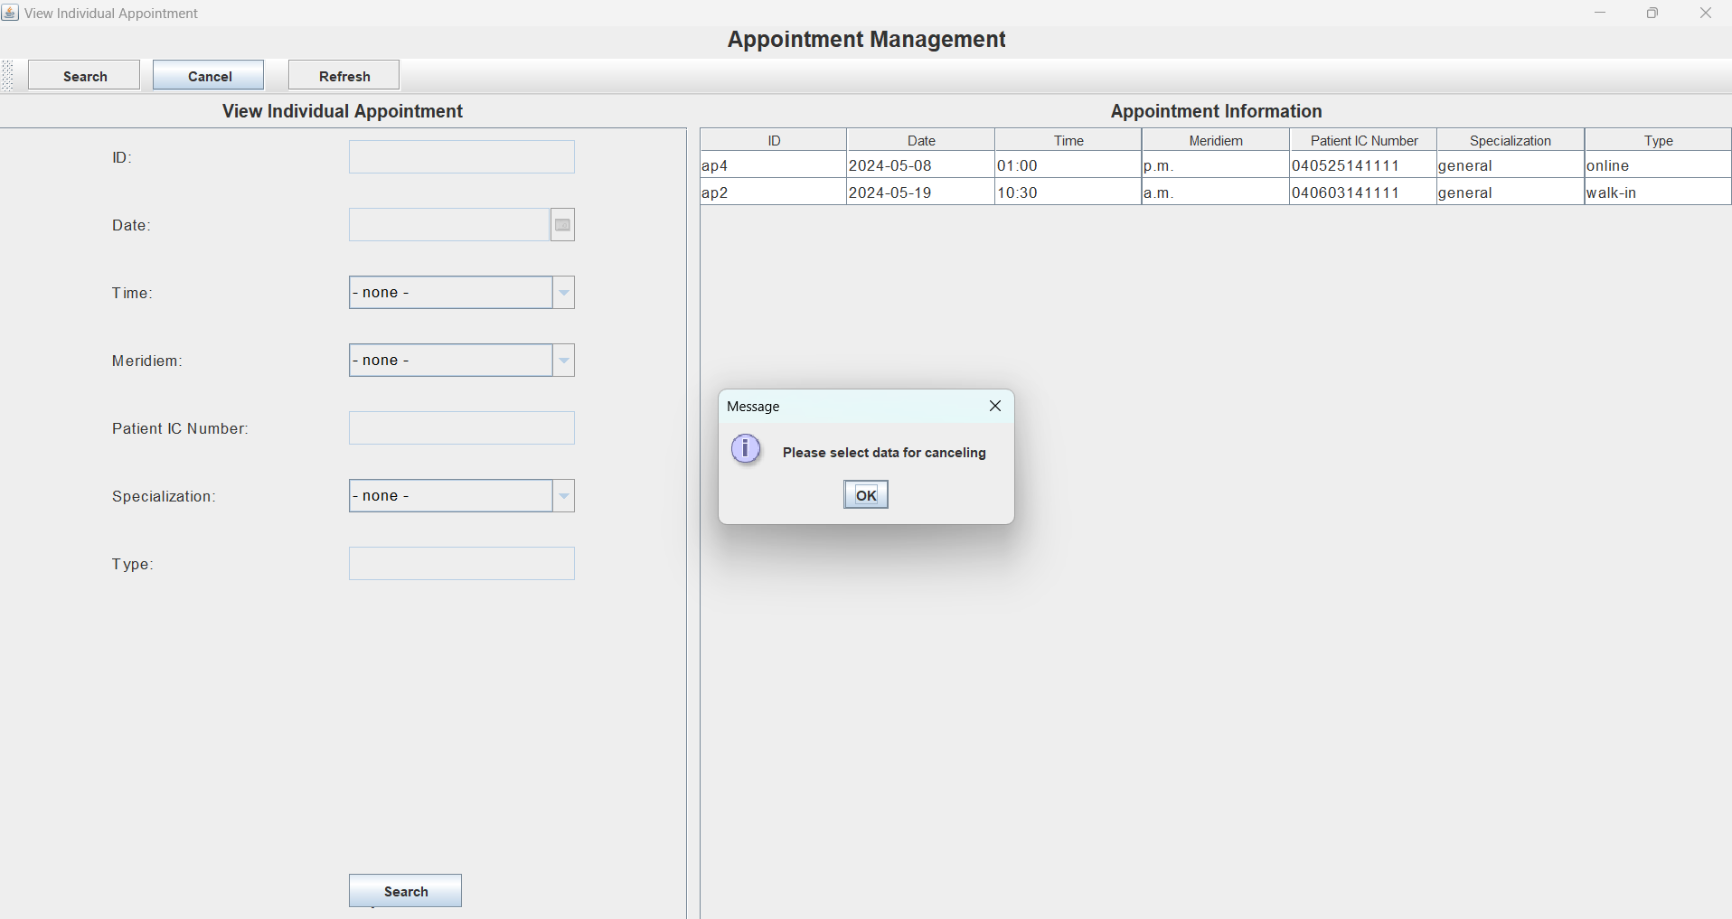 Figure 73 : User can choose to cancel appointment by pressing the cancel button. After pressing the cancel button, a pop up message box will ask the user to select an data for canceling

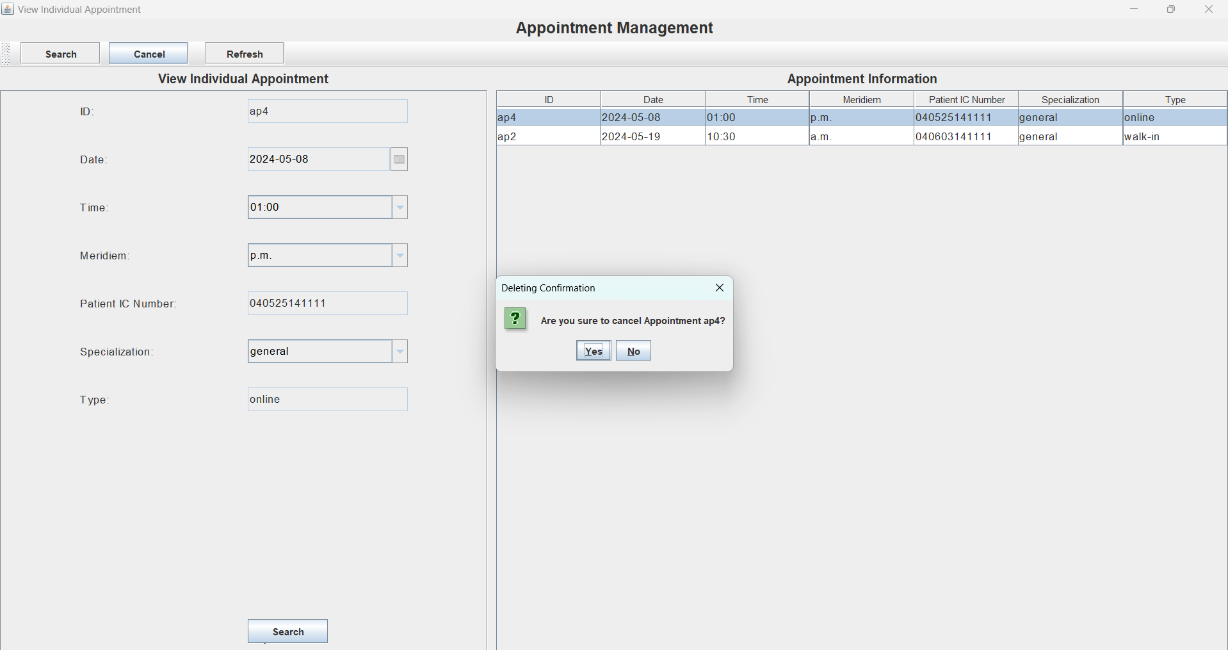 Figure 74 : A pop out message box will ask the user to ,if he or she confirm to cancel appointment

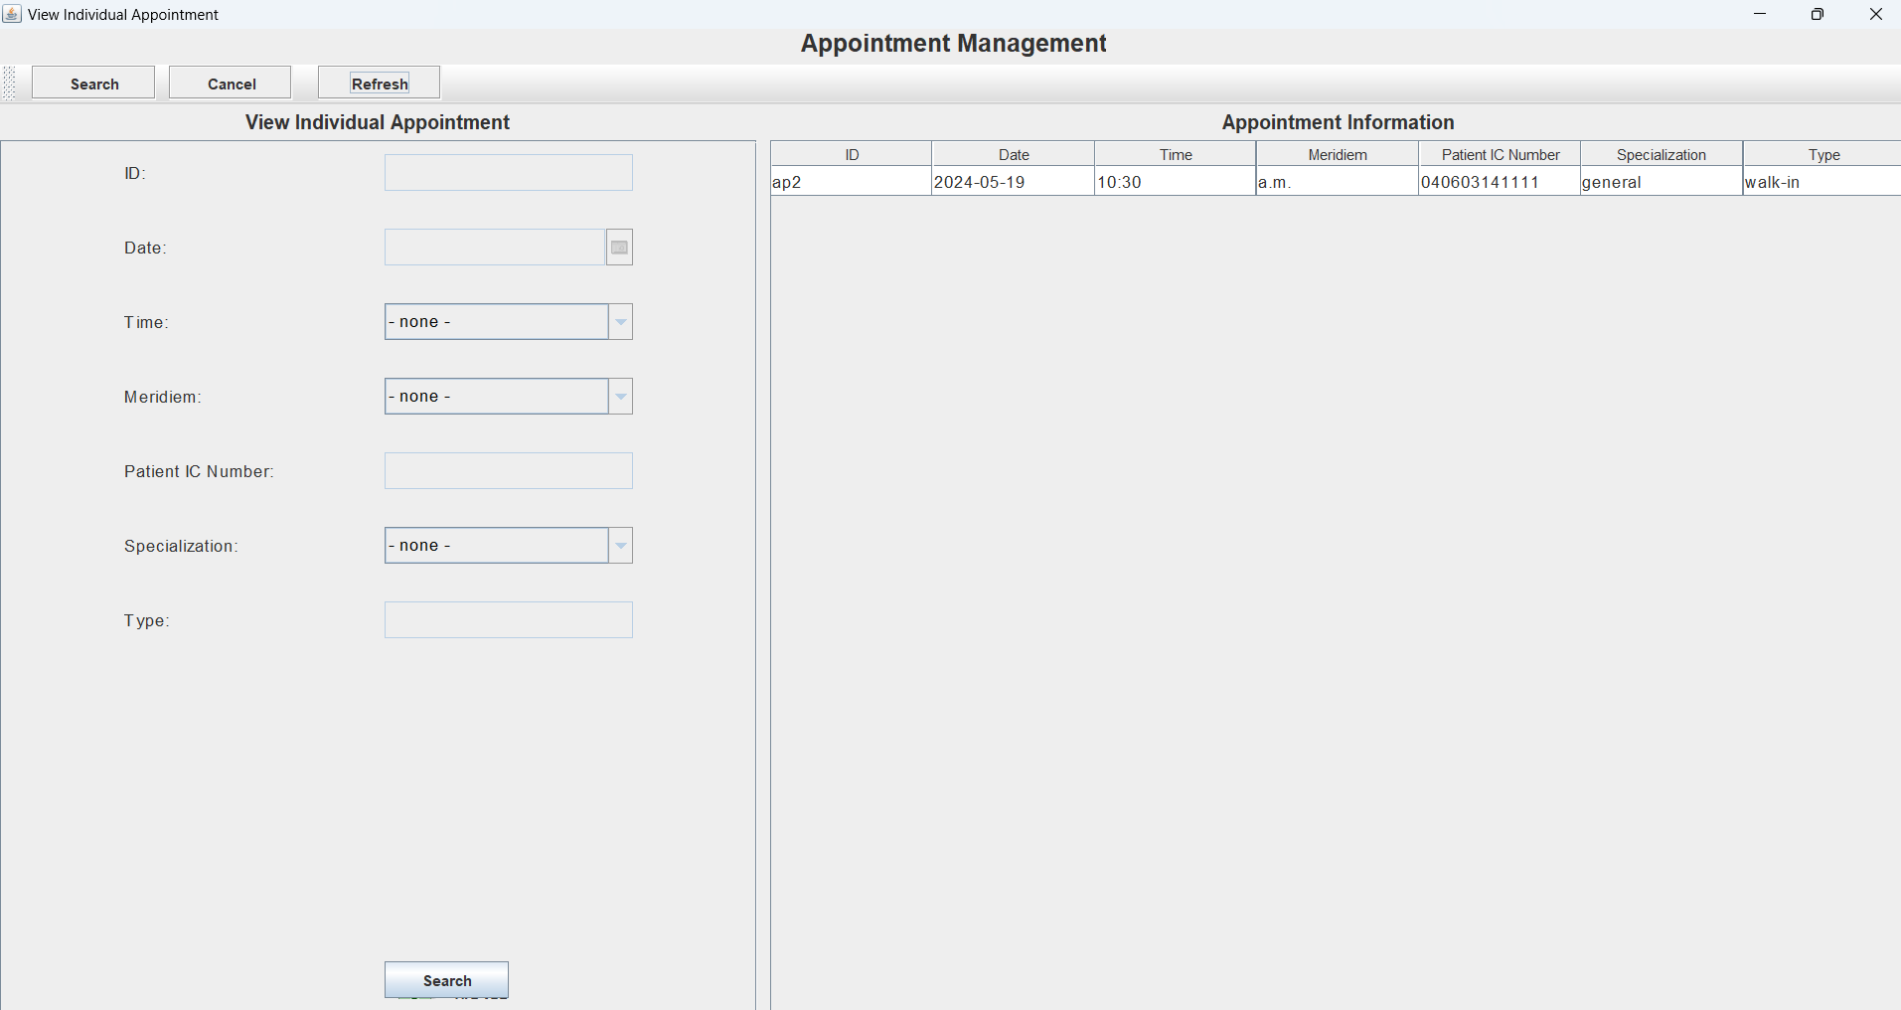

Figure 75 : After confirmation, the selected cancel appointment data is remove from the table

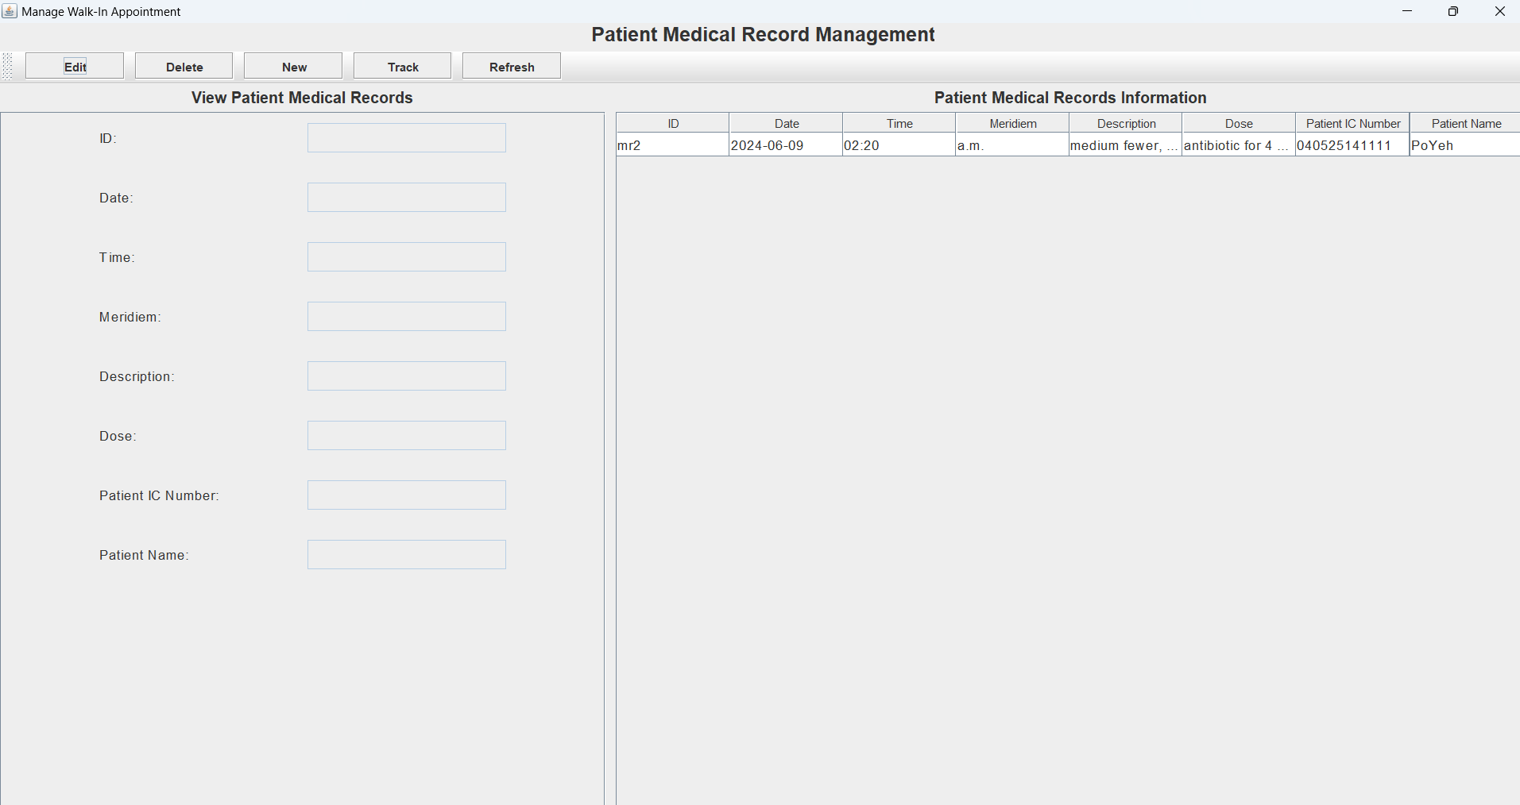Figure 76 : As shown above, user can edit the patient medical records information. If the user want to edit , he or she can press the edit button

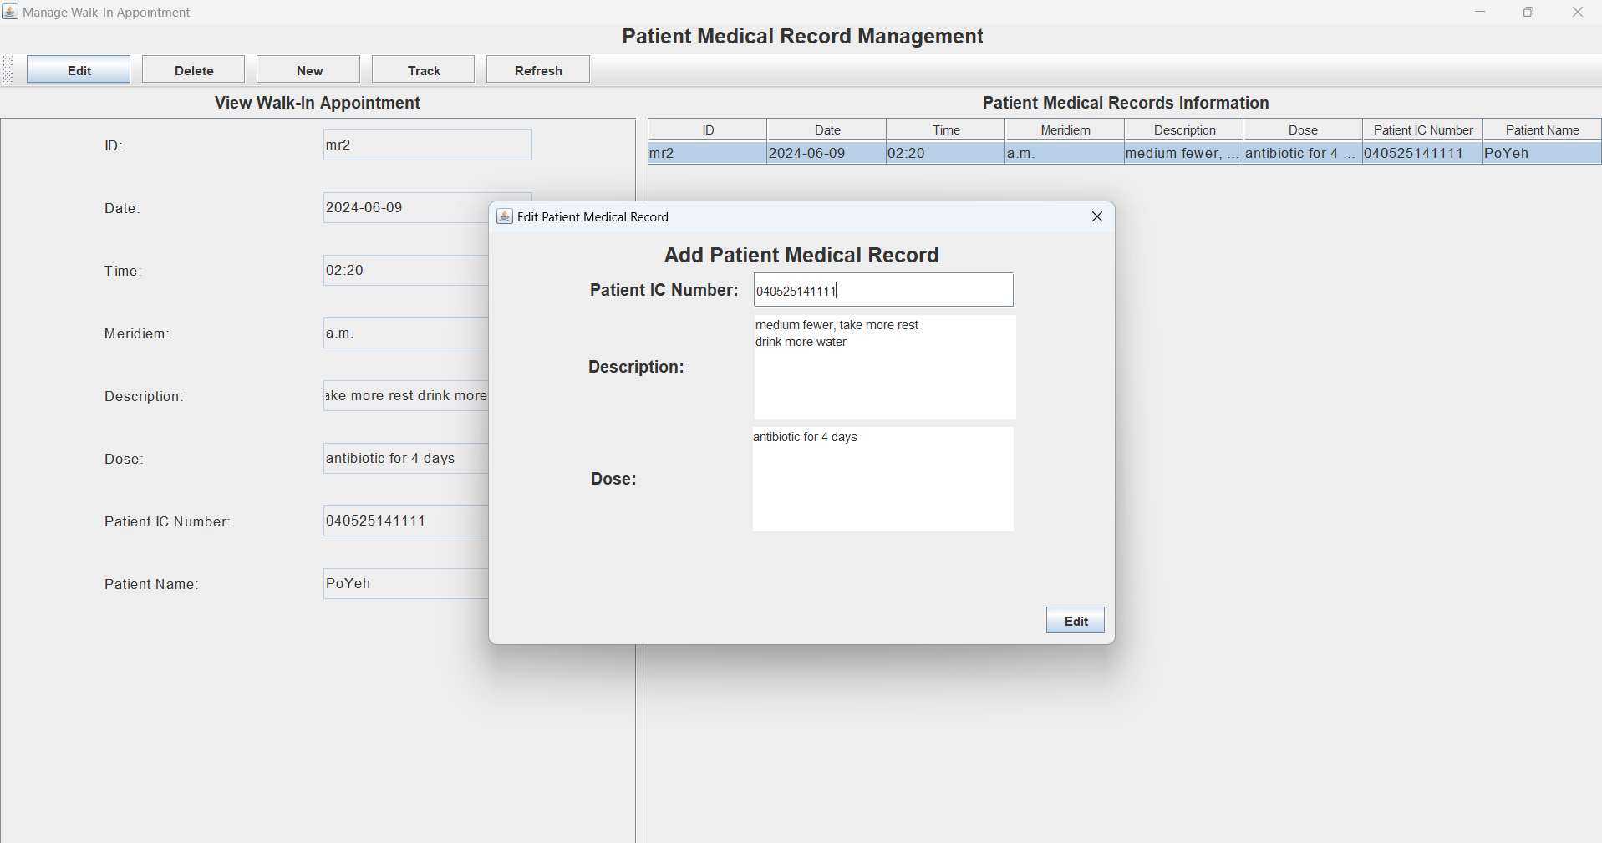Figure 77 :After pressing the edit button, a pop up box where user can edit the Patient Medical Record .Editable information such as the Patient IC Number ,Patient Description , and Dose .

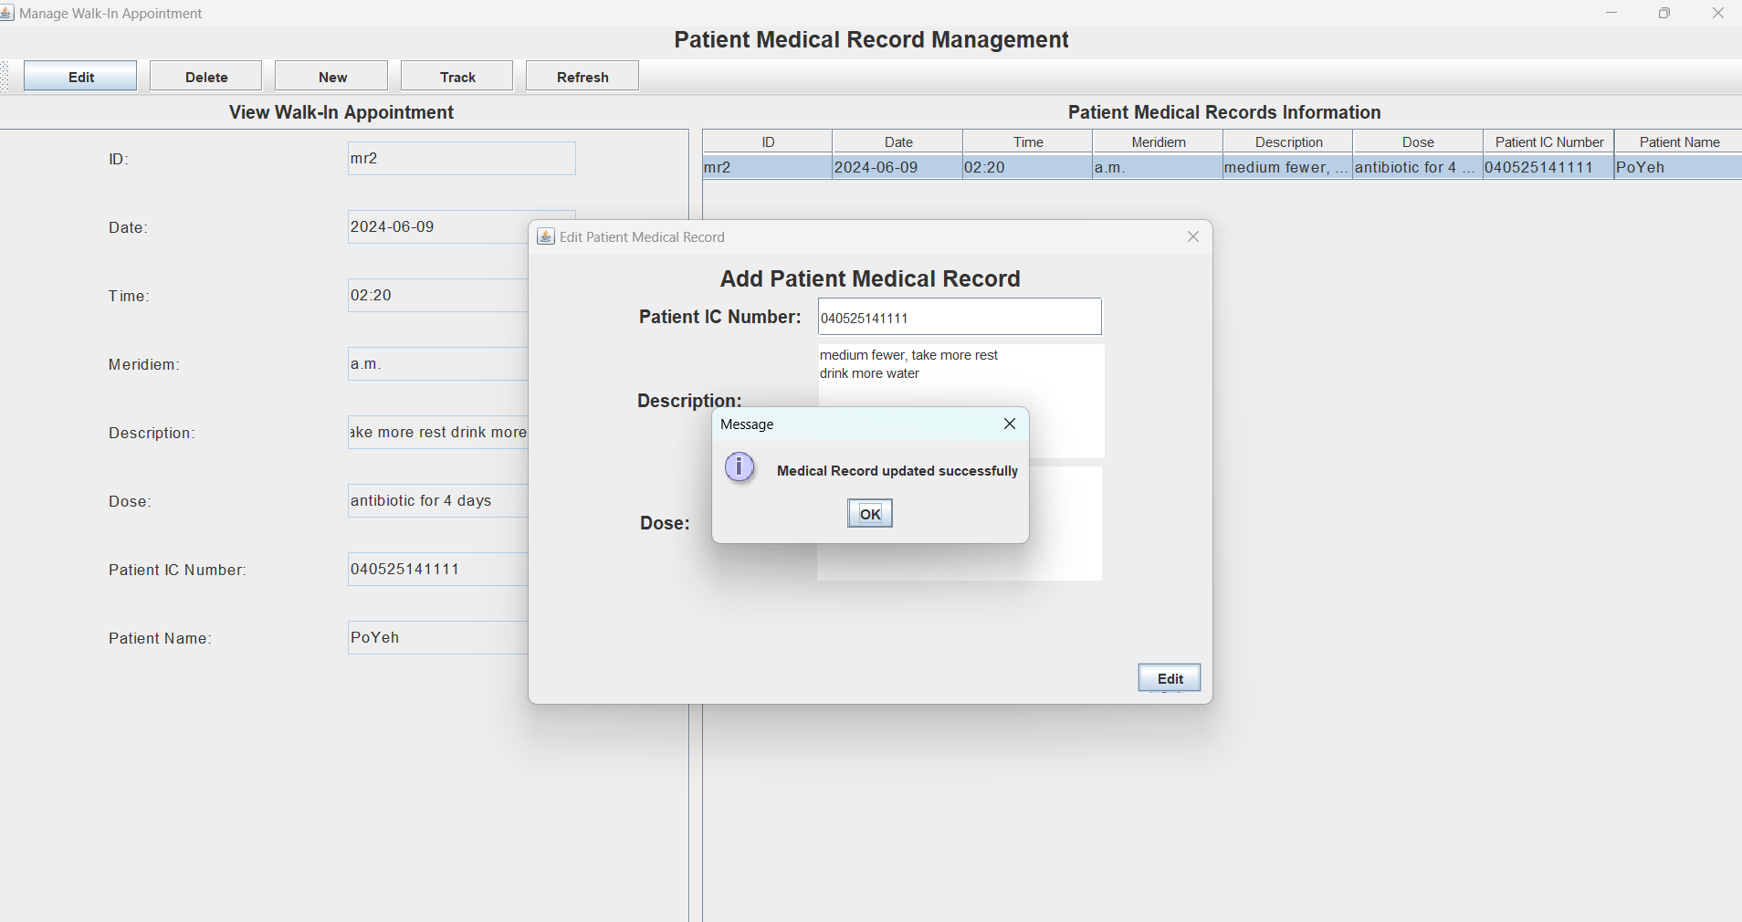Figure 78 :After the user done editing the Patient information ,they can press the edit button again in the pop out message box a message box will show a message “Medical Record Updated Successfully”.

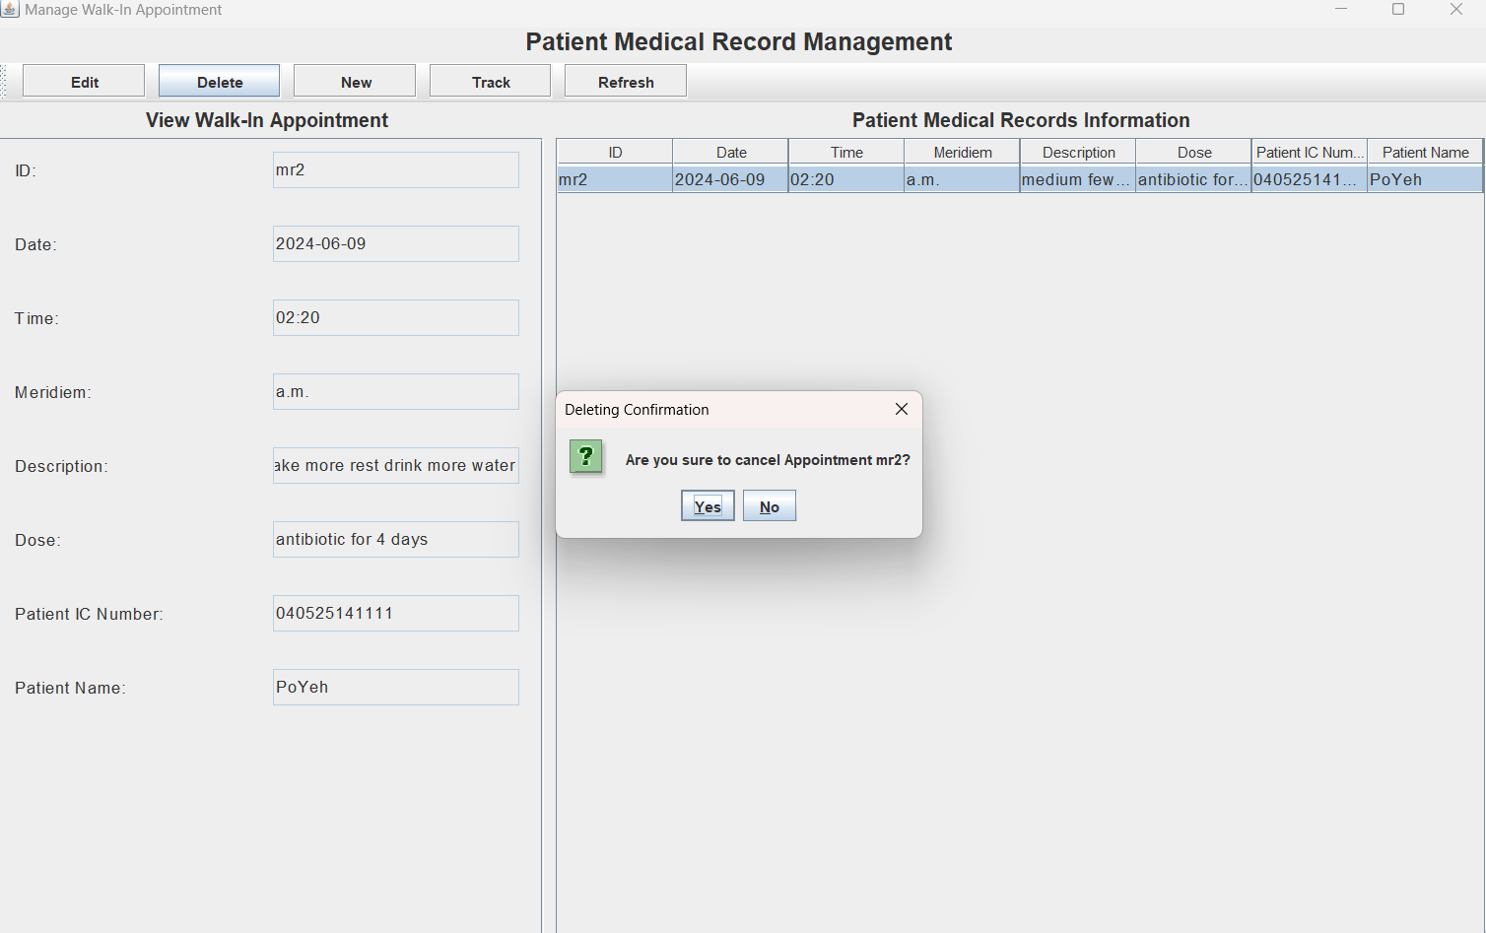

Figure 79 :If the user want to delete appointment he or she can press the delete button ,where the user must select the data. After selecting the data a pop out message box will appear asking for confirmation from the user.

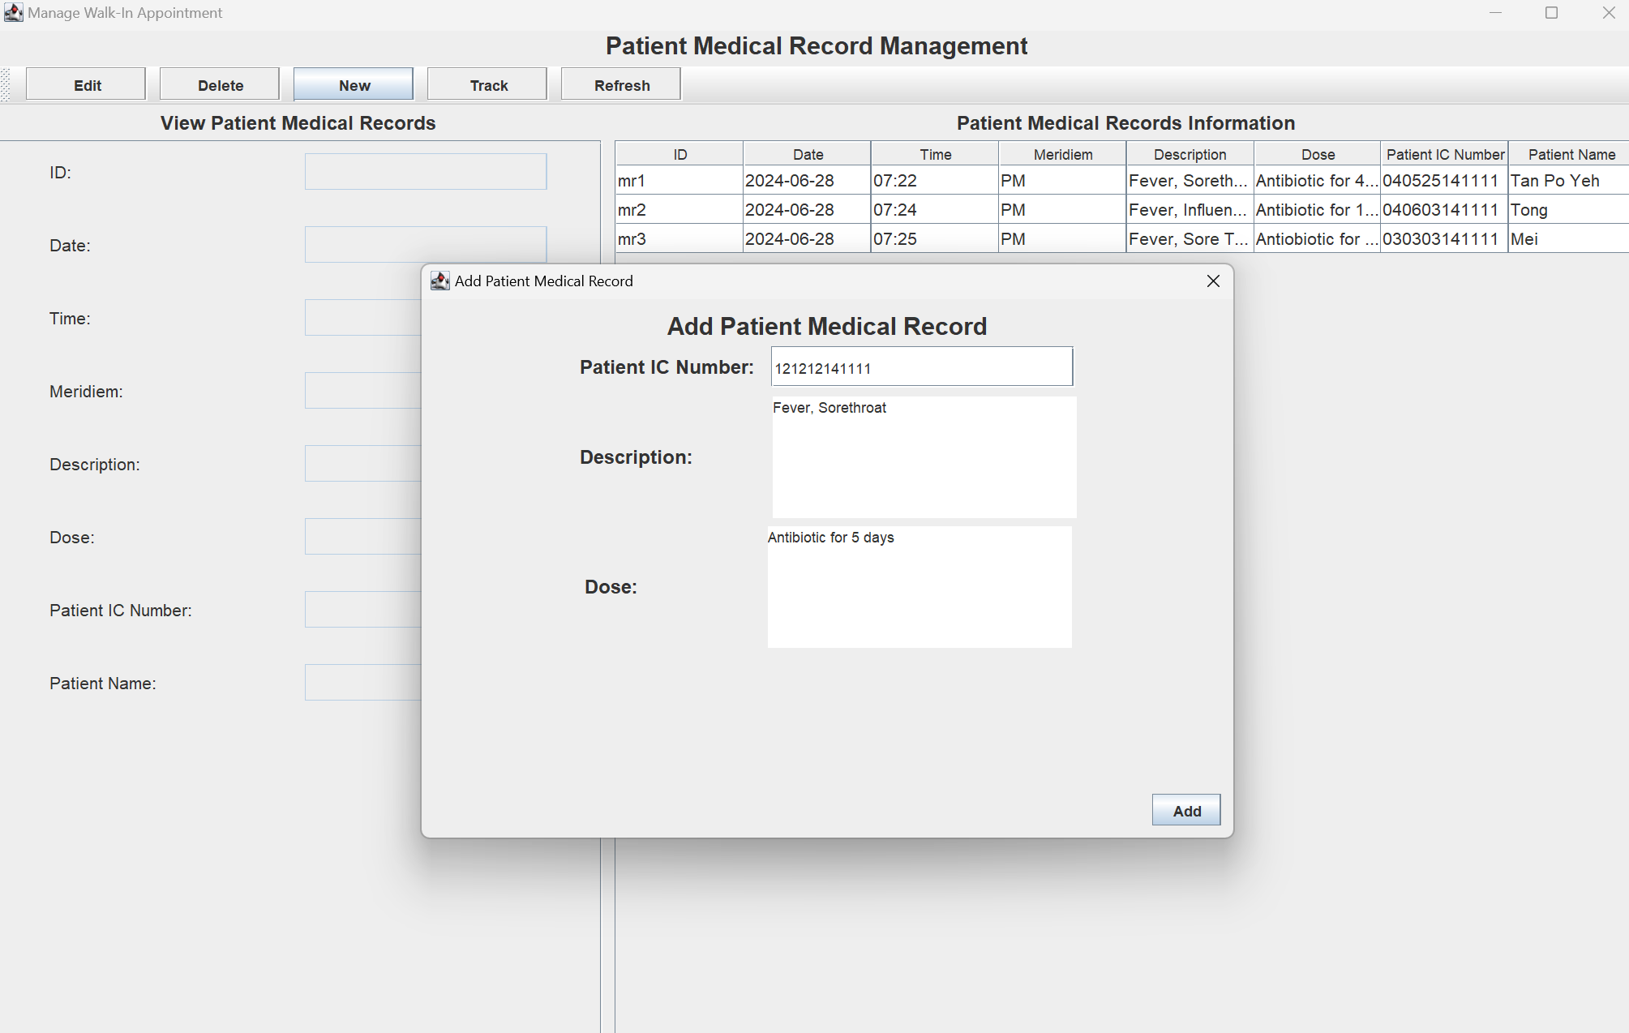

Figure 80 :If the user want add new Patient Medical Record ,he or she can press the new button where then the user will see a pop out message box .In the pop out message box user can insert new Patient IC Number ,Patient Description and Dose. After filling up the information the user can press the add button ,where the new data will be display at the Patient Medical Record Information Table.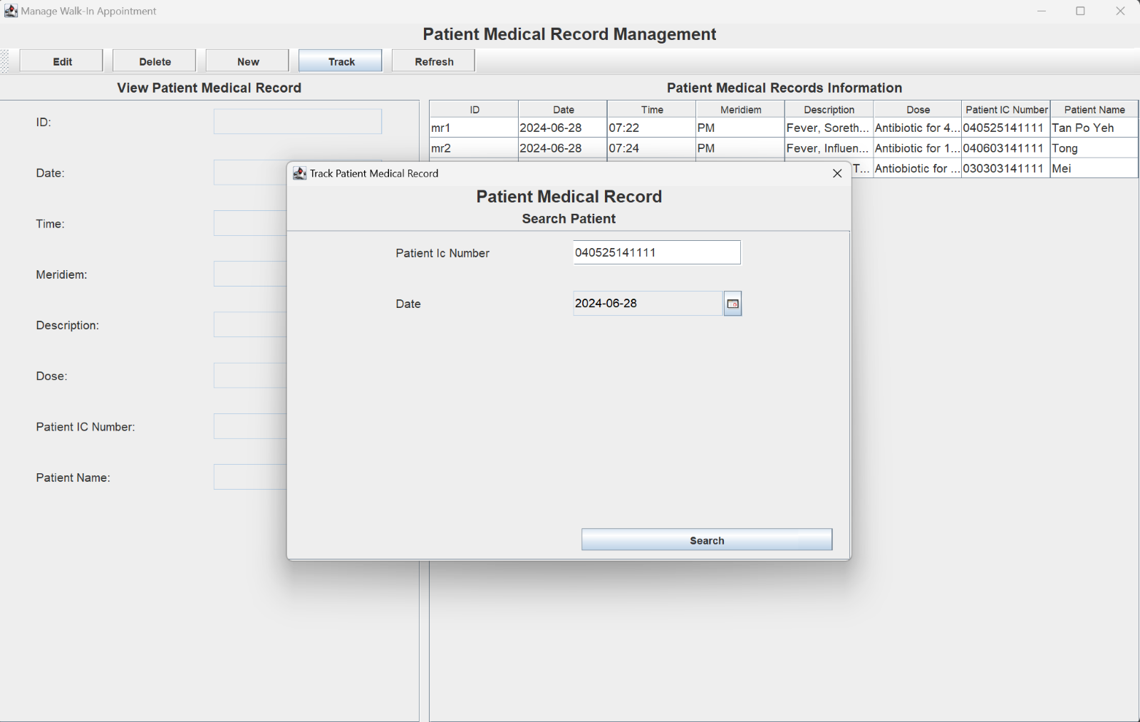Figure 81 :If the user want to track Patient Medical Record ,he or she can press the track button .After pressing the track button a pop out message box will appear .

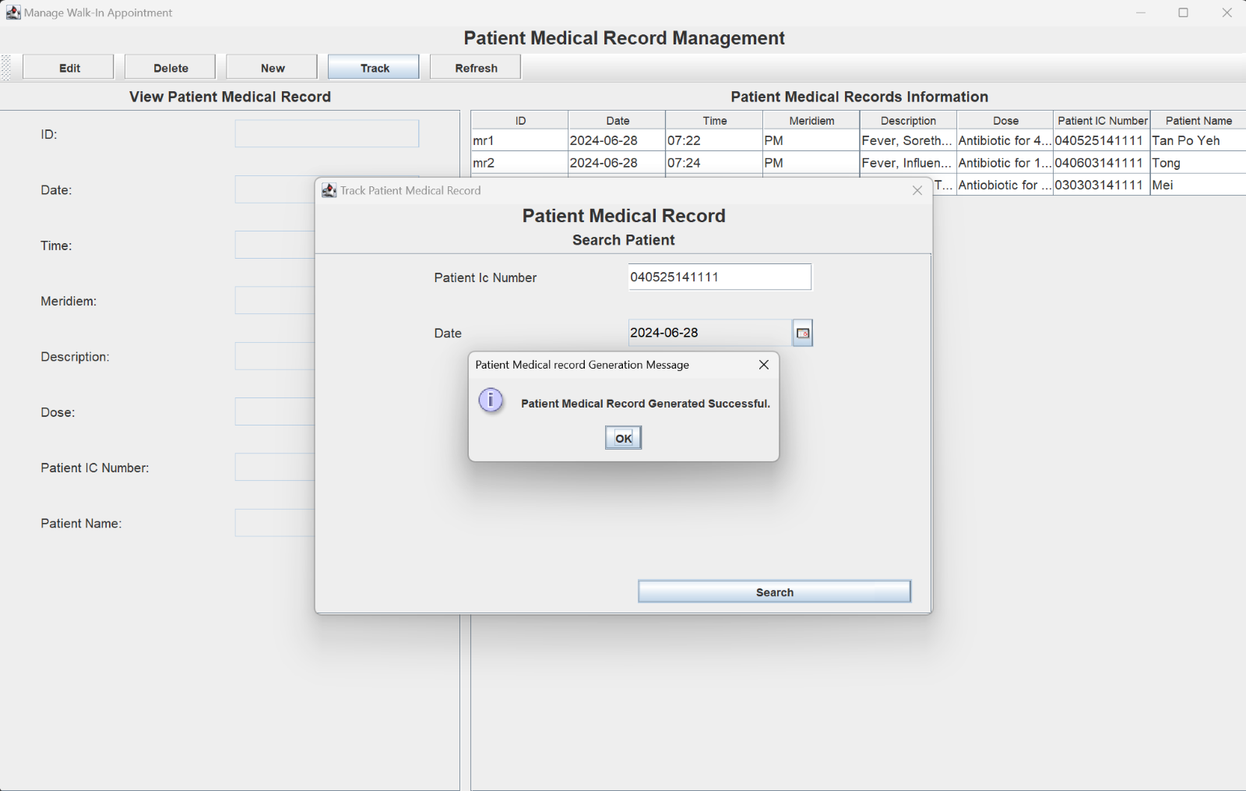Figure 82 :After pressing the search button , a pop message box will appear with a Pateint Medical Record Generated Successful

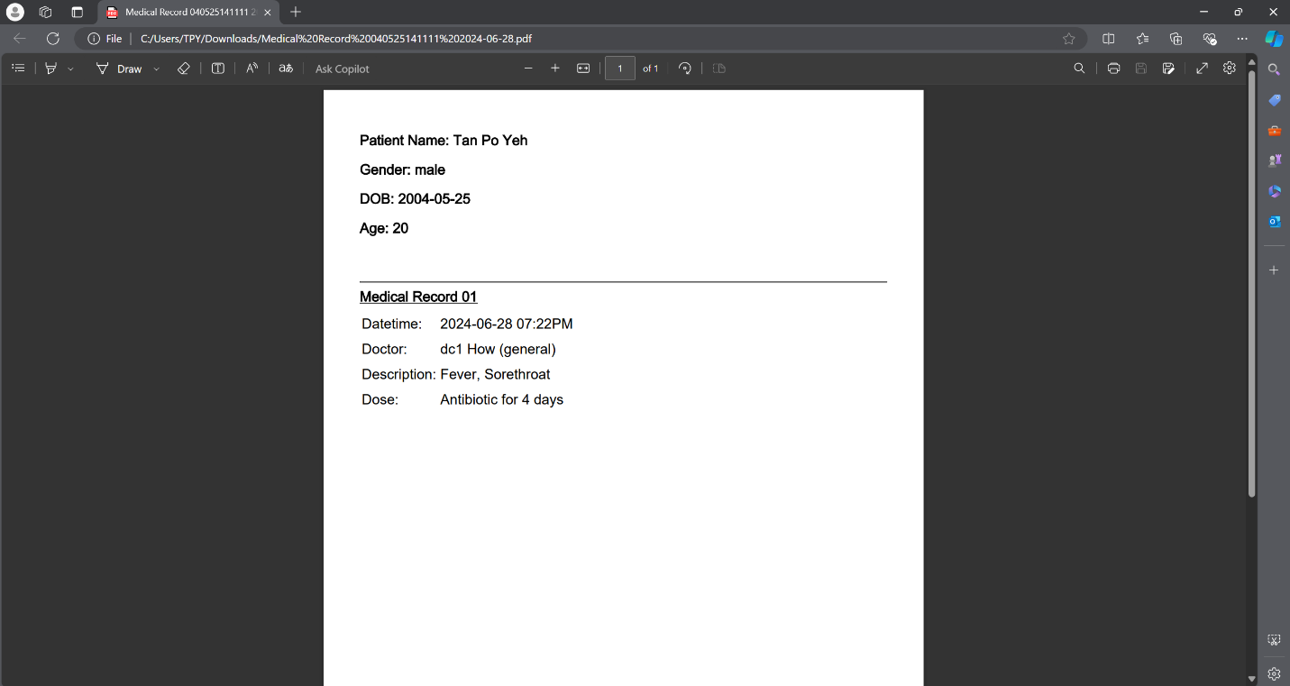Figure 83 :After pressing the ok button , the program will bring the user to a pdf file where all the Pateint inromation will be store

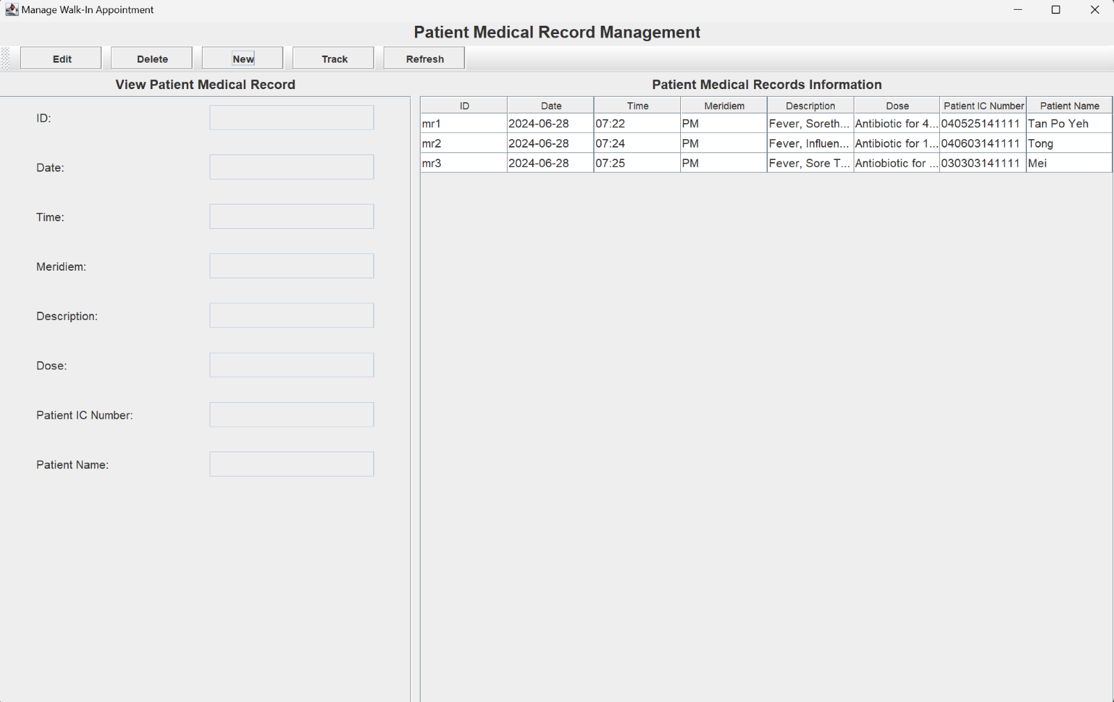Figure 84 :if the user want to refresh the page ,he or she can press the refesh button where all the data will be refesh inclduing the new data that been added to the table .

## 2.3 Patient Features

### 2.3.1 Patient Authentication

In order to log in as a patient, the user will need to press the "Patient Login" button. Once the button is clicked, the system will display the patient login page.

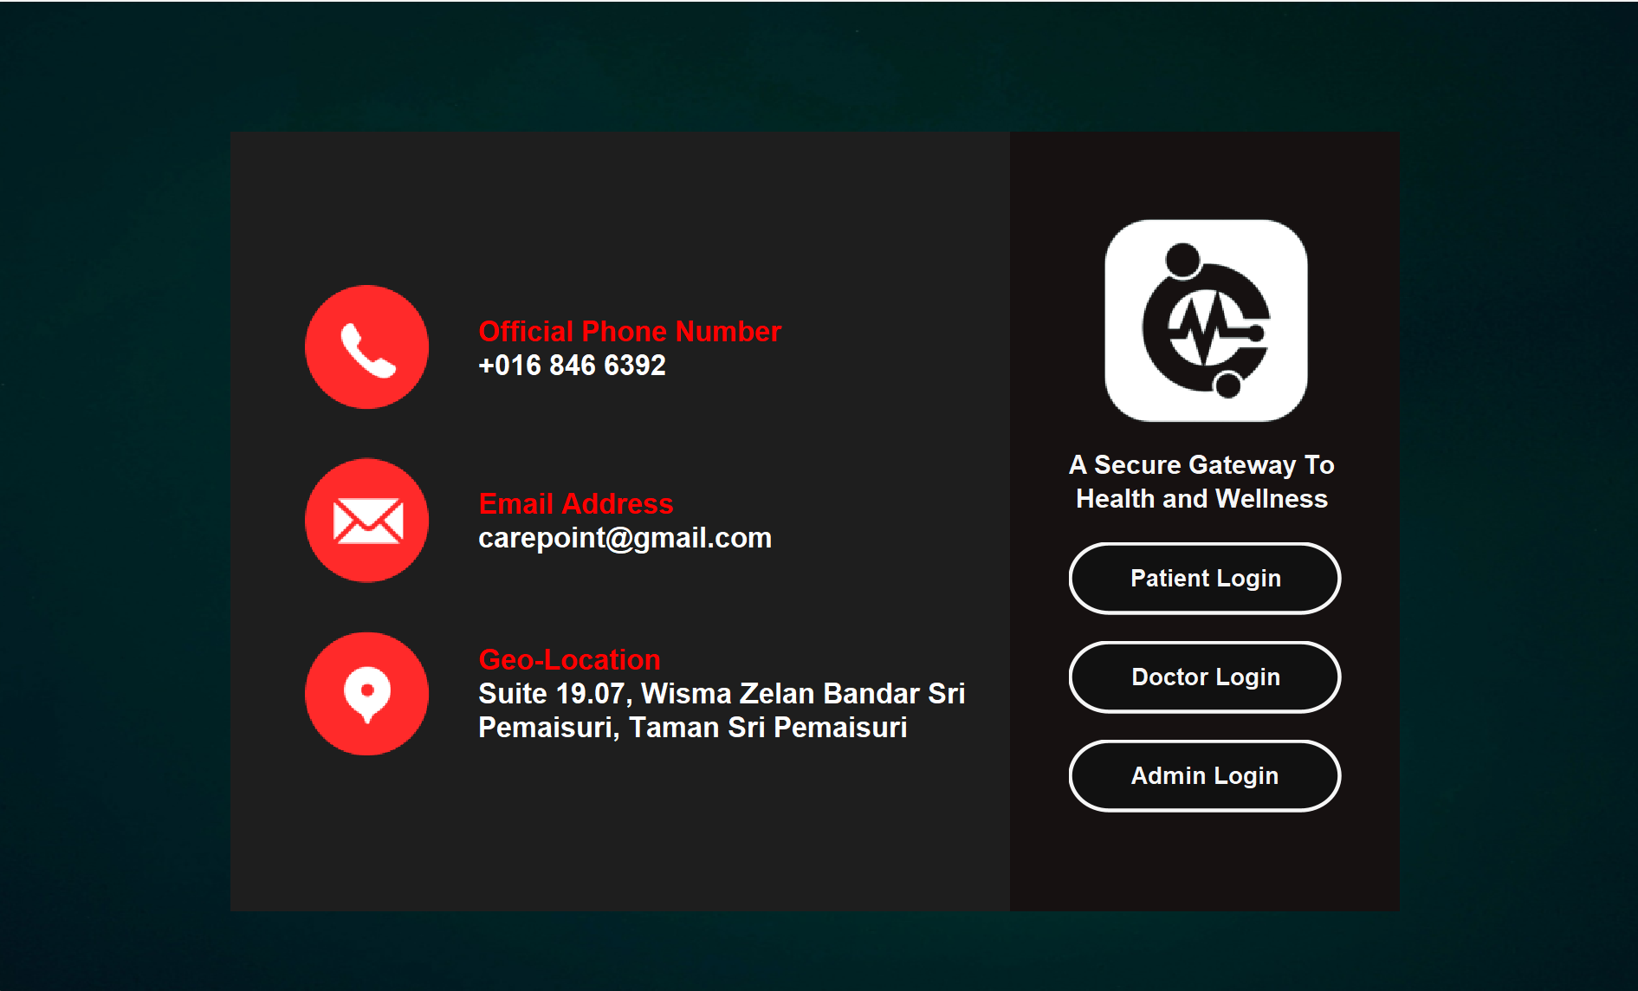

Below are the login page for the patient, user will need to enter the correct credentials to access the system.

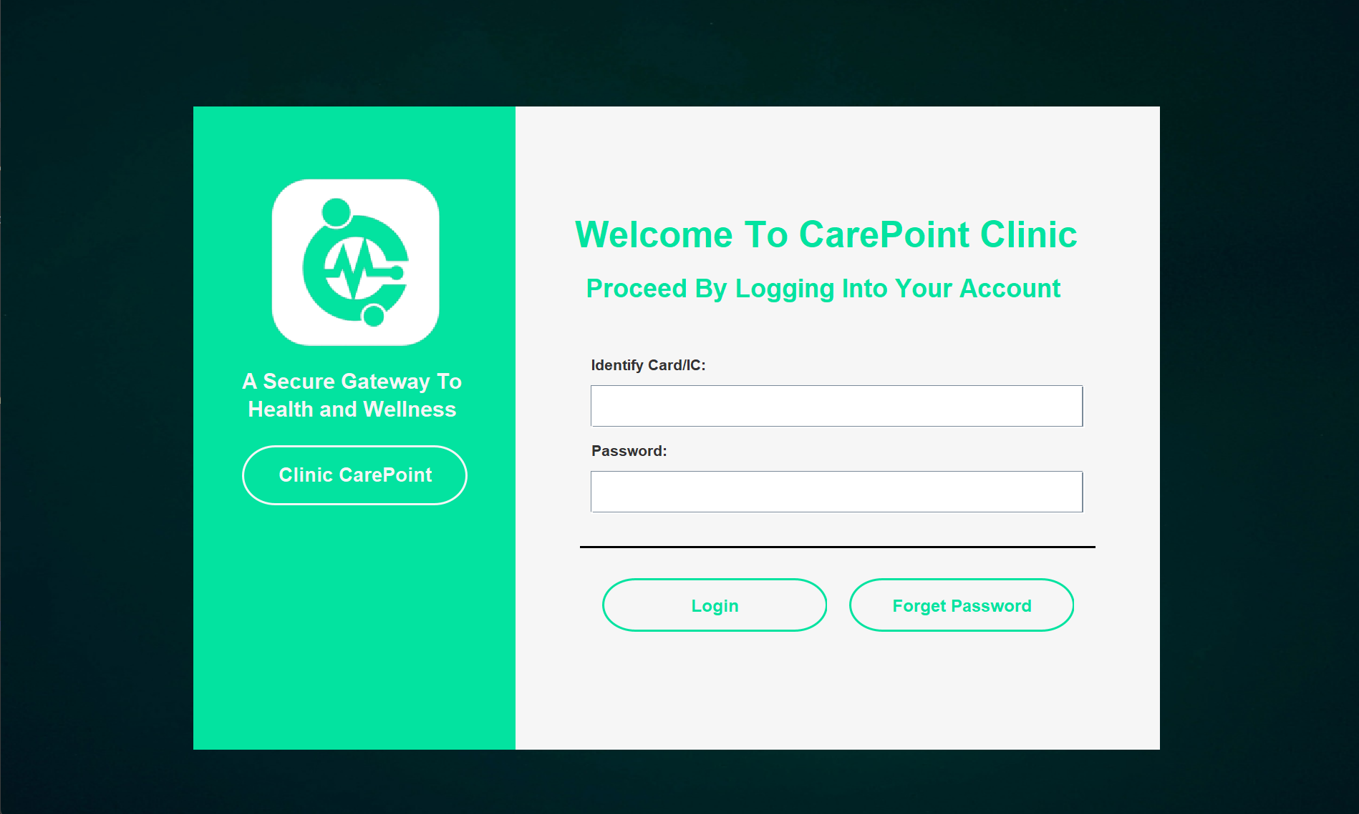

In the case below, we enter the correct user information as the figure shown below. The system will display a success message to the user and redirect the user to the main page of the appointment system page.

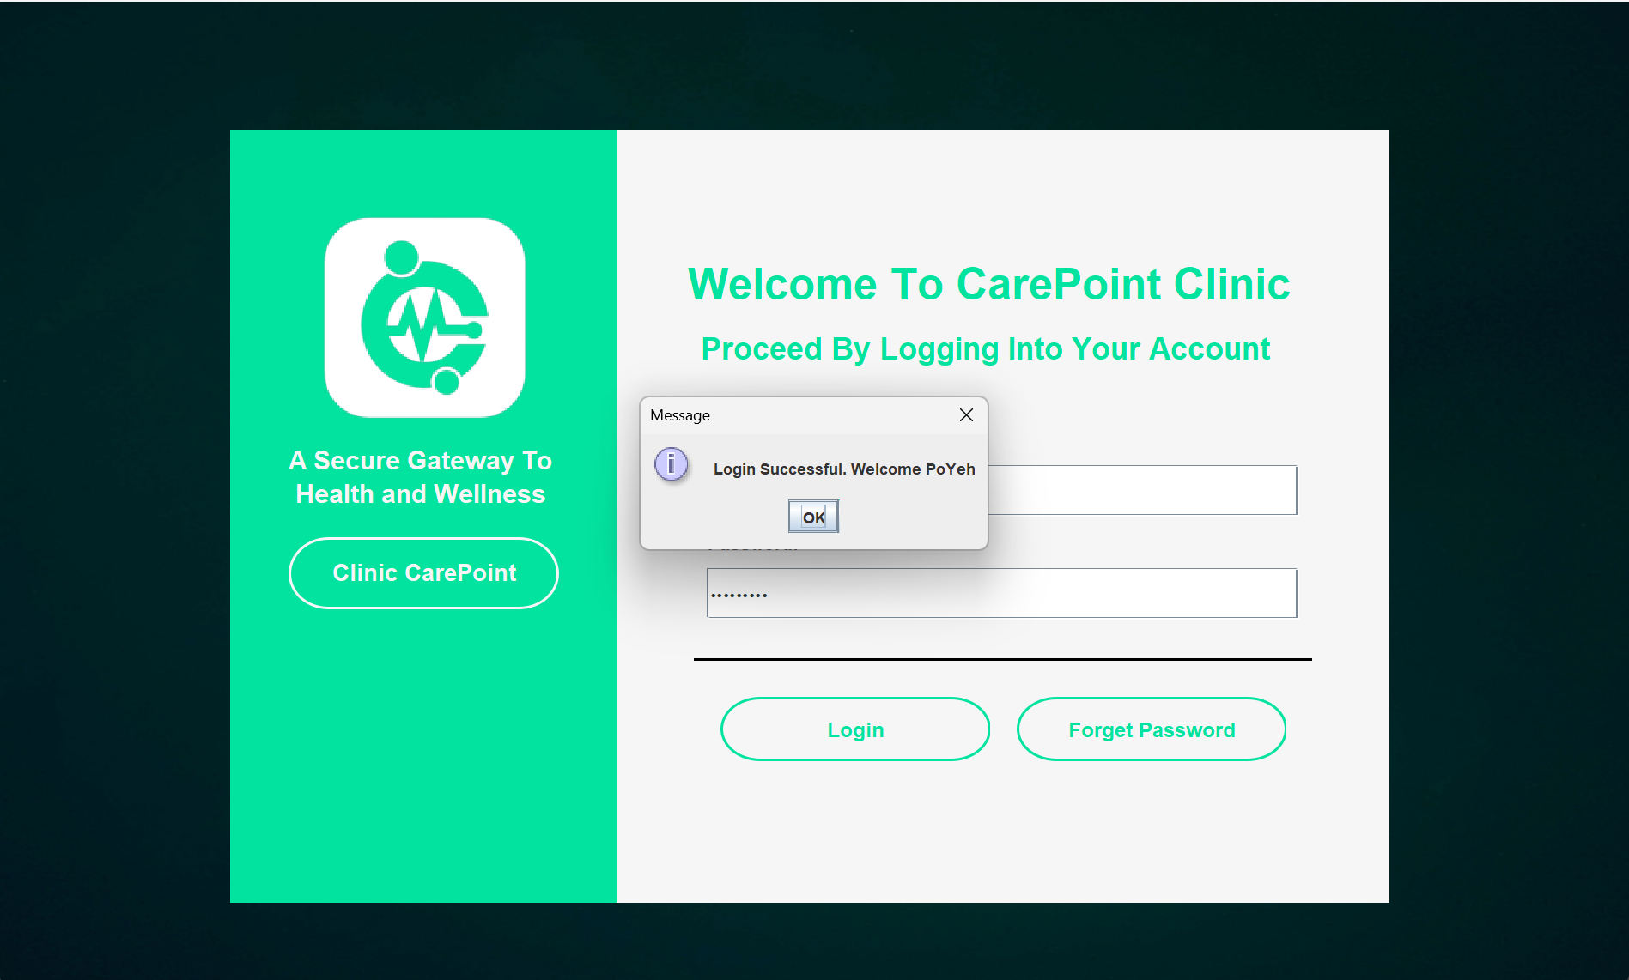

In contrast, if the user enters an invalid IC number or incorrect user password, the system will display an error message to the user. If the user is unable to log in to their account, they will need to either use the forget password feature to reset their password or contact the admin to retrieve back their information.

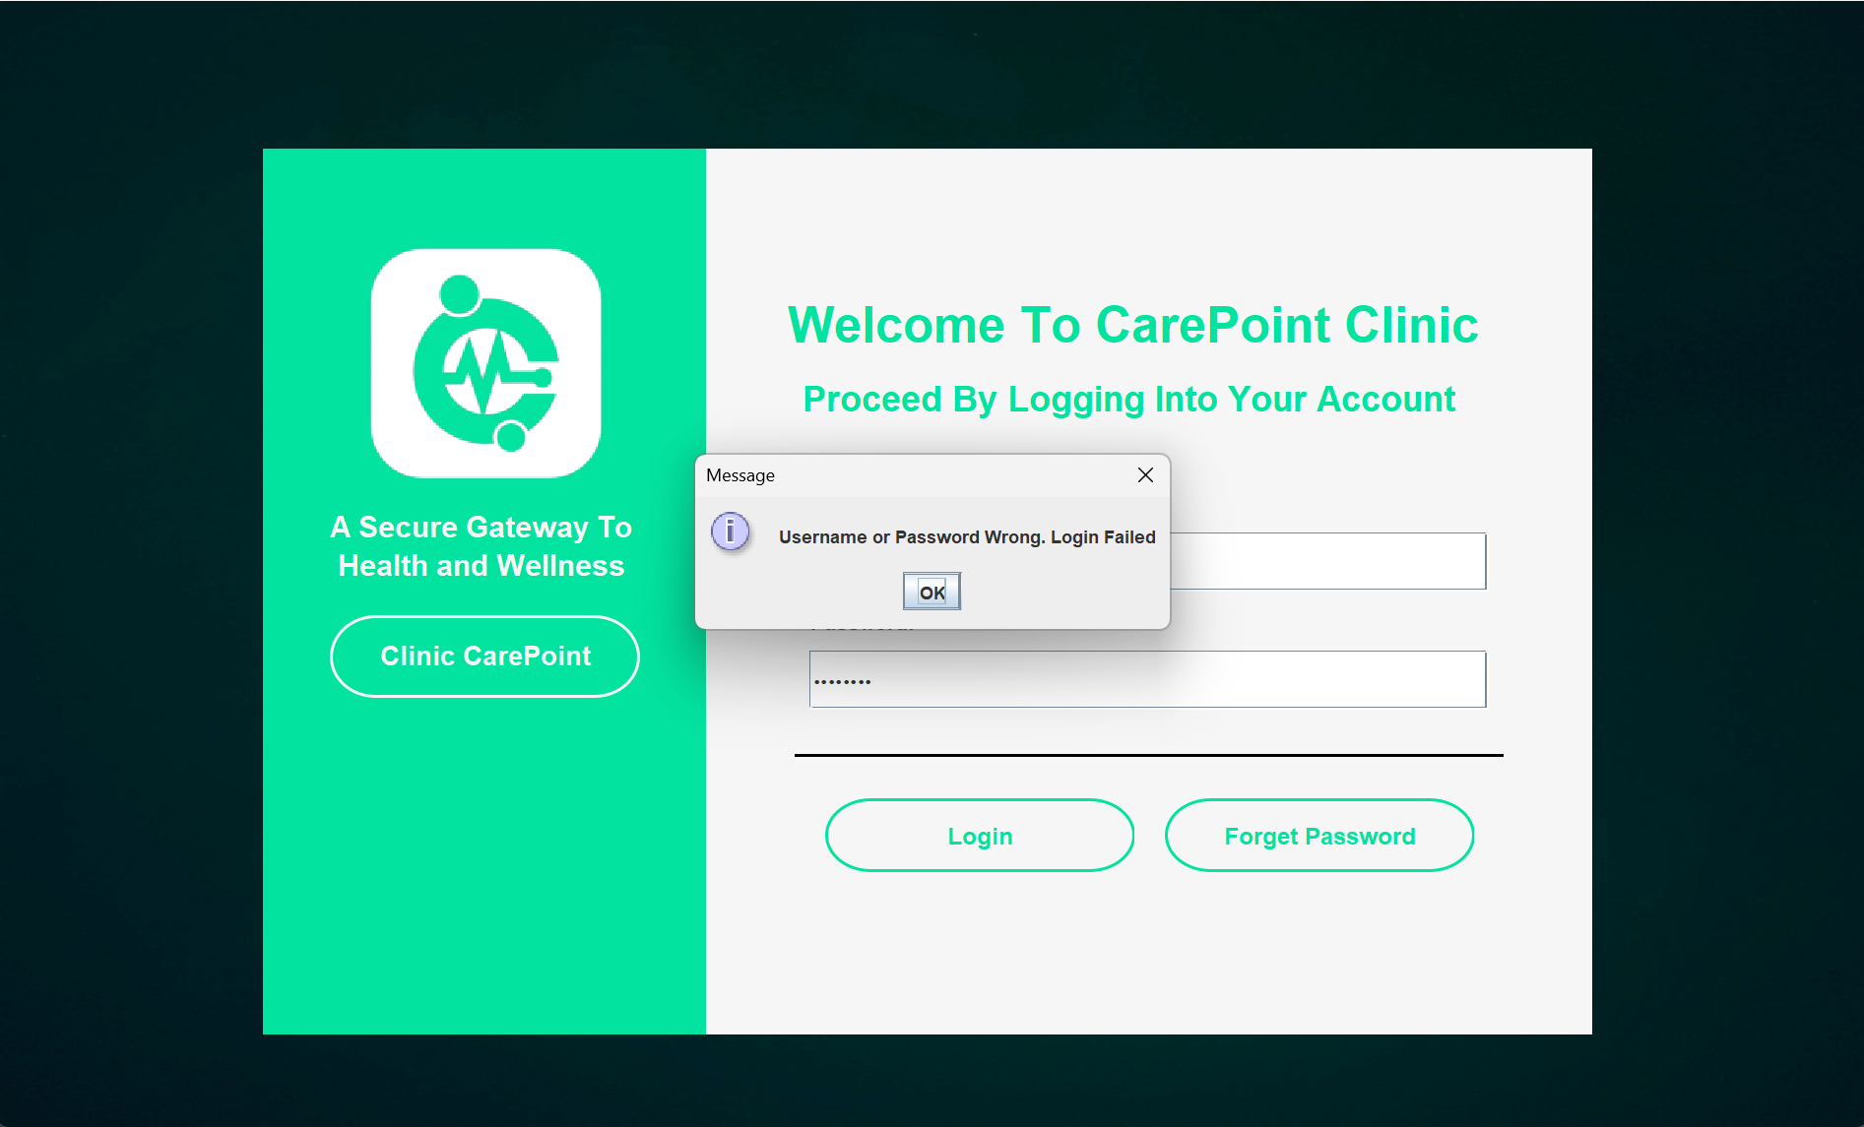

### 2.3.2 Dashboard - View Available Timeslot

Once the user login successfully, the system will direct the user to the patient dashboard page as the figure shown below. On this page, patients are able to view their own incoming appointment numbers, the available appointments and the total history appointments they made.

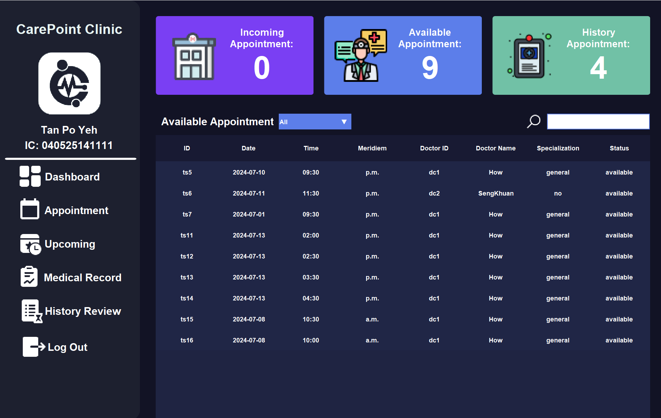

The number of indicators on the page above will change according to the patient’s action. In this scenario, there are a total of 9 appointments available in the clinic and the patient "Tan Po Yeh" booked 4 appointments before.

On the dashboard page, patients can also search for specific appointments by using the search bar and the multiple-select bar. In the figure below, the patient searches for the Doctor "How" to find the specific doctor’s appointments. The system will change the table list and only display Doctor "How" appointments on the page.

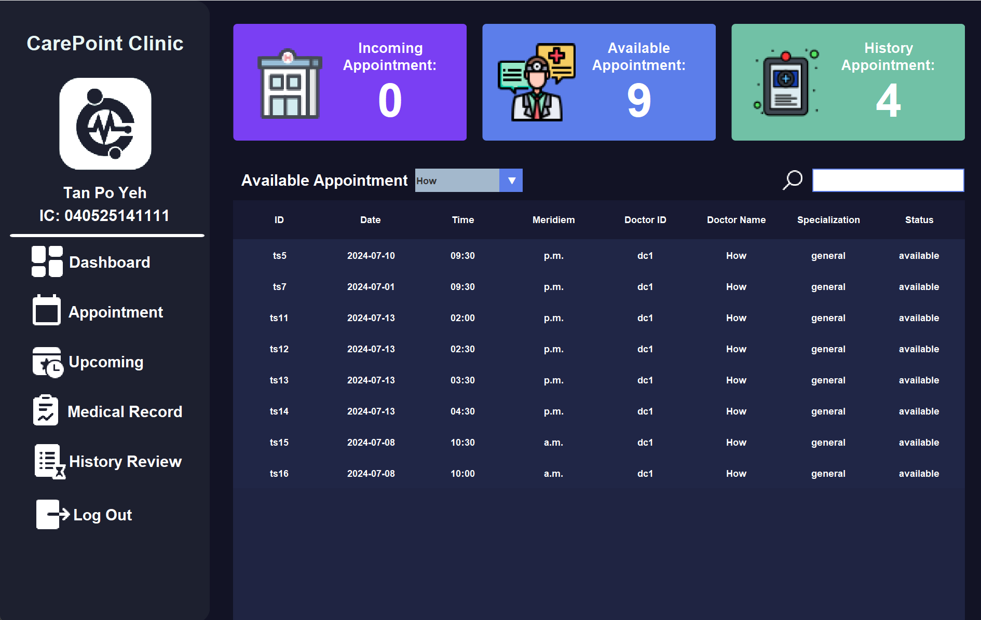

If the patient wants to find an appointment based on the specialization, the patient can just use the search bar to filter the results. The figure below shows the result of searching the specialization "No" on the page.

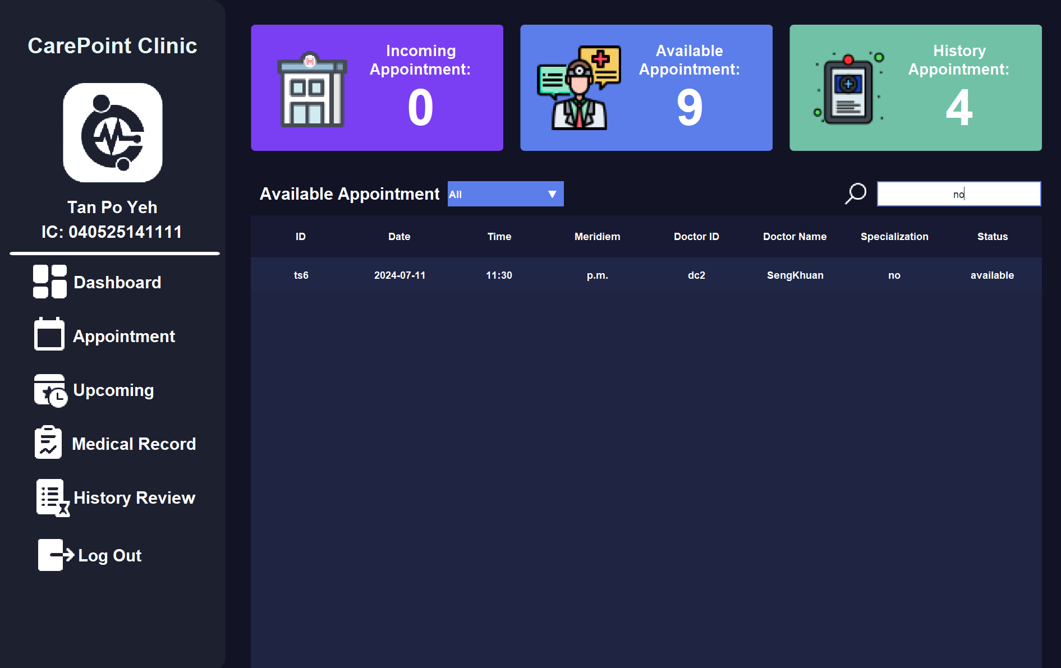

### 2.3.3 Appointment - Make Appointment

The second feature is located on the appointment page, patients can access the page by pressing the "Appointment" button on the left panel. Below are the patient appointment page.

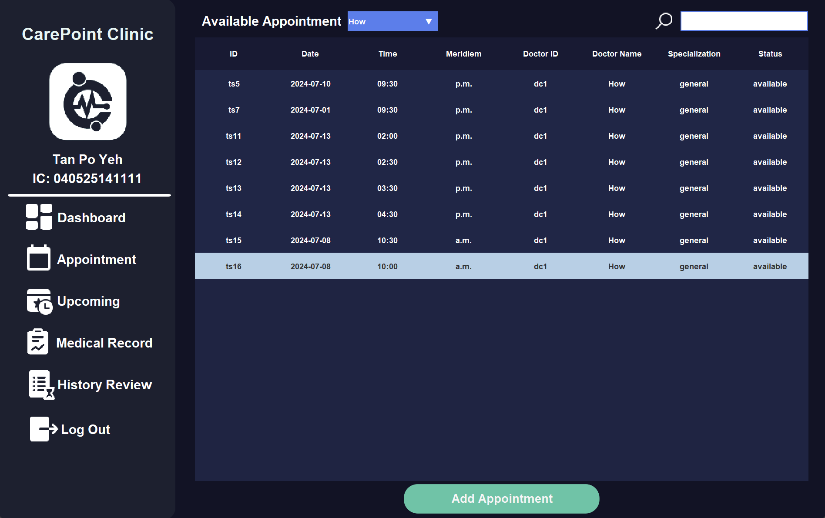

On this page, the patients are able to make an appointment by selecting the desired time slot in the table list. Then, patients simply click the "Add Appointment" button to add the appointment to the page. The system will display a confirmation panel for the patient to double-confirm the appointment reservation.

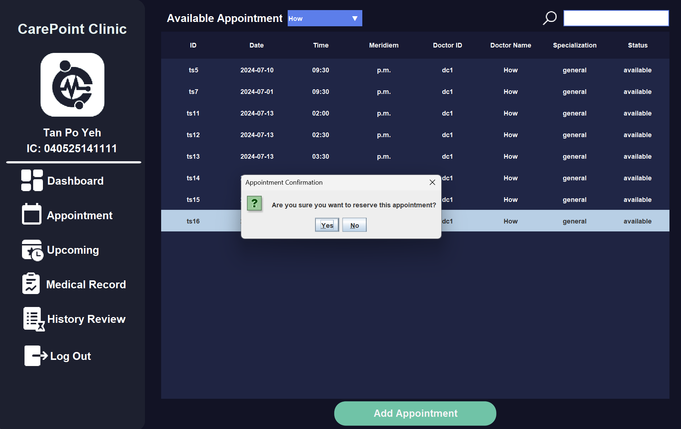

Patients can proceed to appointment booking by clicking the "Yes" button. If there is no error, the system will display a success message to the patients and redirect the user to the dashboard page.

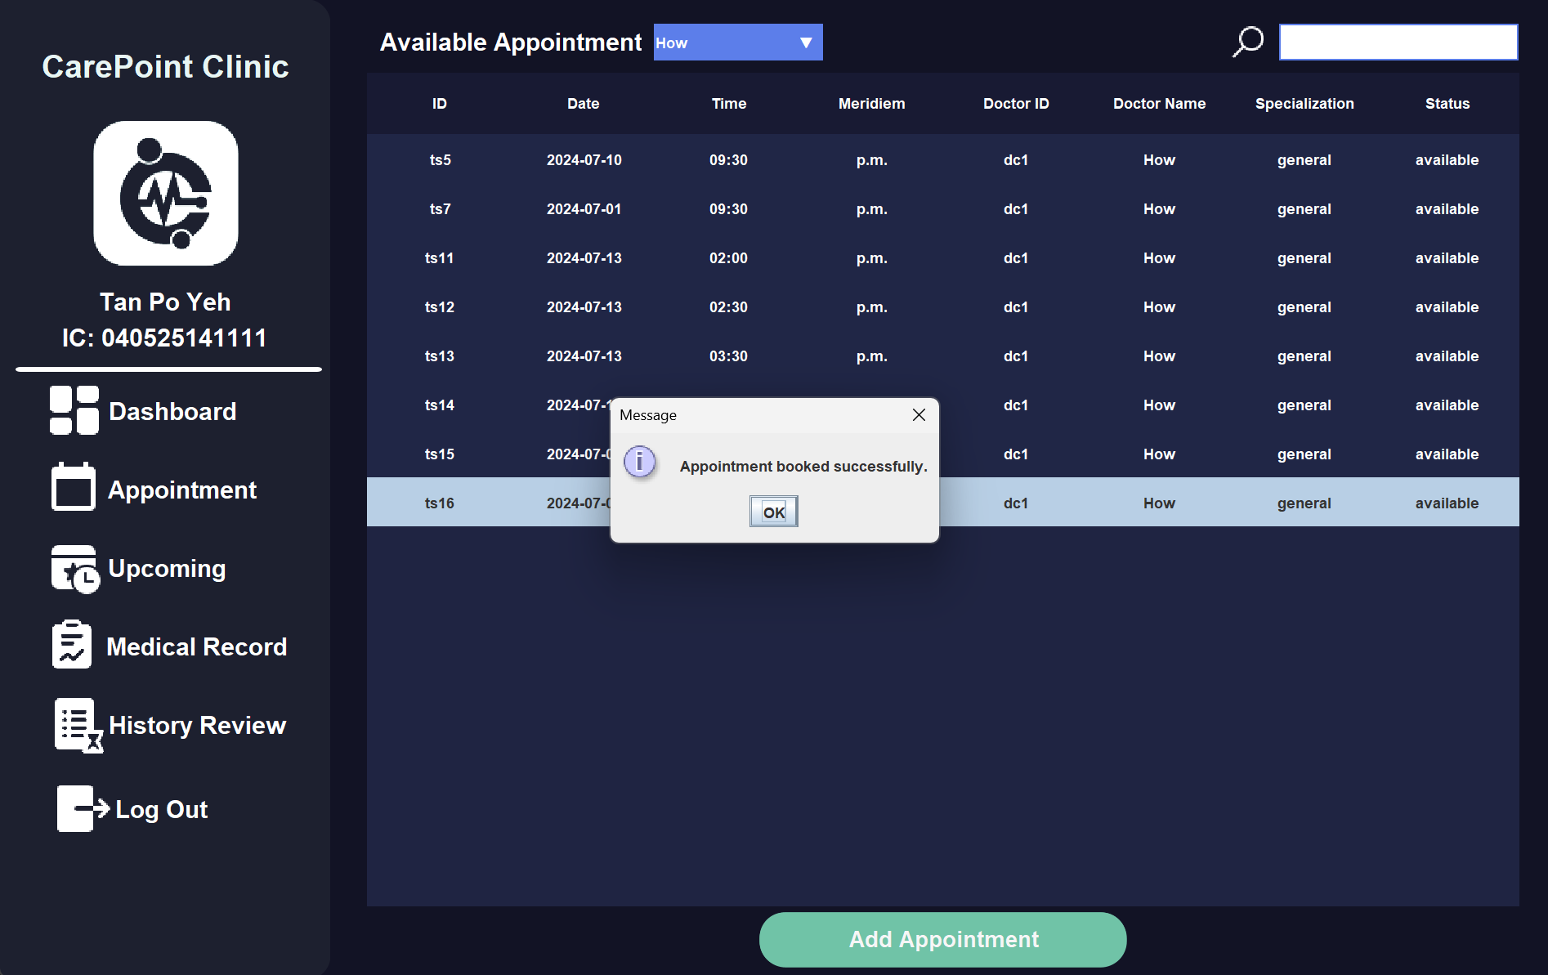

On the dashboard page, if the appointment is successfully booked. The dashboard will display the total number of appointments currently booked by the patient. Here, the number of incoming appointments changes from 0 to 1 as the patients just make an appointment and the total available appointments decrease from 9 to 8.

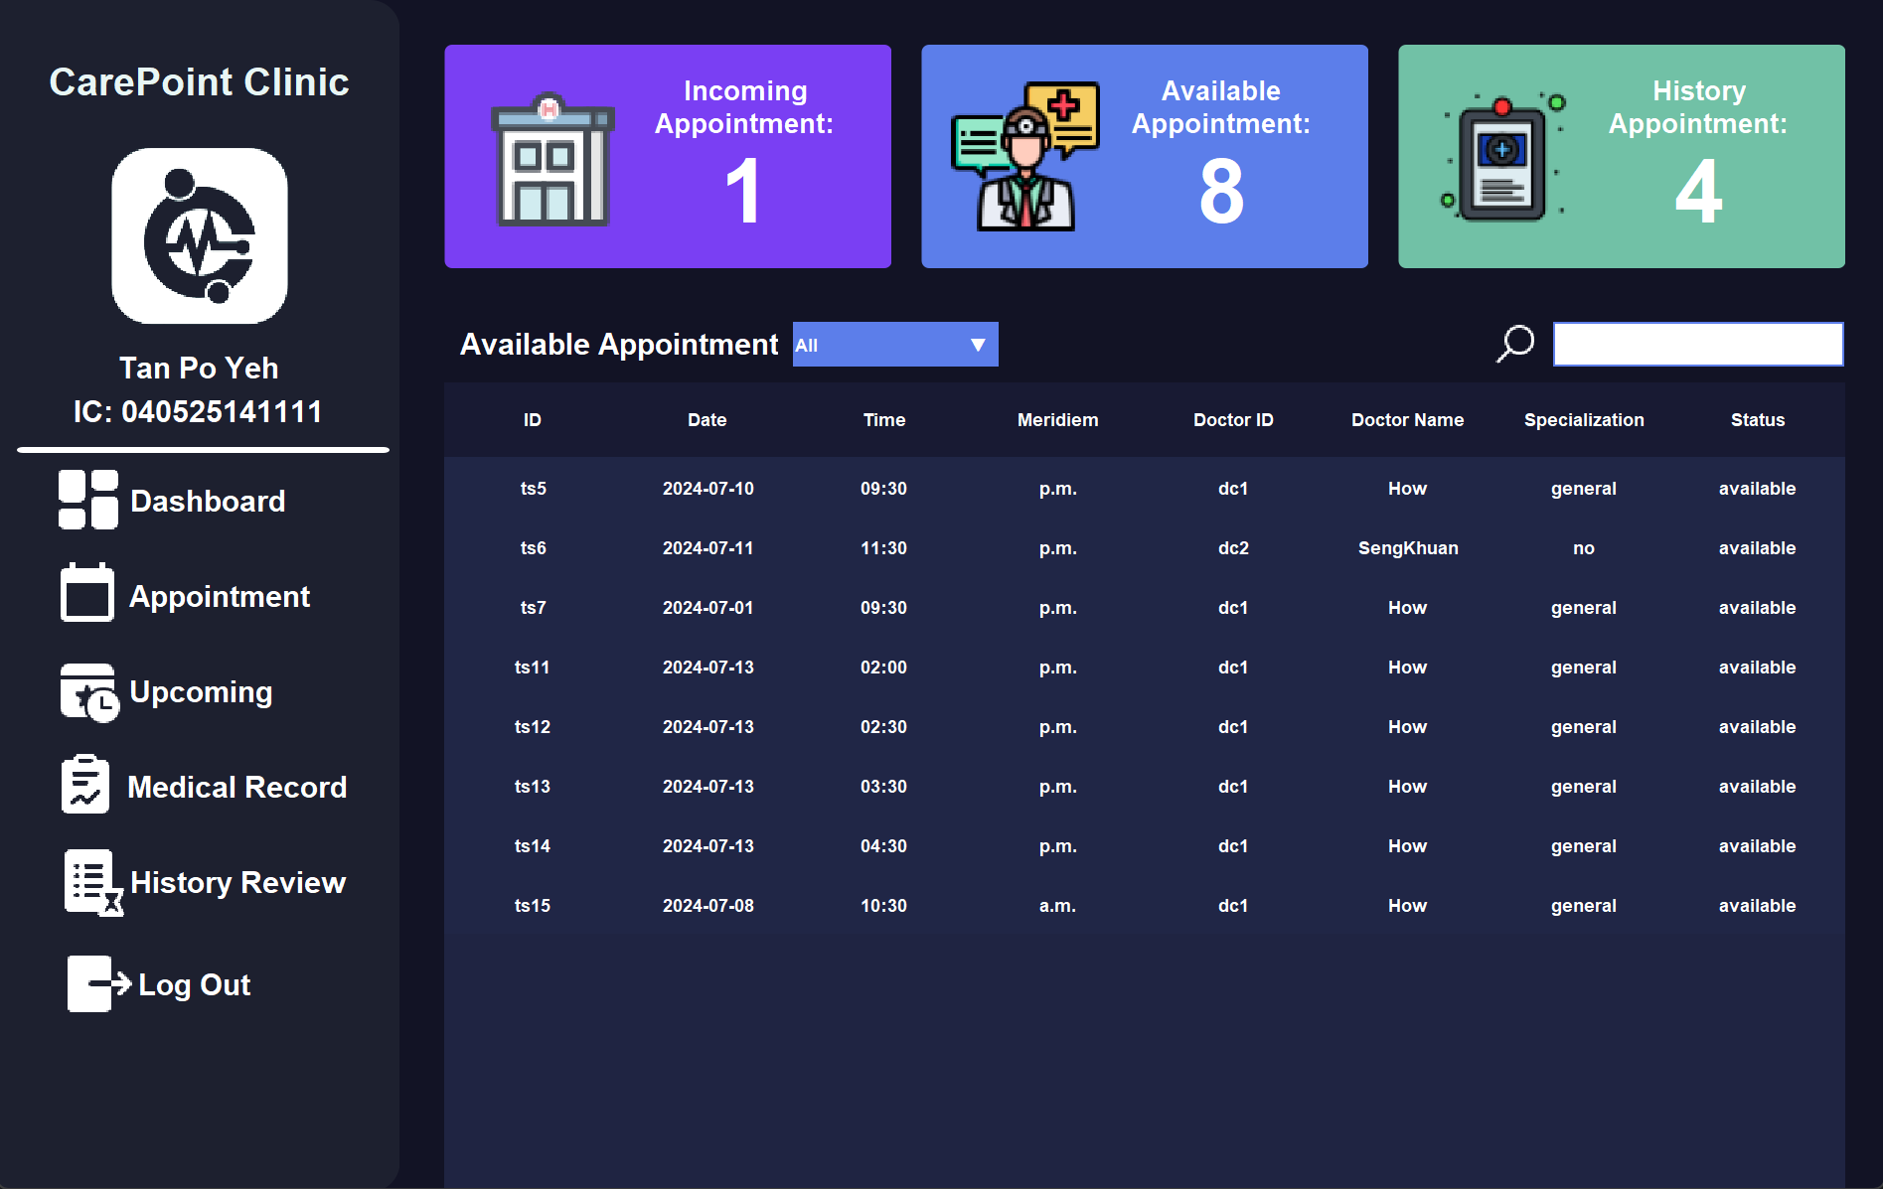

### 2.3.3 Upcoming - Cancel Appointment

To cancel or view the reserved appointments, patients can click the "Upcoming" button on the left panel. On this page, patients are able to cancel the reserved appointment.

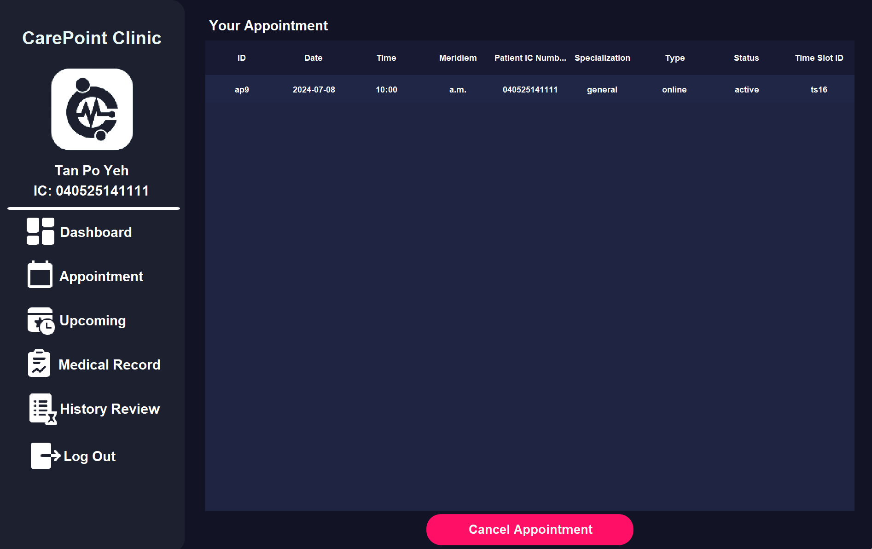

By selecting the appointment want to cancel, patients can just click the "Cancel Appointment" button to cancel an appointment. The system will display a confirmation panel for patients to double-confirm

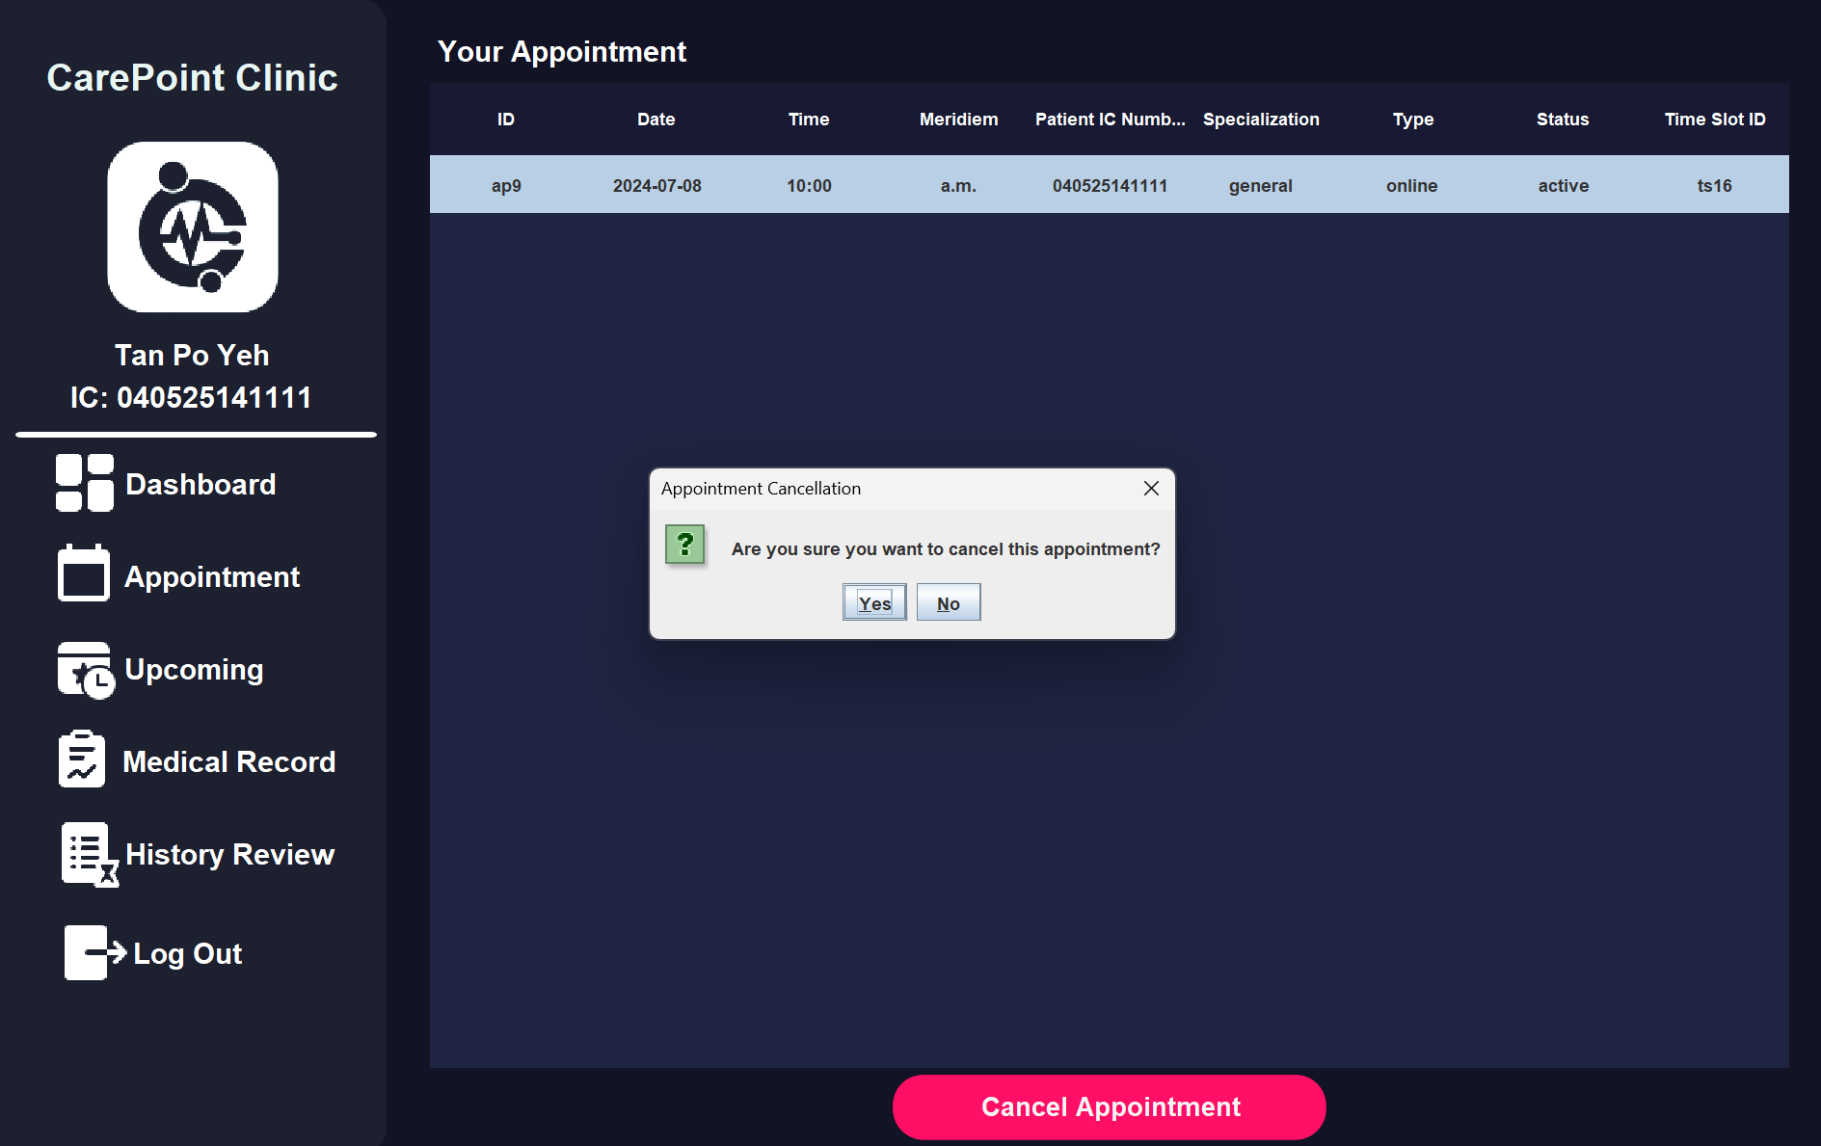

The patients can process the deletion by clicking "Yes" on the pop-up message. If the appointment is deleted successfully, the system will display a success message to the patients.

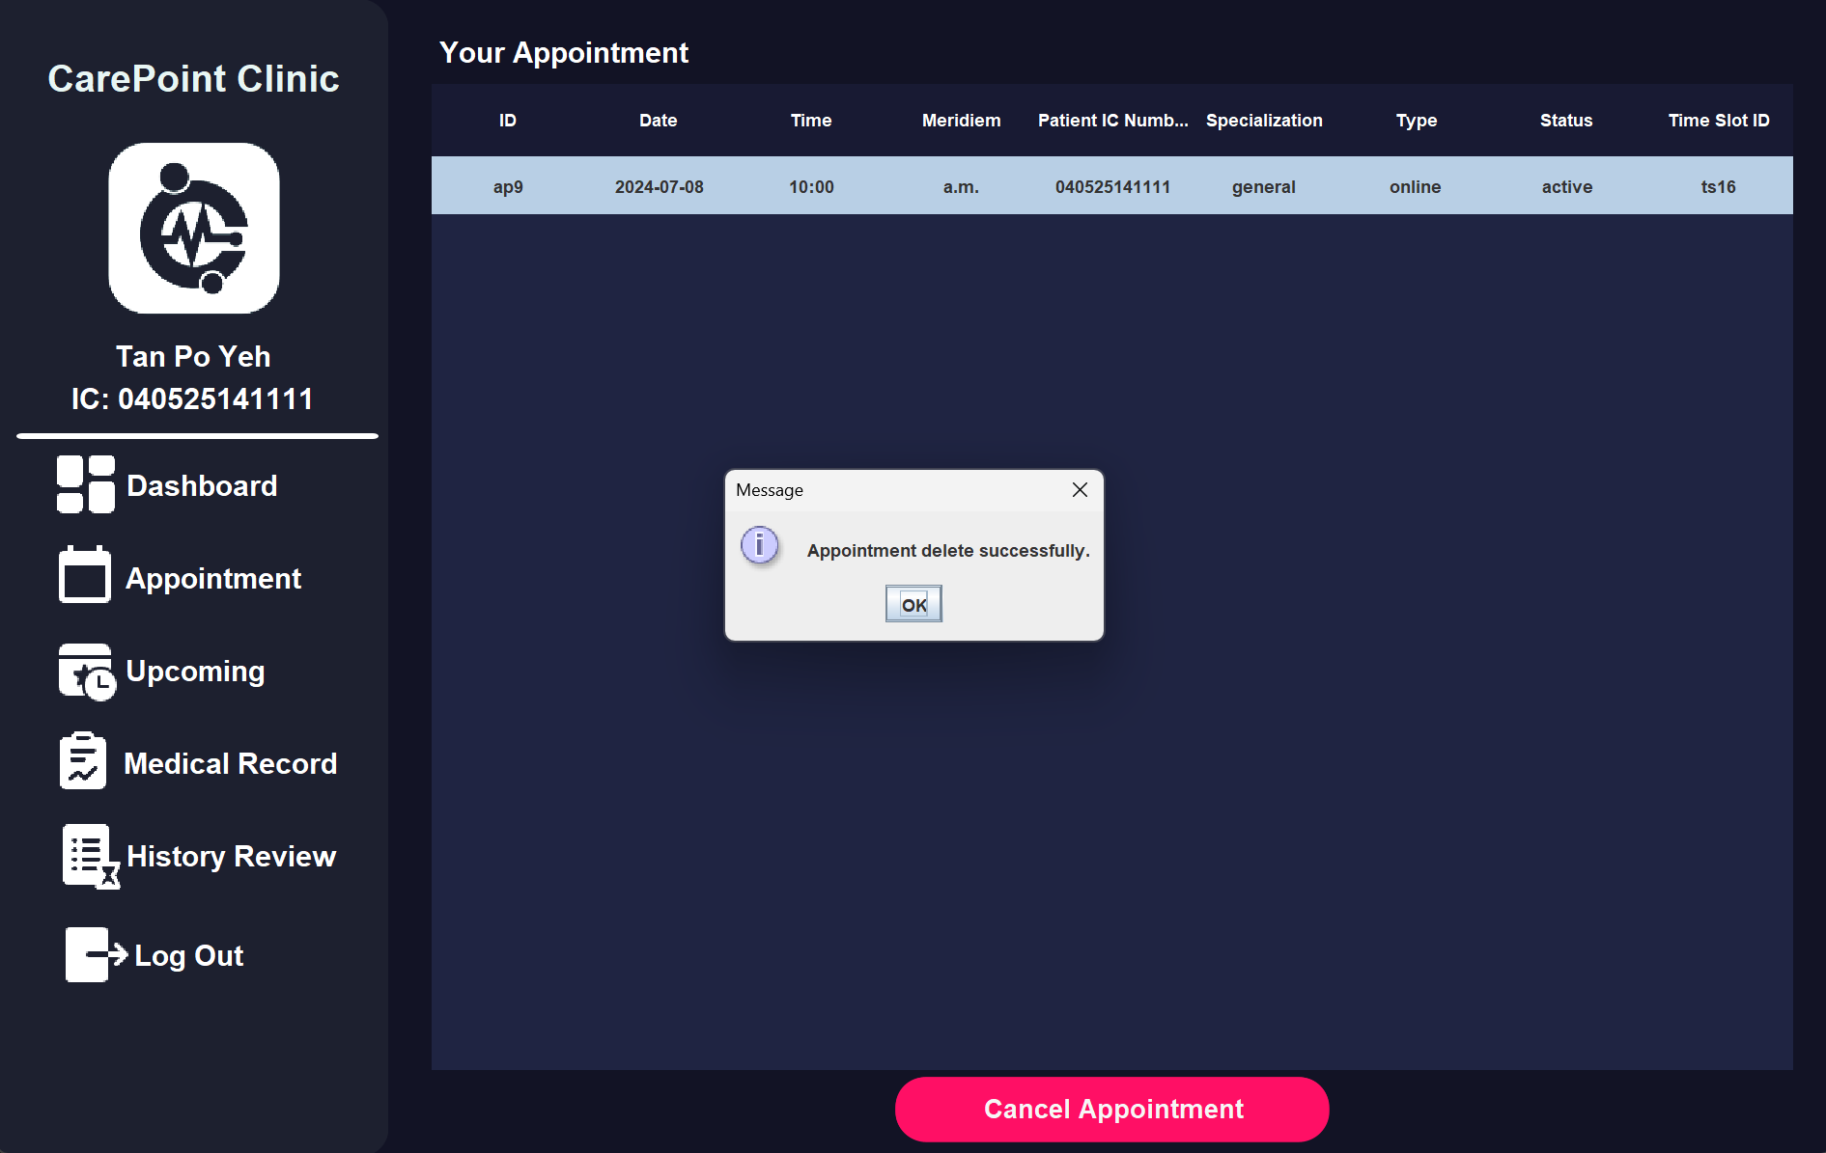

The system will direct the patients to the dashboard page and the three indicators on the above will change.

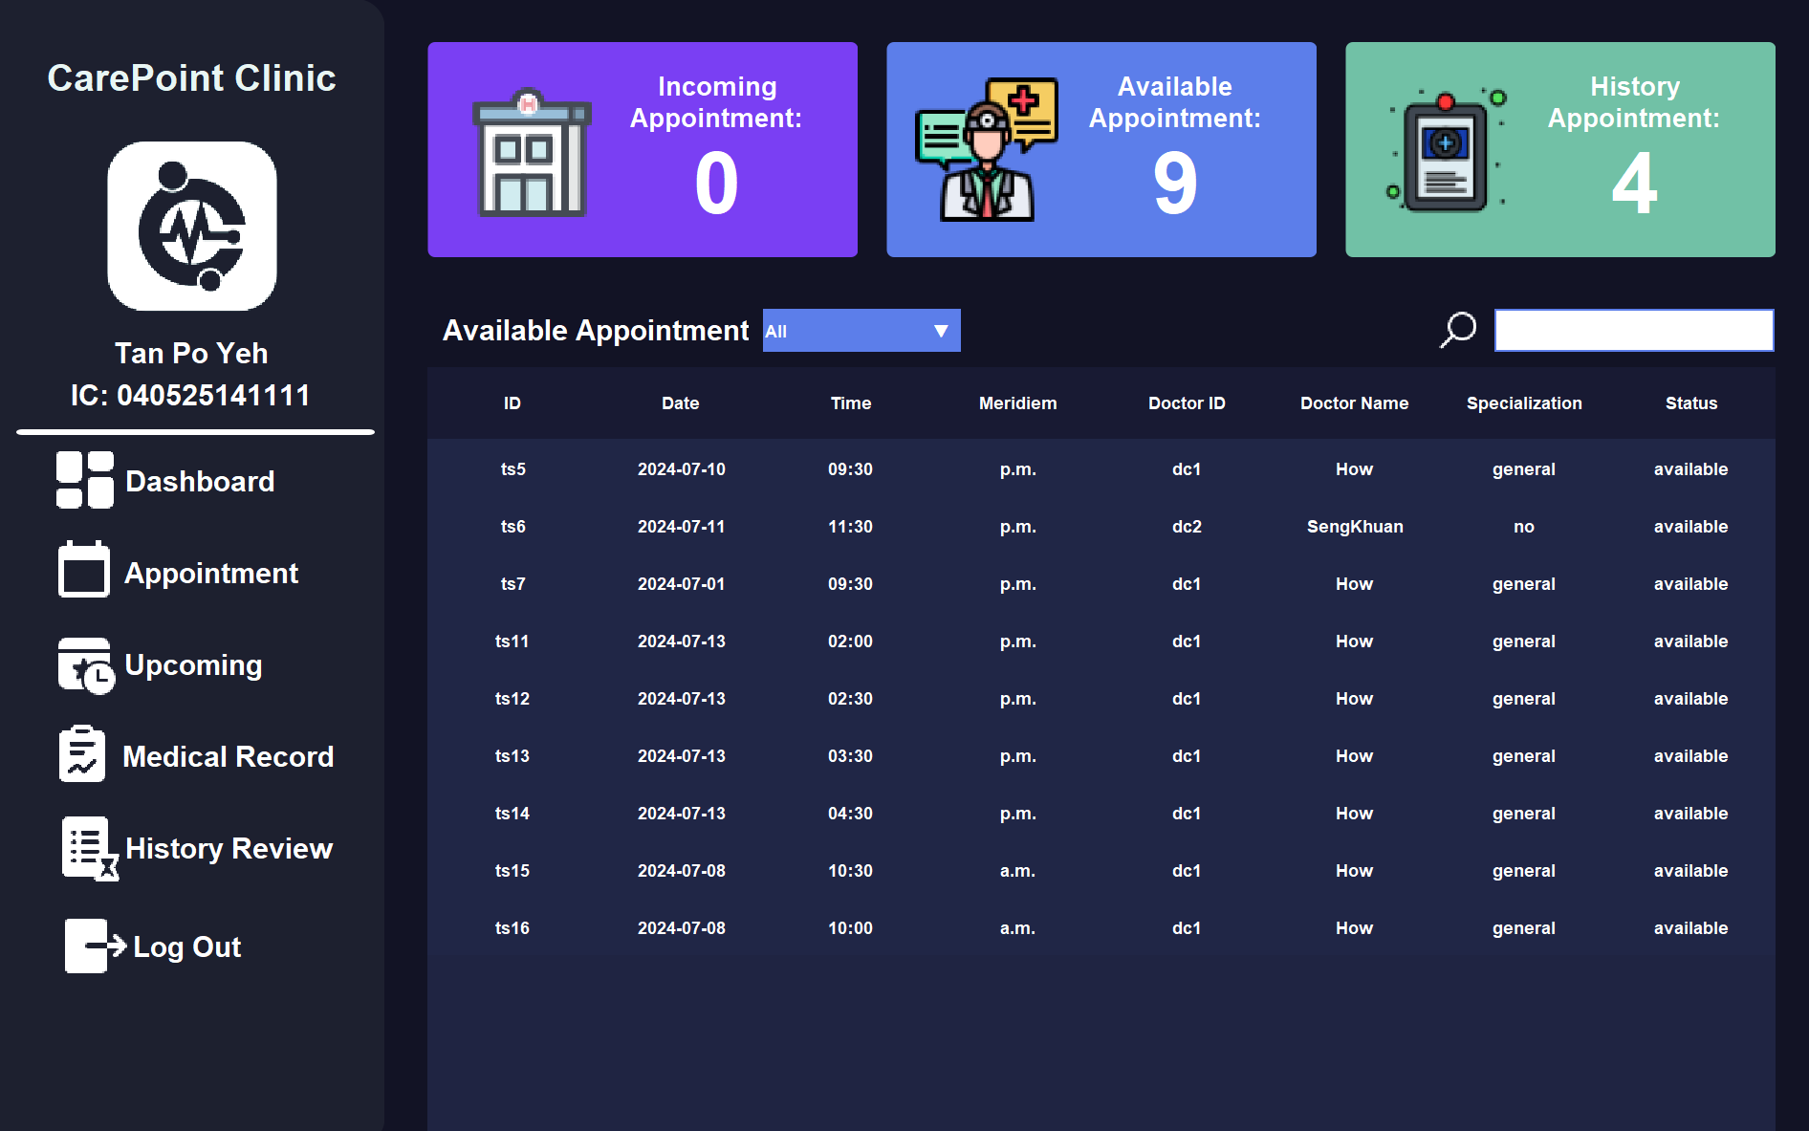

The canceled appointment will remain on the upcoming page for viewing purposes. The canceled record will not able to be canceled on this page.

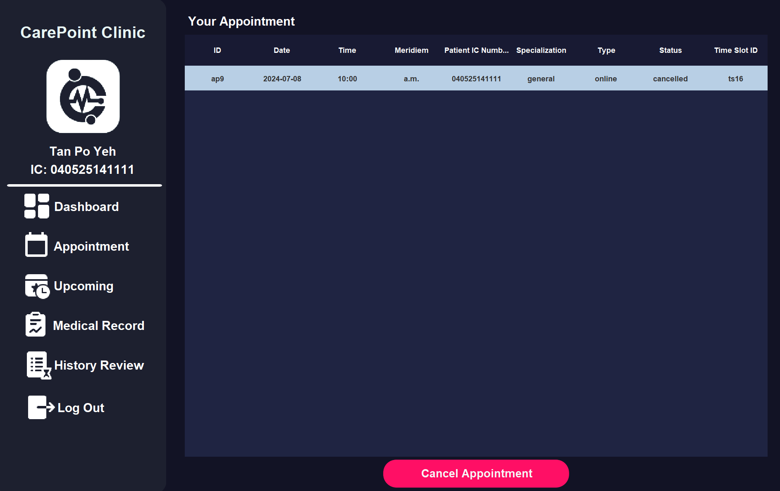

The system will display an error message whenever the patients try to delete an invalid appointment (cancelled appointment).

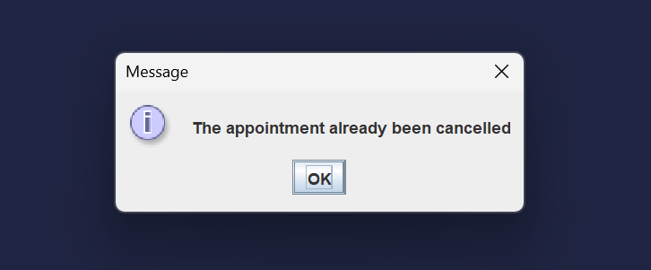

### 2.3.4 Medical Record - Track Personal Medical Record

The fourth feature for the patients is the personal medical record, this features allow the patients to review their own personal medical records provided by the doctor. The patient can access the medical record page by clicking the "Medical Record" button on the left page.

Once clicked, patients are able to review the medical records belong to them. The medical record contains the specific time the doctor gave this record and the doctor's information as well as the patient's information. Below are the medical record page in our system.

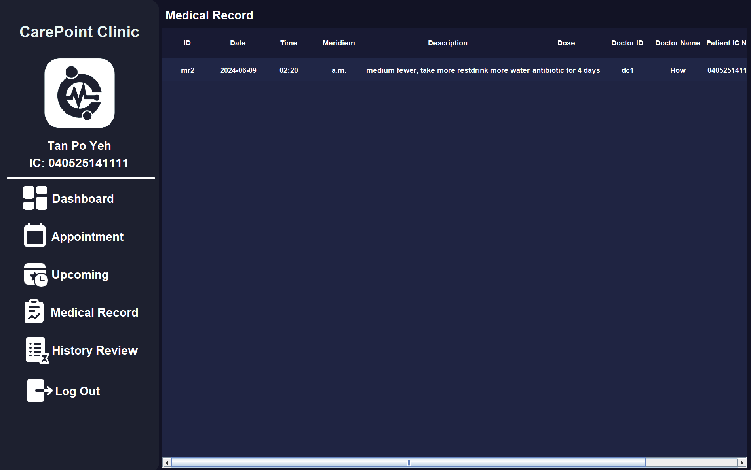

### 2.3.5 History Review - Track Personal Historical Appointment

The fifth feature for the patients is the personal historical appointment review system, these features allow the patients to review their own historical appointment. The patient can access the record page by clicking the "History Review" button on the left section.

Once clicked, patients are able to review the historical appointment records belong to them. The historical appointment record contains the appointment date, time, type and patient information. Below is the historical appointment page in our system.

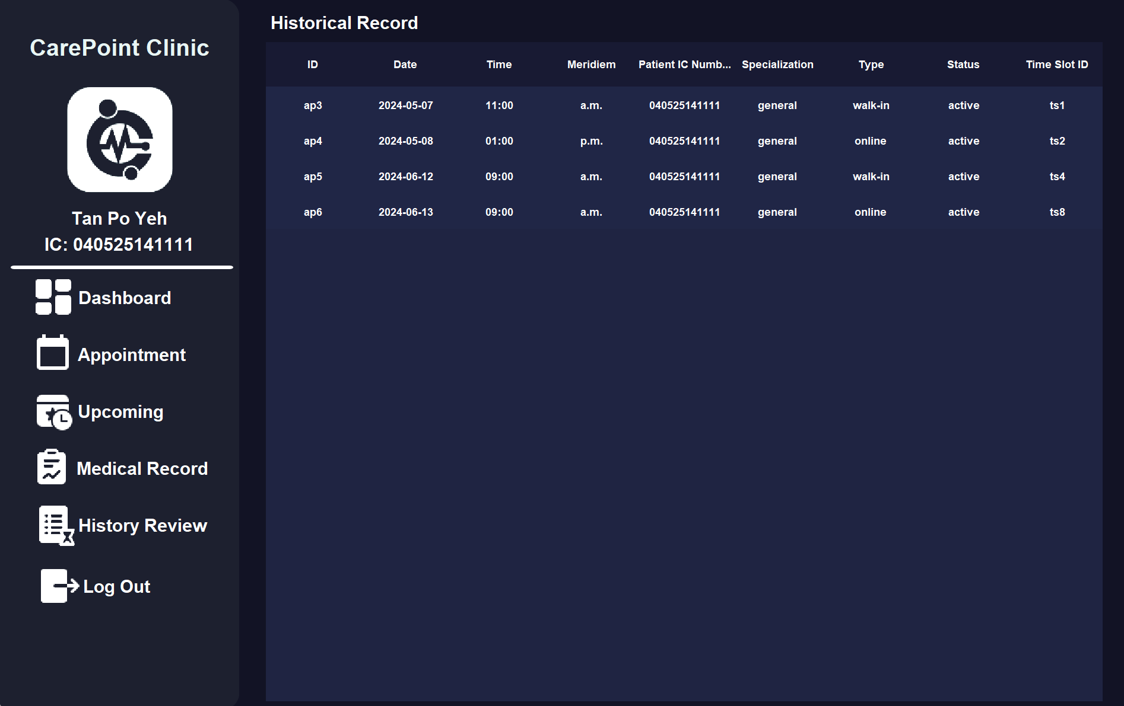

### 2.3.6 Log Out

The patient is able to log out their account by clicking the "Log Out" button on the left section on the page. Once the "Log Out" button is clicked, the system will display out the confirmation panel to enable the patient double-confirm the decision.

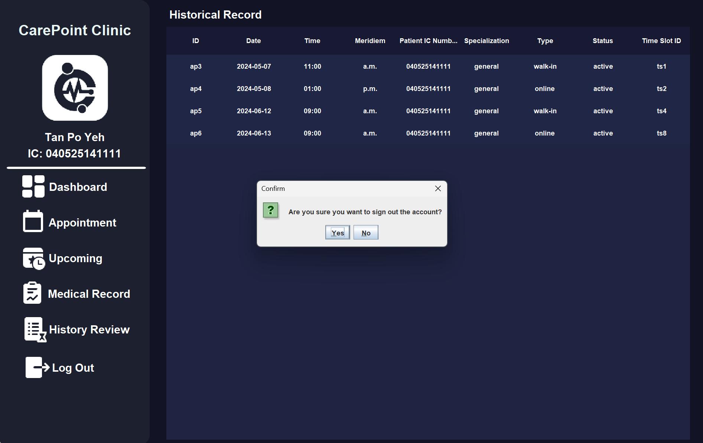

The system will then display a success message to the patient like the picture shown below. By clicking "Ok", patients will be redirect to the login page of the system.

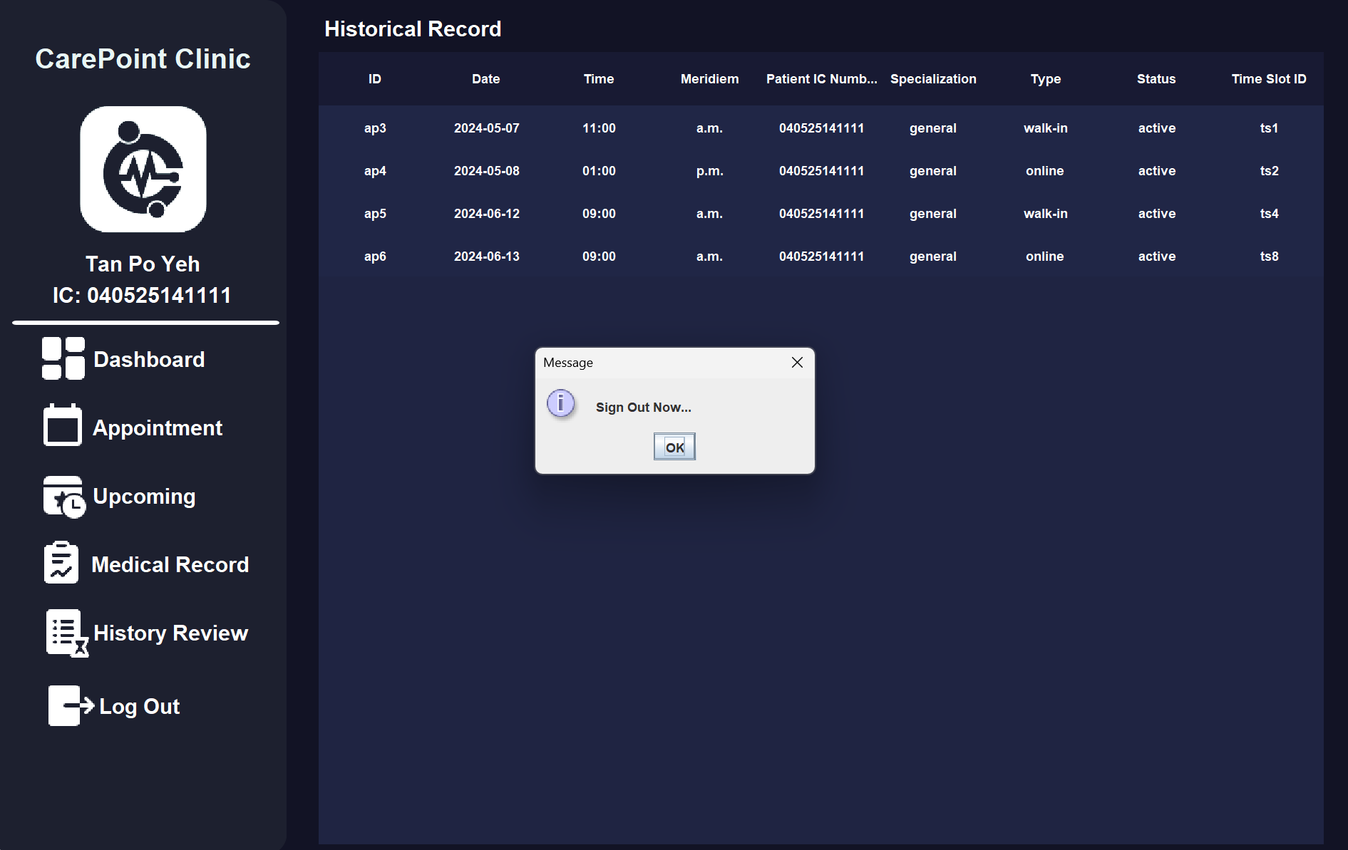

# 3.0 Object Oriented Concepts

Java is one of the most popular Object-Oriented Programming (OOP) languages in the world. According to Kyle (2023), OOP organized a set of data attributes along with methods into object. (Kyle Herrity, 2023) It acts as a blueprint for creating objects that contain similar attributes and behavior. Each class in Java can instantiate multiple objects (instances), and each instance operates independently of the others.

Object-Oriented Programming in Java is built around four fundamental principles that provide the foundation for creating robust and maintainable software.

## 3.1 Class and Object

Class and Object are the main concepts in the realm of Object-Oriented Programming. A class is essentially a blueprint or template for creating objects. It defines a set of attributes and methods that the objects created from the class will possess. Classes can be imagined as the design for a house, specifying what features the house will have and what facilities can be used. This system has various User Interface pages to show information to the user. For example, “DoctorAccUI” class defines the structure and properties of the doctor account management page. It declares 5 buttons, 7 panel boxes, 3 textbox and 1 table field inside the page. Additionally, it includes variables such as “header” and “data” to store the doctor account data for display in the table.

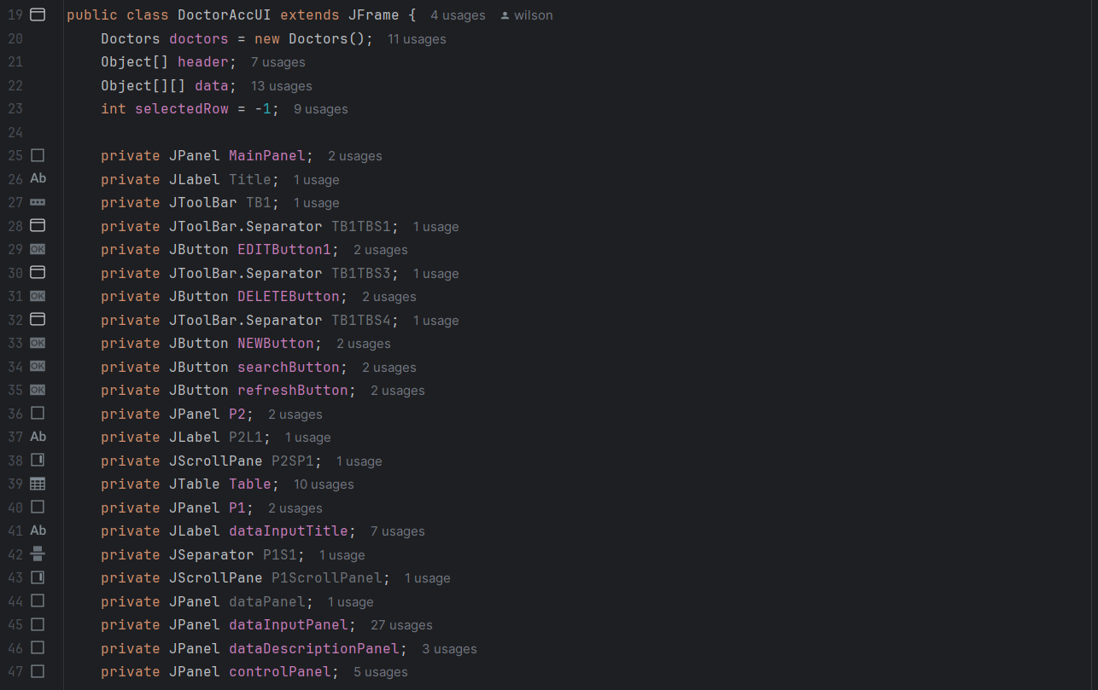

An object is an instance of a class. When a class is instantiated, memory is allocated on the heap for the object, and its attributes are initialized. In Java, the lifecycle and resource management of objects are handled by the Java Virtual Machine (JVM). The JVM is responsible for allocating memory for objects, managing their lifetime, and releasing resources through a process called garbage collection. Each object has its own unique memory address and state, even if they created from same class. The diagram below shows the memory allocation for creating objects. The object will be placed into Heap Space after initializing. It will be removed from the space once the object is no longer needed or referenced.

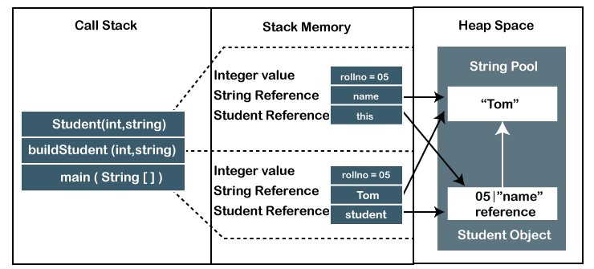

For instance, an admin can click on the “doctorAccountButton” to create a new instance of the “DoctorAccUI” class. This action involves the “new” command, which directs the system to allocate memory for the new object. Consequently, a new doctor account management page appears. If there is an existing reference in “doctorAccUI” variable, this reference will be reset and refer to a new “DoctorAccUI” object. The old object is released from memory because the new “DoctorAccUI” object is distinct from the previous one, even though they are instantiated from the same class.

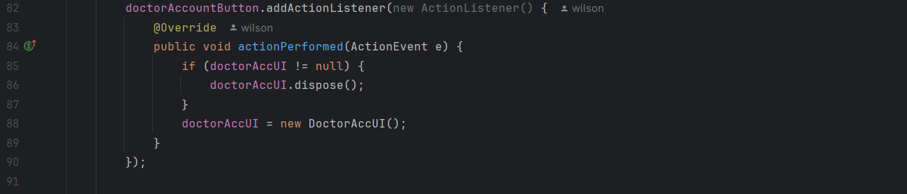

## 3.2 Encapsulation

**Encapsulation** involves bundling data (variables) and methods that operate on the data into a single unit, known as a class. (Thorben, 2024) This concept ensures that the internal state of an object is hidden from the outside and can only be accessed or modified through a controlled interface. Access Modifiers are key to implementing encapsulation in Java. Java provides four types of access modifier that control the visibility and accessibility of class members such as private, protected, public and default.

Members declared as private are accessible only within the class in which they are defined. This level of access restricts external classes from directly interacting with the private members, ensuring data protection. The attributes inside “AppointmentData” class have the least accessibility, they only can be modified by the method inside the class. This encapsulation ensures the credential and integrity of these attributes.

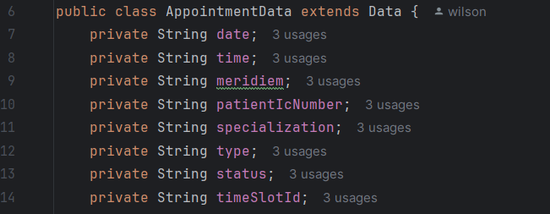

Members marked as protected are accessible within their own package and by subclasses even if they are in different packages. This allows for controlled access, especially accessible in inheritance hierarchies. For example, the id with string type in “Data” class is marked as protected as this attribute can be reassigned value and read in subclasses. However, classes which do not inherit Data class cannot access the attribute.

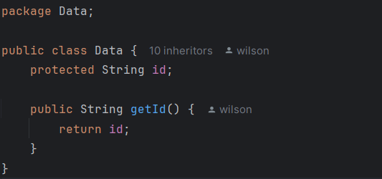

Members labeled as public are accessible from any other class. This provides the widest level of access, allowing methods and fields to be universally available. Public access is commonly used when certain functionality or variable wants to be used freely by other part of program. The “UserData” class contains two public methods, getter and setter for the “name” attribute. The getter method allows outside classes to retrieve the value of the “name” attribute, while the setter method enables them to modify it.

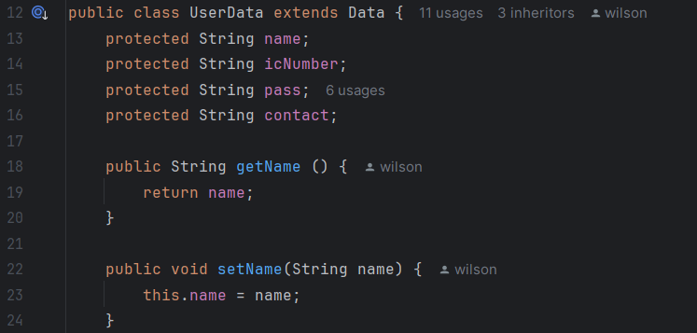

## 3.3 Inheritance

Inheritance is a fundamental concept in OOP that allows a child class (subclass) to inherit the attributes and methods from a parent class (superclass). This feature promotes code reuse and helps establish a hierarchical relationship between classes. In essence, common functionality defined in a superclass can be extended by its subclasses, which can then extend or override their own attributes and methods to perform additional functions.

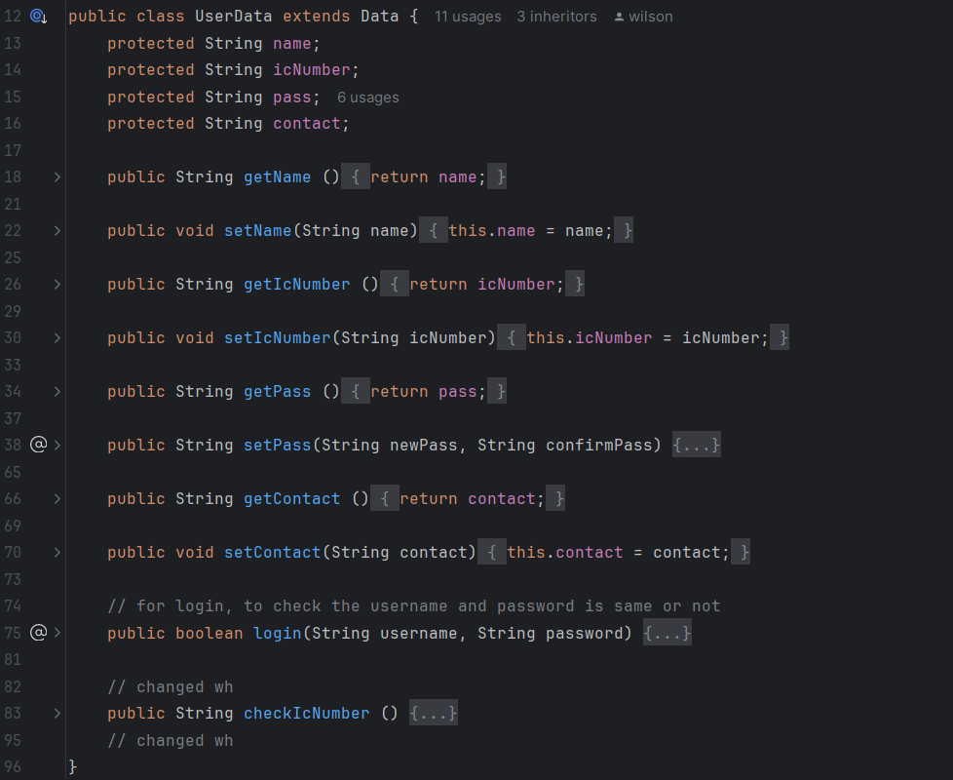

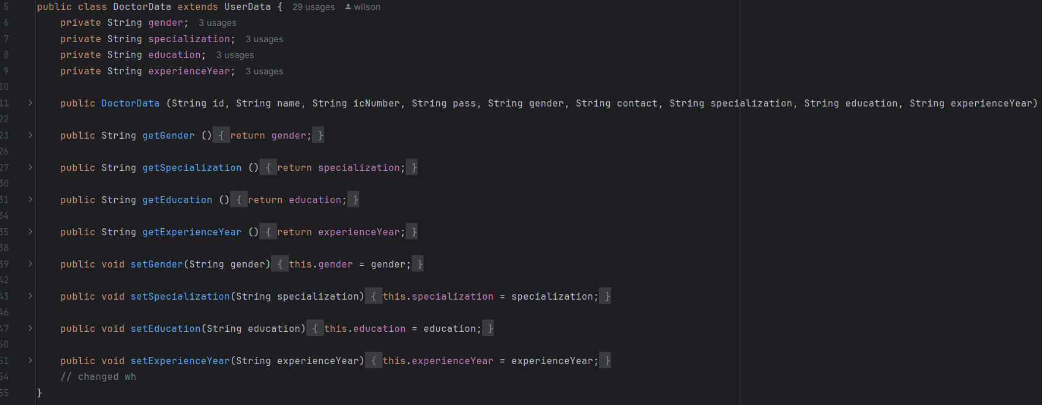

The “DoctorData” class extends the “UserData” class. This means “DoctorData” inherits the attributes such as “name”, “icNumber”, “pass” and “contact” from “UserData”, allowing these attributes to be reused without redeclaration. Additionally, “DoctorData” adds its own specific attributes such as “gender”, “specialization”, “education” and “experienceYear”, and provides methods to manage these attributes. This is because doctor has its own account information that other’s role might do not have.

The diagram below shows the inheritance relationship of our system.

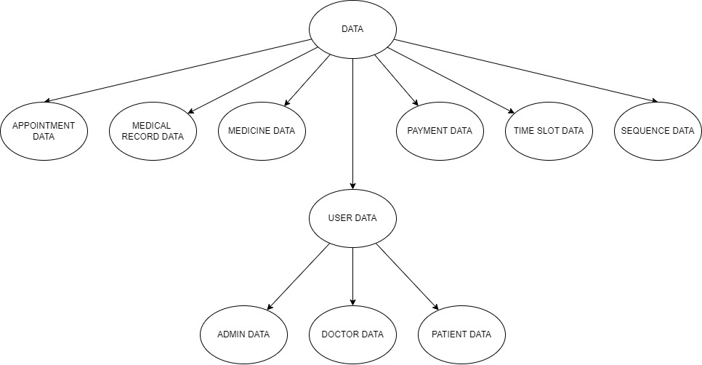

## 3.4 Polymorphism

Polymorphism allows objects of different classes to implement one or more methods defined in a superclass. This is particularly useful when we want to execute a common action in response to user events, such as button clicks. In our Java development, the “ActionListener” interface is commonly used to handle these events. Specifically, the “LoginUI” class needs an interface to enable user interaction with our system. By implementing the “ActionListener” interface, the “LoginUI” class gains access to the “actionPerformed” method, which handles button events.

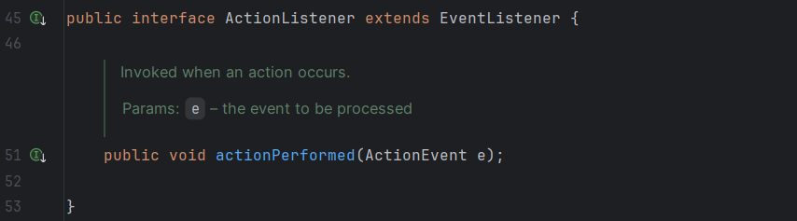

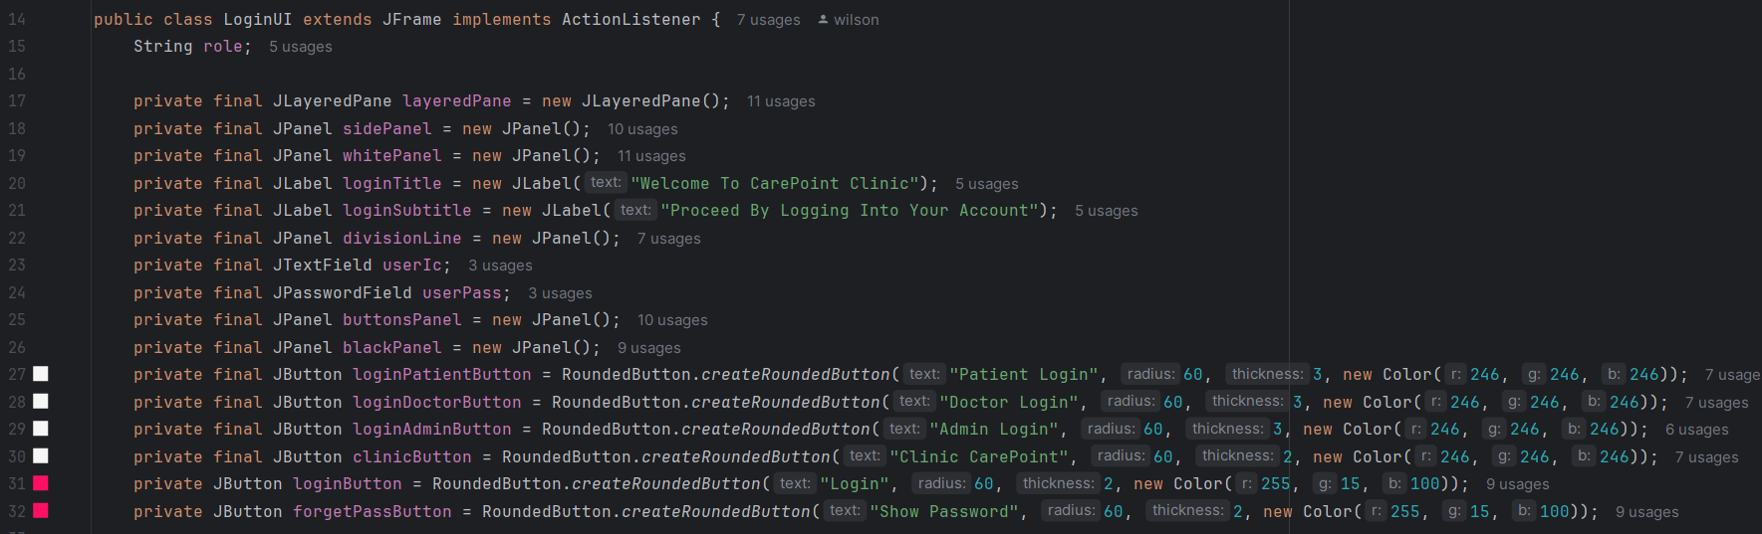

The “LoginUI” class provides its own implementation of the “actionPerformed” method defined in the “ActionListener” interface. Through method overrding, the “LoginUI” class can exhibit different behavior such as submitting login input, applying forget password feature and animation reset.

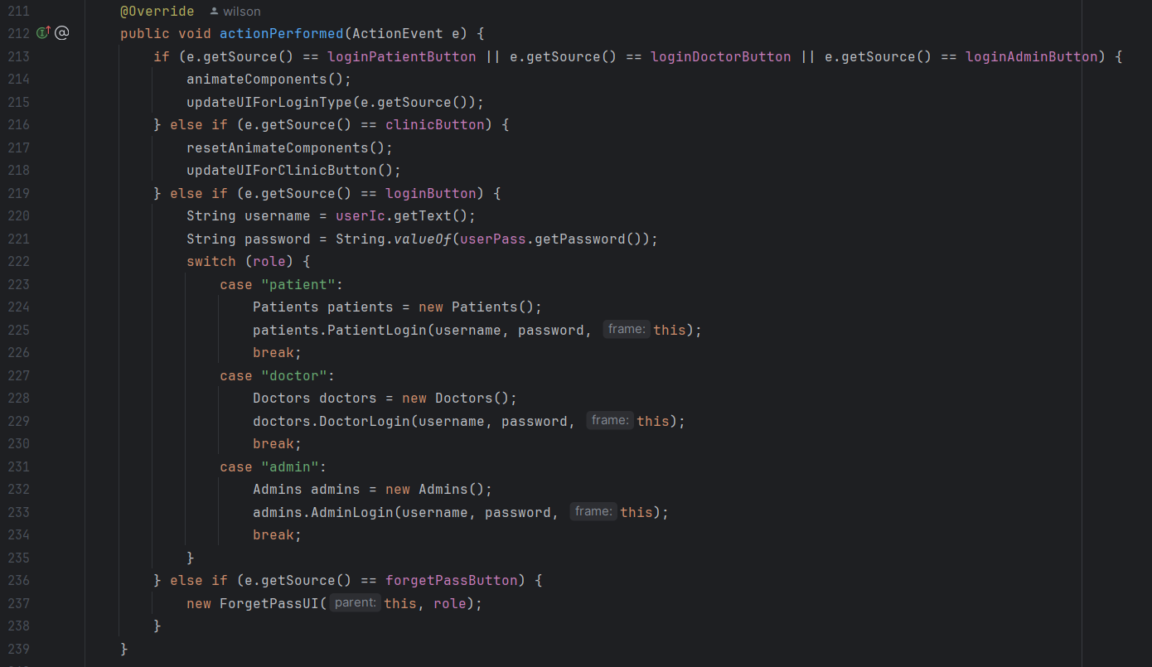

# 4.0 Java Features

**1.Exception Handling:**

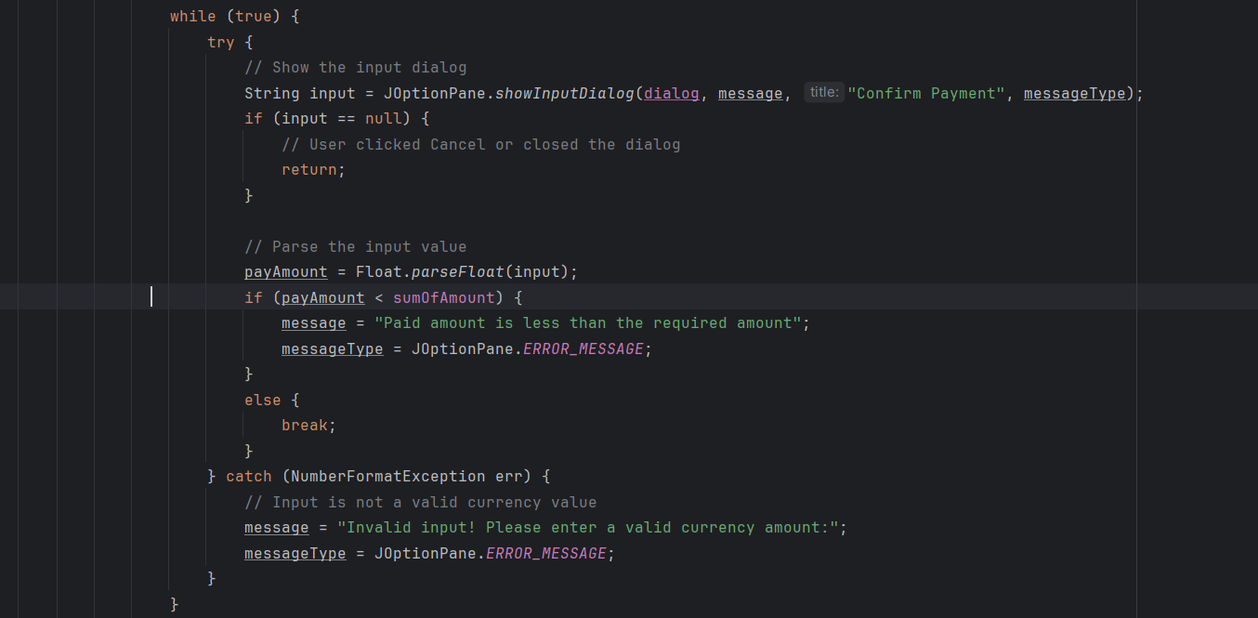

The code as shown above manages patient invoicing with the need for user to input a specific payment amount using the JOptionPane.showInputDialog .The user input is processed as a float; if this is unsuccessful, a NumberFormatException occurs, and the user gets prompted again with an error message. If the amount is insufficient, the user gets notified and the program repeats. This ensures, that the user must enter a specific payment amount.

**2. IF, Else :**

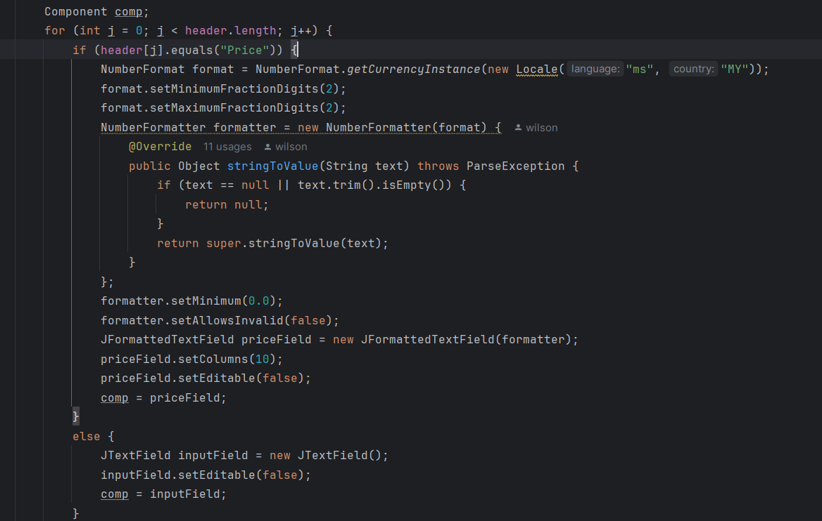

This program starts by looping through the header array. IF the header is “Price”, the program creates “JFormattedTextField” for user input. Furthermore, A “NumberFormatter” is used to make sure correct currency input and the value is not negative. The “JFormattedTextField” is created with a formatter, set to a specific width (setColumns(10)) and to make sure is non-editable. The “Else” is used to identify if the header if is not “Price” then the programs will create a “JTextField” and this field is set to non-editable .

**3. Try - with -Resources :**

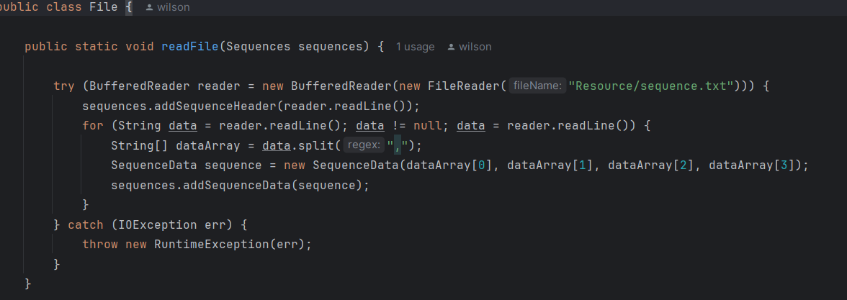

The readFile method in Java illustrates quick file processing and strong error management by utilizing the java features such as try-with-resources and exception handling. In the procedure, the try block creates a BufferedReader called reader to read the file "Resource/sequence.txt". This usage of try-with-resources makes sure that the BufferedReader is immediately closed when the block exits, such and throws an IOException. For example, if an IOException occur, like when a file is missing or unreadable, the catch block quickly solves the issue. After that it throws a RuntimeException, which encapsulates the original IOException. In addition to that, this step ensures that the BufferedReader resource is correctly run and terminate properly.

**4. File.IO :** 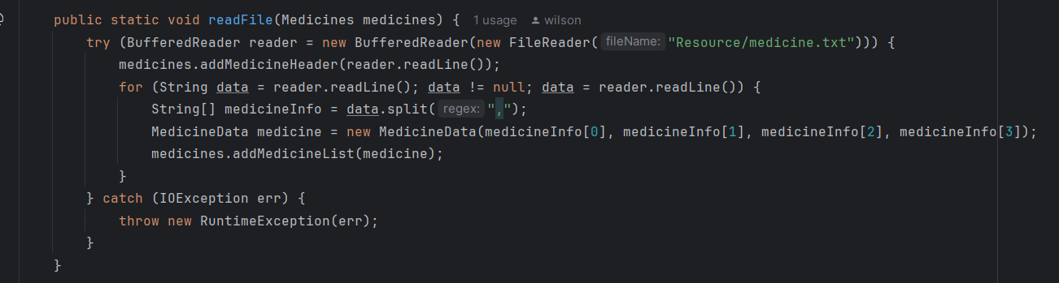

Java's BufferedReader class is crucial for effective file reading, particularly when working with text files. By doing this so, buffering input and reducing the amount of read operations on the underlying I/O flow.The readLine() function, whiach reads a line of text one at a time, is one of its primary characteristics. This makes it easier to handle text files results in cleaner and easy to read code. ReadLine() provides a whole line as a string rather than reading individual characters and looking for line terminators, which is particularly helpful for structured text files. Moreover, BufferedReader also manages resources efficiently. When used in a try-with-resources statement, it ensures the file stream is properly closed after operations, even if exceptions occur, preventing resource leaks and related issues. In summary, BufferedReader and readLine() method improves performance and simplifies file reading in Java.

**5.While Loop:** Creates an infinite loop with condition

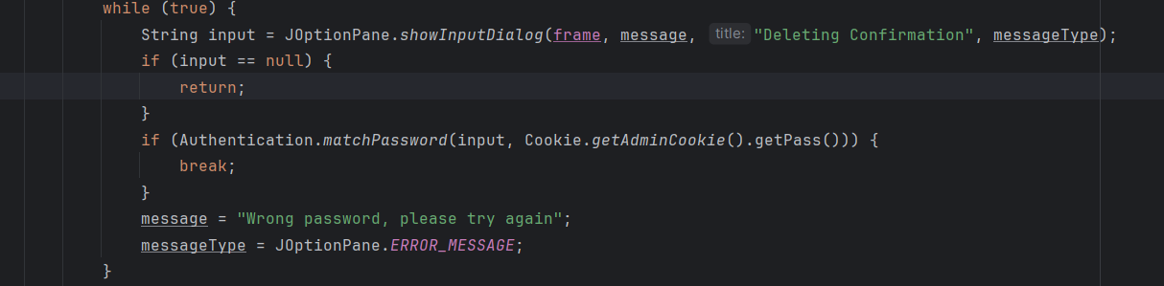

The while (true) loop generates an endless loop that is can be broken out of under certain conditions. In the loop, the JOptionPane.showInputDialog function displays a dialog box that requests input from the user. In context to that, if the user enters a password, the code uses Authentication.matchPassword to see whether it matches the admin password that is saved in a file. The program continues if the passwords match, it will break out of the loop using a break statement as shown above. The user will be prompted to try again if the passwords do not match and if the user terminates the dialog or quits the program, the input is null and the process returns, ending the loop and its execution. In summary, this to make sure that the user must provide correct input before proceeding.

**6.Switch Case:**

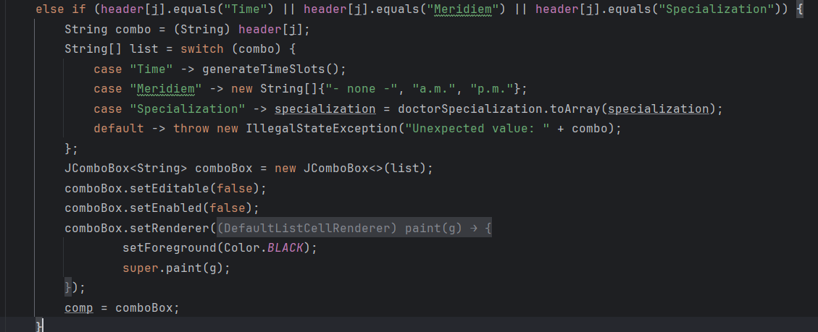

The switch statement is an effective control structure that improves code readability. The code first checks if the current header value matches "Time", "Meridiem", or "Specialization". If it does, it assigns the header value to the variable combo. The switch statement then evaluates the combo and executes the corresponding case block as shown below.

* **Case "Time"**: If the header value is "Time", it calls the method generateTimeSlots(), which presumably returns an array of time slots. These slots are then used to populate the JComboBox.
* **Case "Meridiem"**: If the header value is "Meridiem", it assigns an array containing "- none -", "a.m.", and "p.m." to the JComboBox.
* **Case "Specialization"**: If the header value is "Specialization", it converts a list of specializations to an array and assigns it to the JComboBox.

However, if the cases don’t match the default case, it throws an IllegalStateException with a message indicating an unexpected value. In a nutshell, the switch statement in this Java code manages the content of a JComboBox based on different header values.

# 5.0 Additional features

## 5.1 Forget Password

The forget password features are able to be accessed by all the users in the system, including patients, doctors and admins. This feature allows the user to reset their password by entering their IC number and phone number registered in the system/clinic. Users are able to access this feature by clicking the "Forget Password" button.

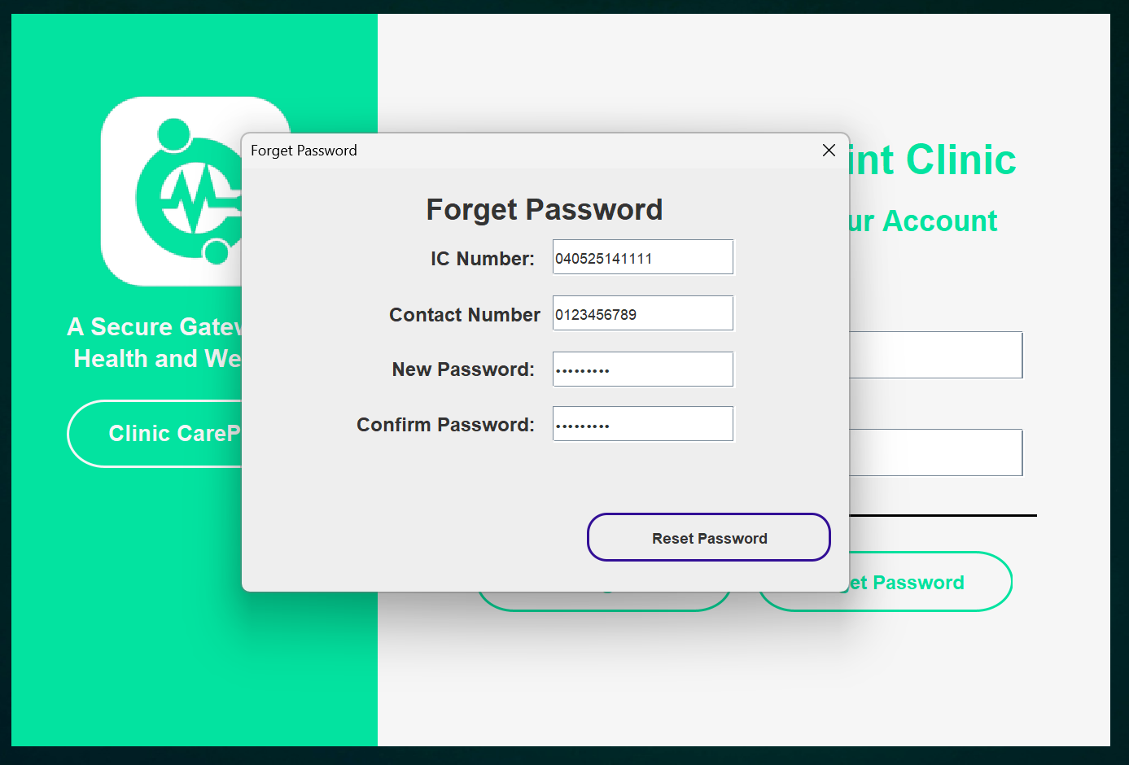

Then, users will be able to see a pop-up panel for resetting the password. To reset the password, users just need to enter the correct IC Number and Contact Number. Next, the user will need to enter a new password in the length of between 8 to 16 characters with a combination of one digit, one uppercase letter and one lowercase letter. Otherwise, the system will display an error message to the user.

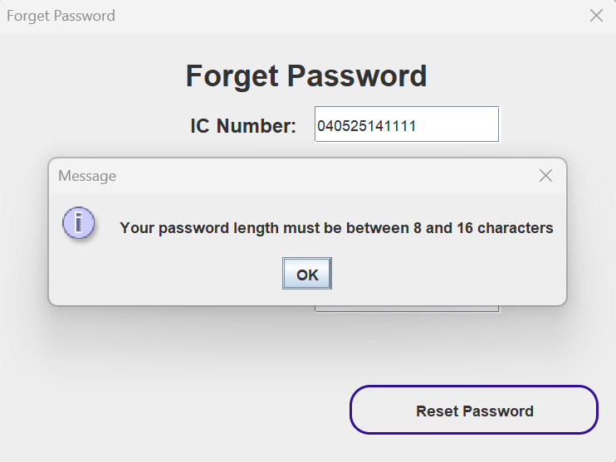

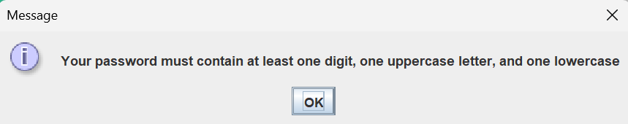

The setPass() method is responsible for checking and validating the entered password length and character so the password fits the condition of between 8 to 16 characters with a combination of one digit, one uppercase letter and one lowercase letter.

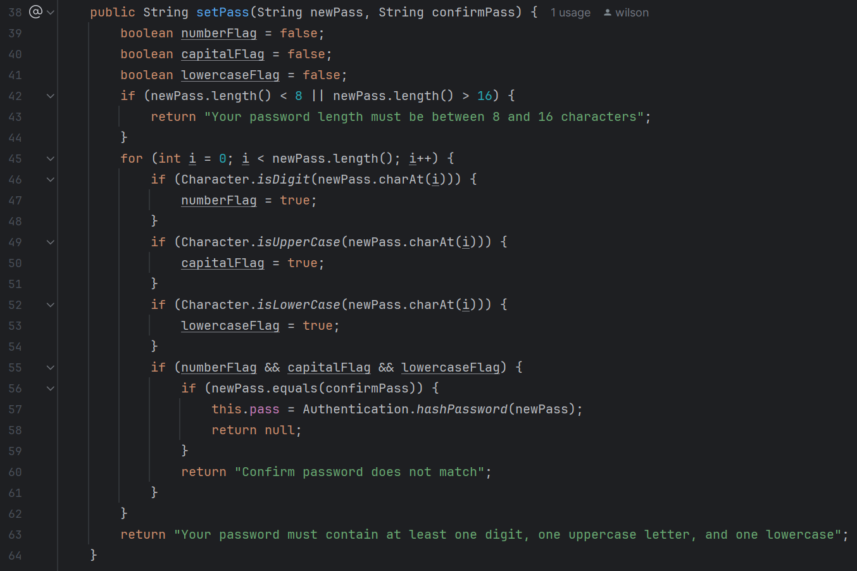

Lastly, click the "Reset Password" button to proceed with the process. Once everything is done, the system will display a success message to the user.

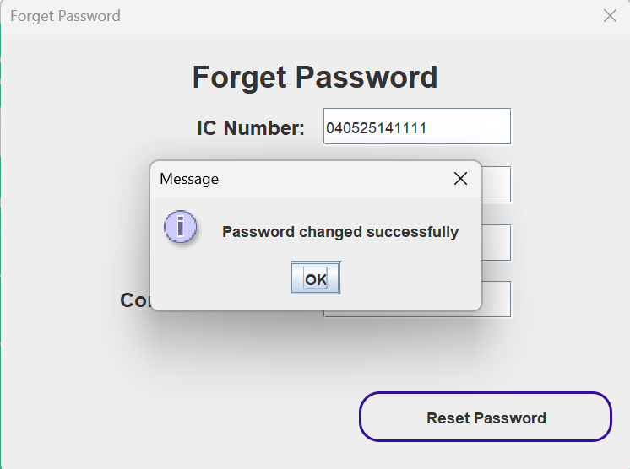

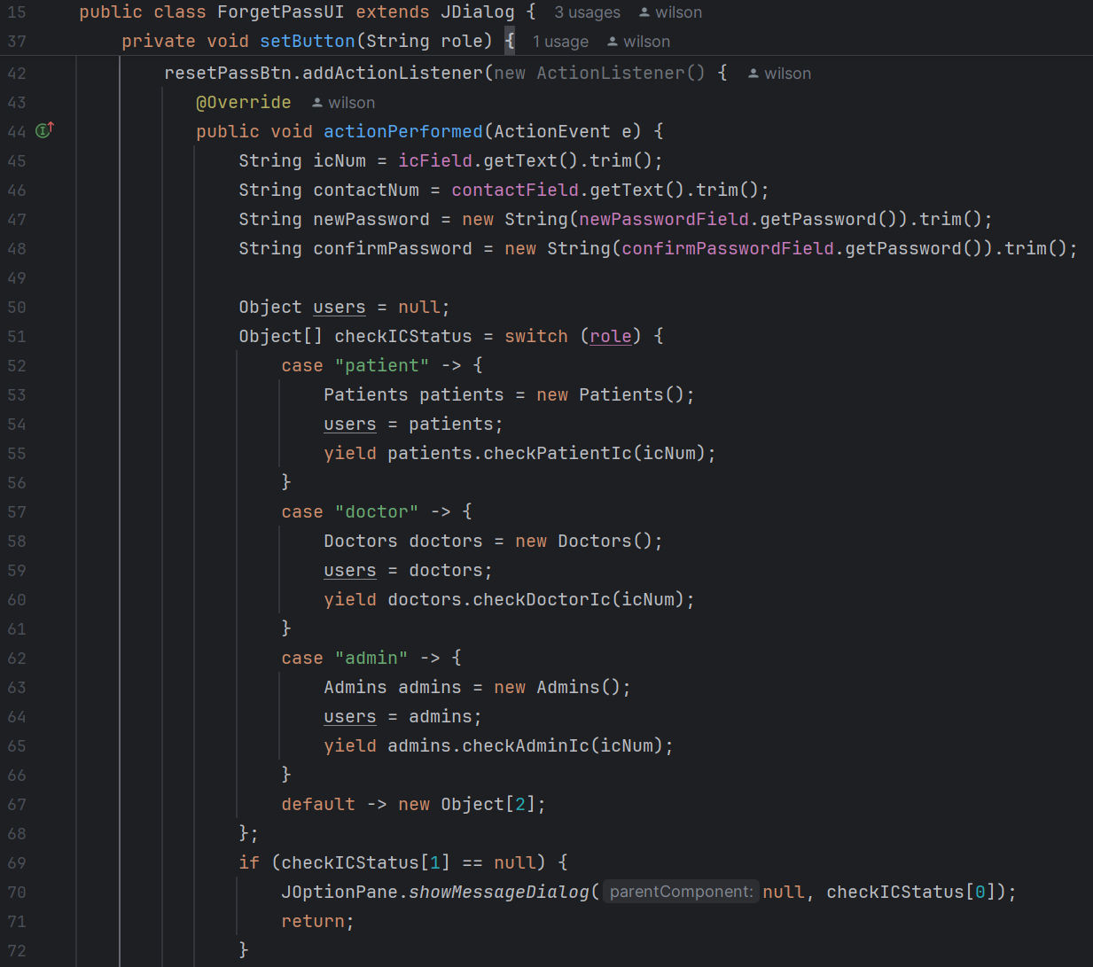

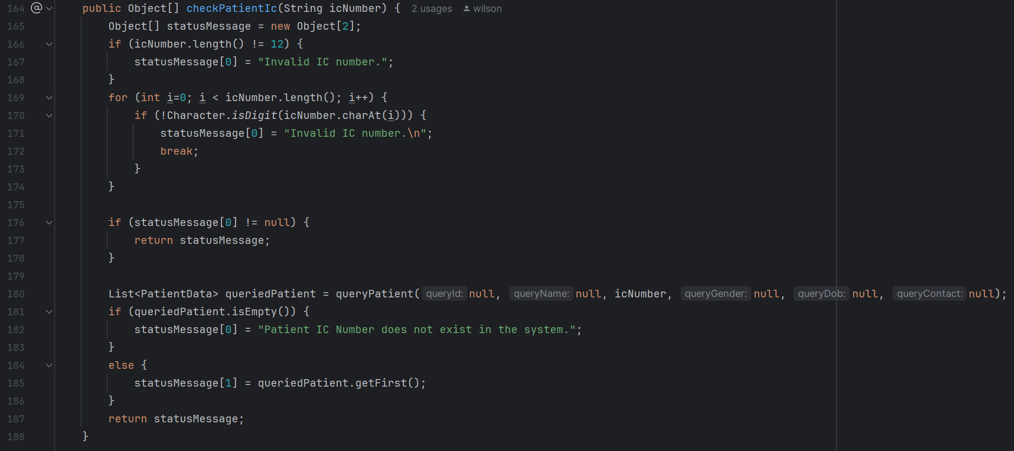

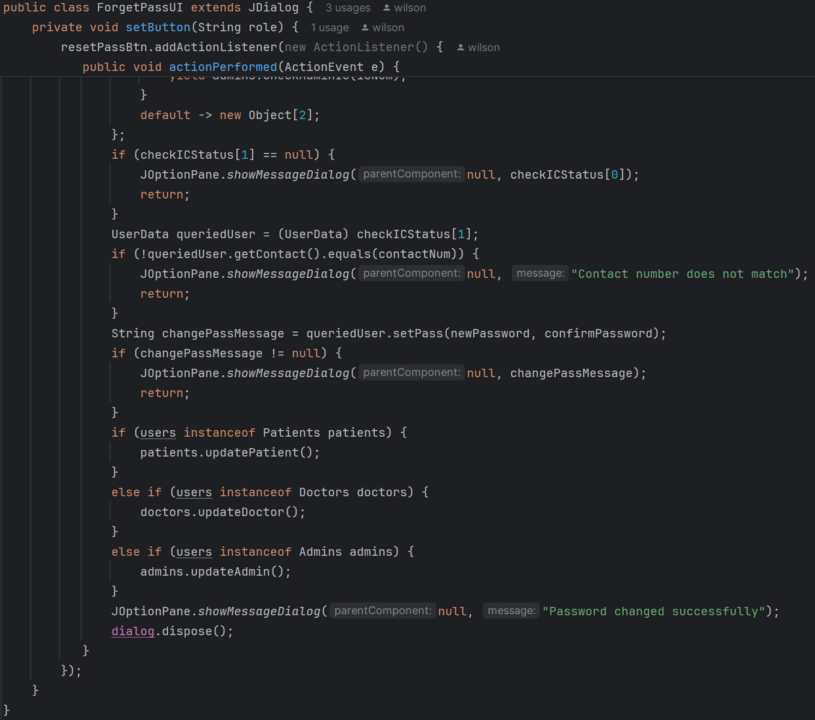

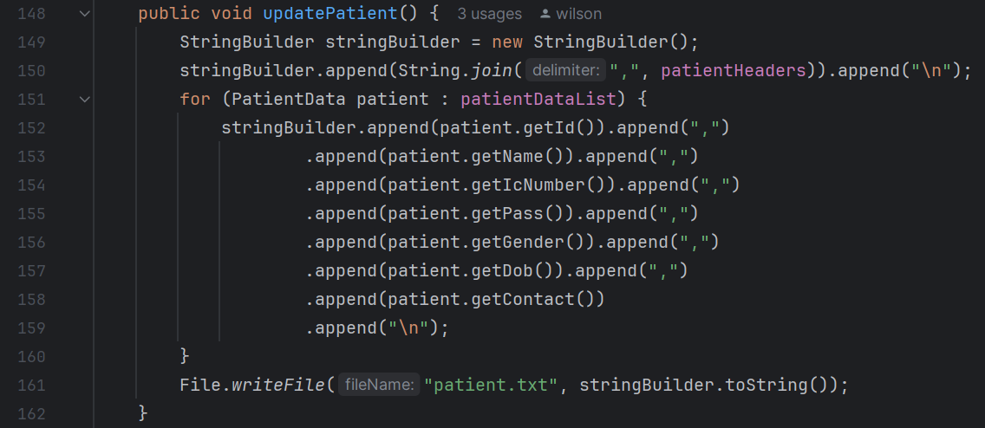

## 5.2 Hashing Password

Hashing passwords is another feature that is vital in our system. When a user registers or updates their password, the system will hash the password using a secure hashing. This feature protects the user's password from being exposed in its plain text form, even if the database is compromised.

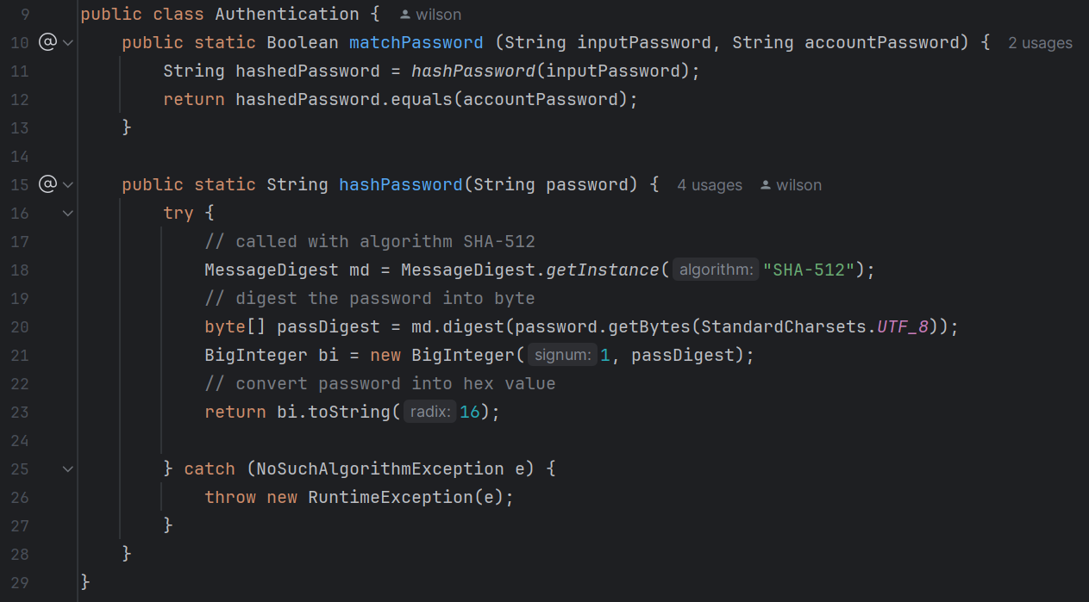

The input password is hashed using the SHA-512 algorithm. This is done in the hashPassword() method. Below is the hashed password sample from the test user.



When a user attempts to log in, the system hashes the input password and compares it with the stored hashed password using the matchPassword() method. If the hashed passwords match, authentication is successful; otherwise, it fails.

## 5.3 Generate Payment Receipt

For the admin, there is an extra feature called Generate Payment Receipt. With this feature, admins are able to generate a payment receipt in the format of PDF. Admins are able to select specific receipts to generate, by simply selecting the target record in the table.

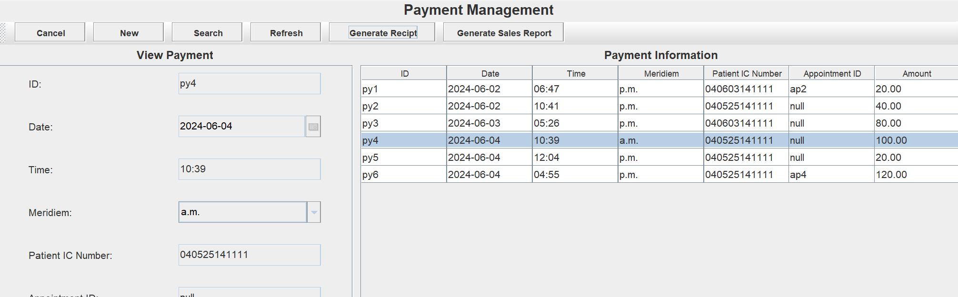

Once successful, the system will generate a PDF file to the admin machine. Below is a sample of a payment receipt belonging to one of the test users.

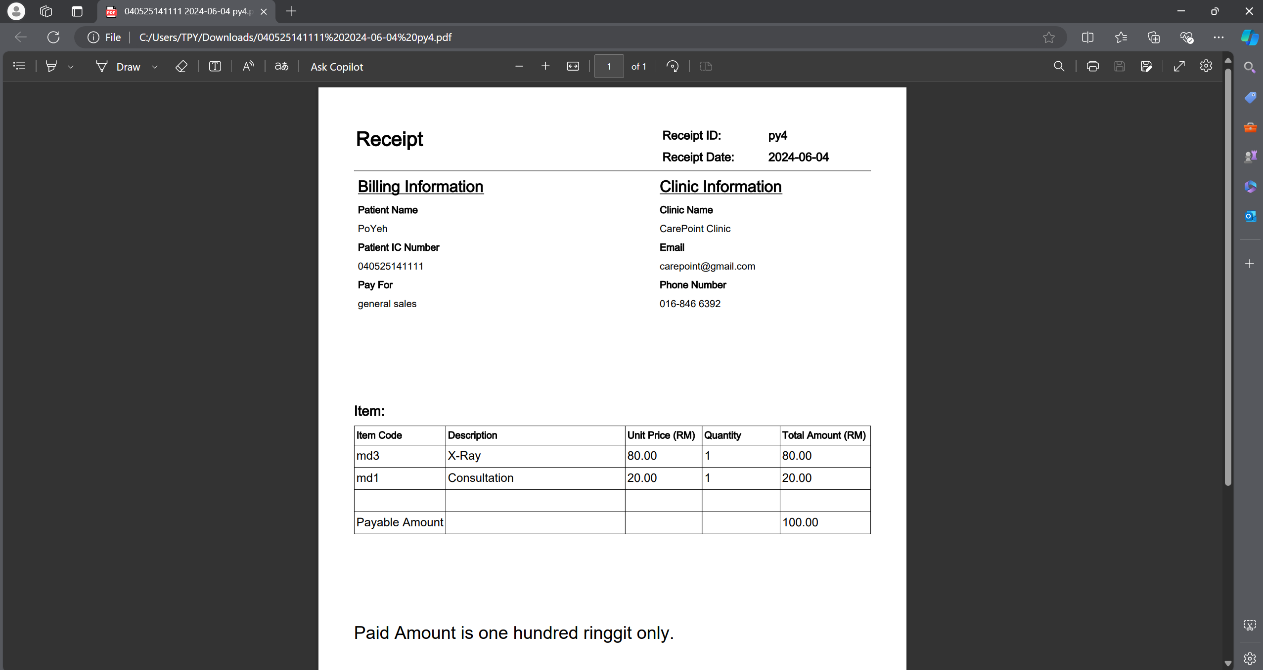

The generateReceipt() method is responsible for handling the receipt generation. The code first collects the selected row record data and sets them inside the PDF content. Below are the code processing the pdf.

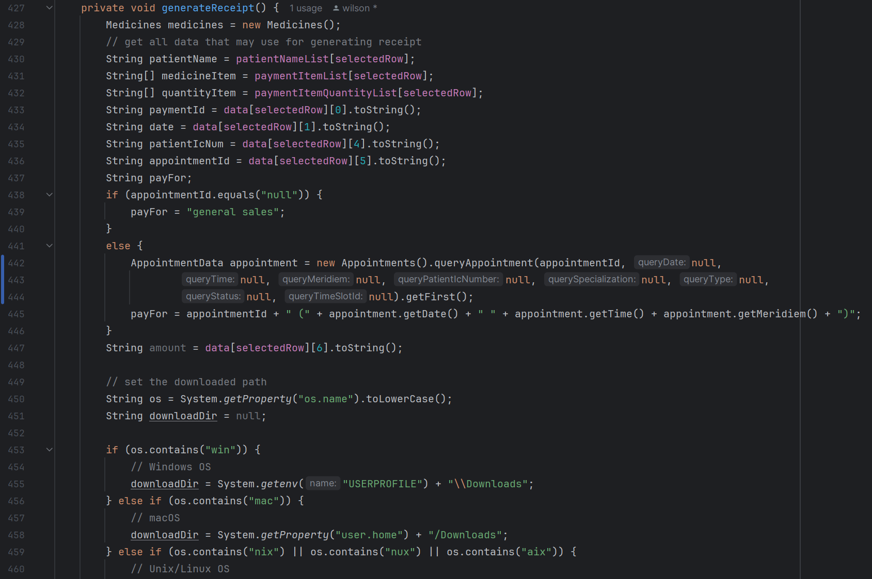

The code below aims to construct the PDF structure using an external library, specifically the iText library. This library provides robust tools for creating and manipulating PDF documents in Java.

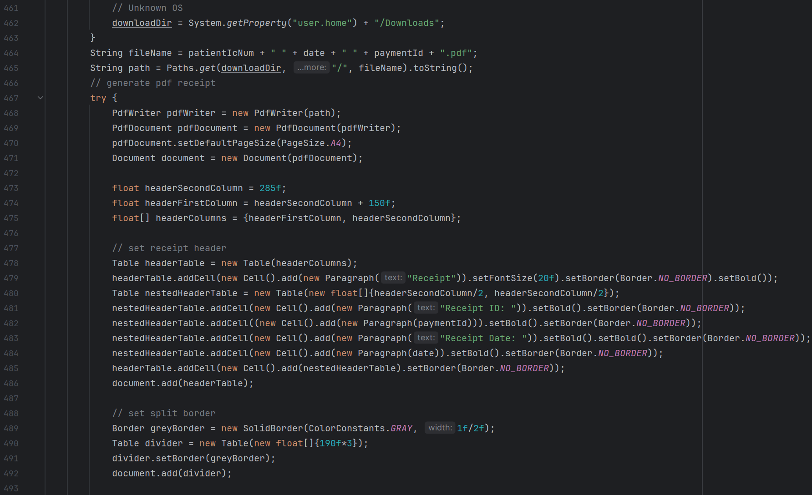

## 5.4 Generate Sales Report

Other than the payment receipt, admins are also able to generate a sales report based on the date selected. By clicking the "Generate Sales Report" button, admins can specify the date range, and the system will generate a summary sales report for the admins. Below is the pop-up window of the date selection after clicking the button.

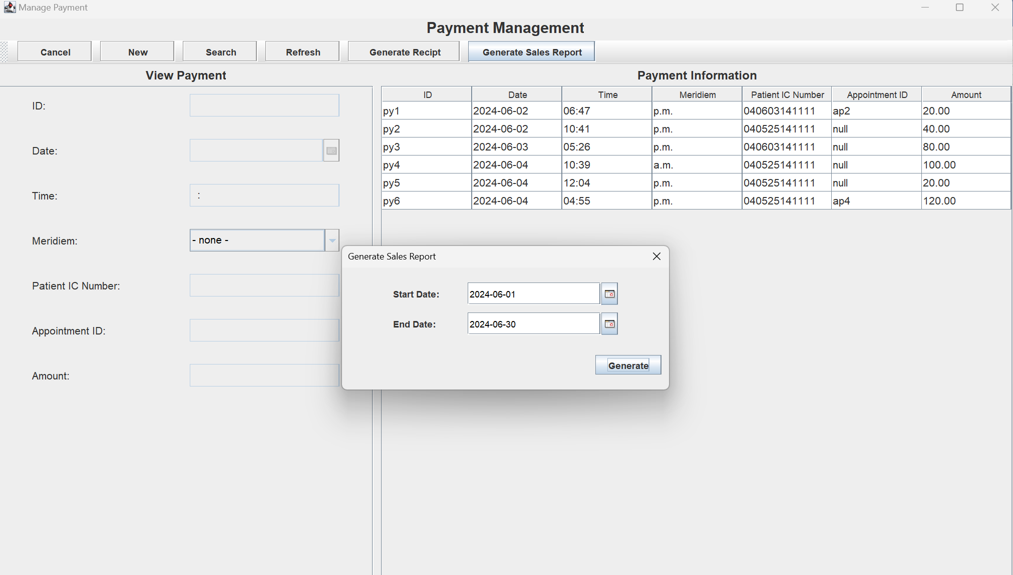

Once successful, the system will generate a sales report pdf as the picture below shows. In this case, the PDF will list out all the sales information followed by the corresponding cash flow.

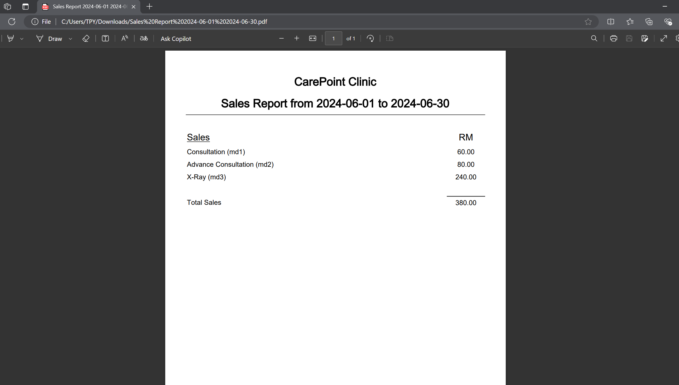

The generateBtn (Generate Sales Report Button) has an action listener for reading the range of data and getting the values to the generateSalesReport() method through the parameter.

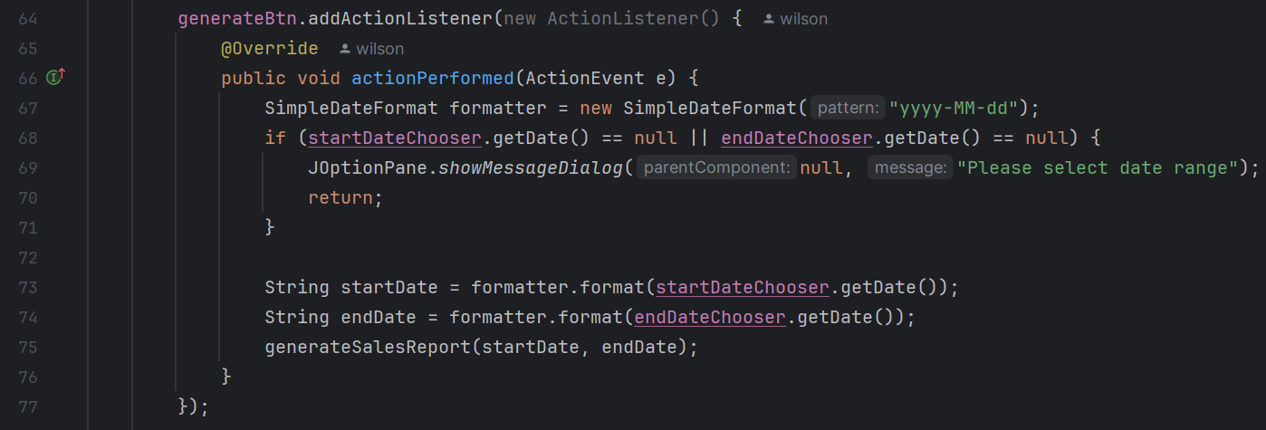

The generateSalesReport() method is used for handling the sales report using iText Library. This report is generated based on payment data recorded in the system. If no sales are found within the specified date range, an error message is displayed to inform the user.

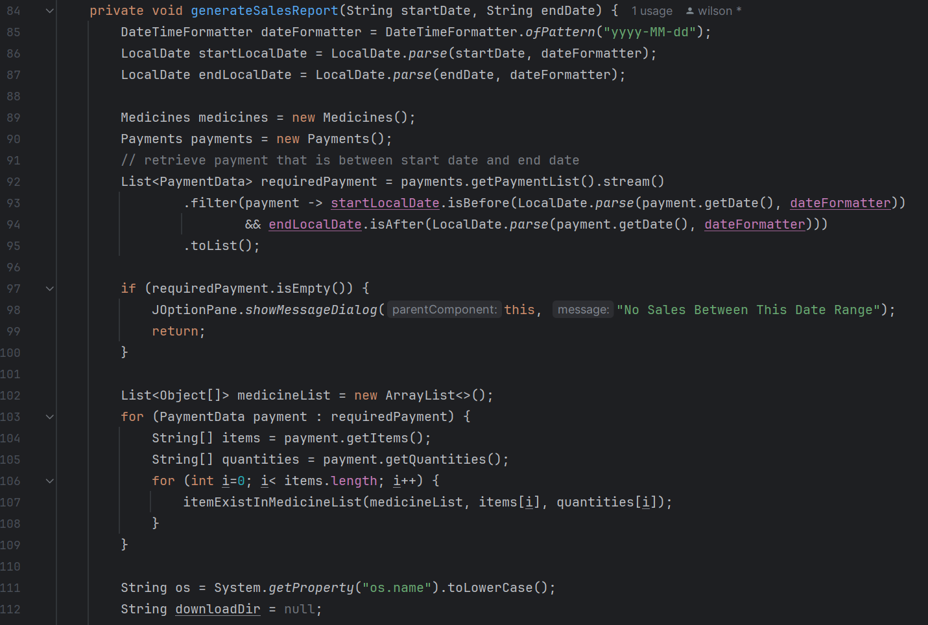

Once successful, the system will generate a sales report PDF based on the date selection. Below are the codes that construct the PDF content.

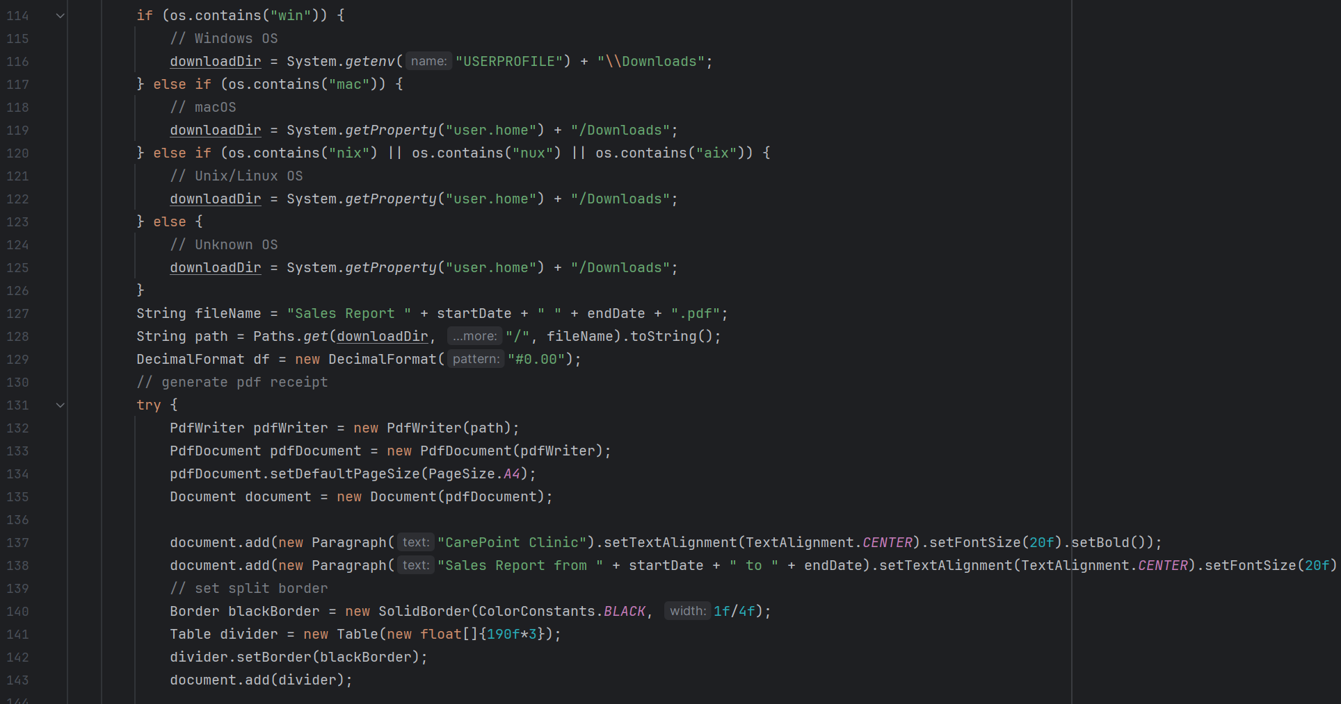

## 5.5 Searching Table Data

In our Java system, search features are heavily implemented across the patient, doctor, and admin pages. The doctor and admin search bars share the same logic, while the patient search bar operates with its own distinct logic. Below is the sample of the doctor and admin search structure.

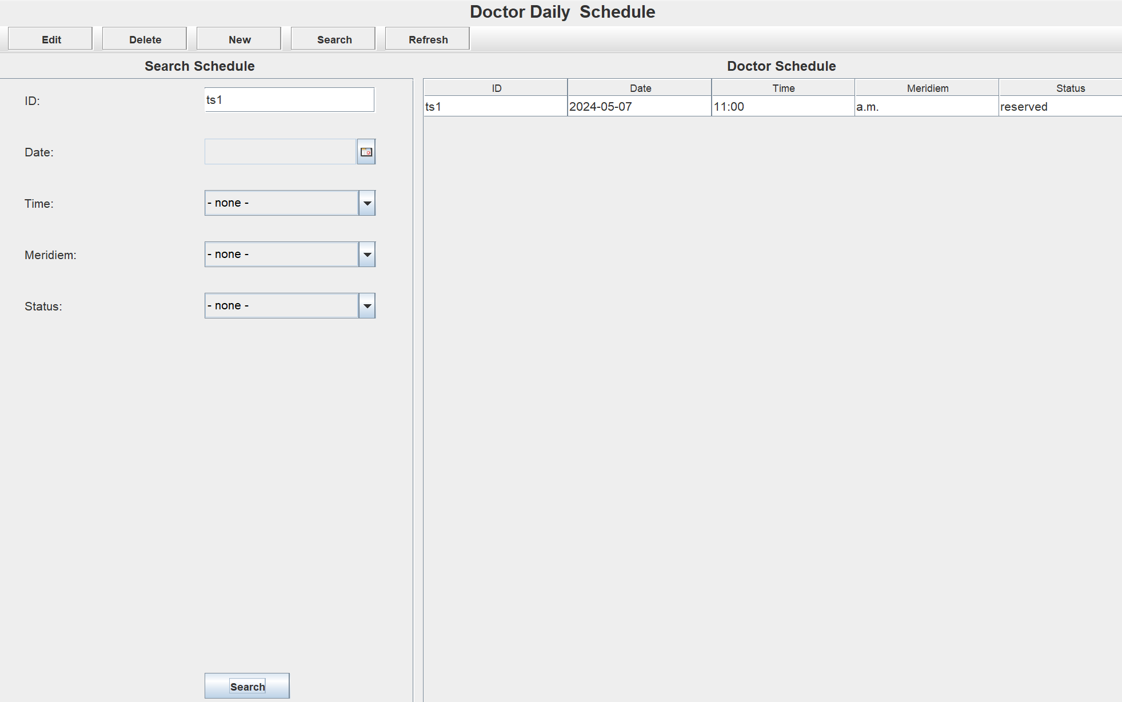

We will be taking the doctor search section as our sample in this case. The code below, DoctorUpdateScheduleUI() method handles different types like JComboBox for gender and JDateChooser for dates using conditional checks. The search parameters gathered are then used to query a list of TimeSlotData objects using the timeSlots object. Finally, it displays a JOptionPane message with the number of results found and updates a table (updateQueryTable) to show the queried results.

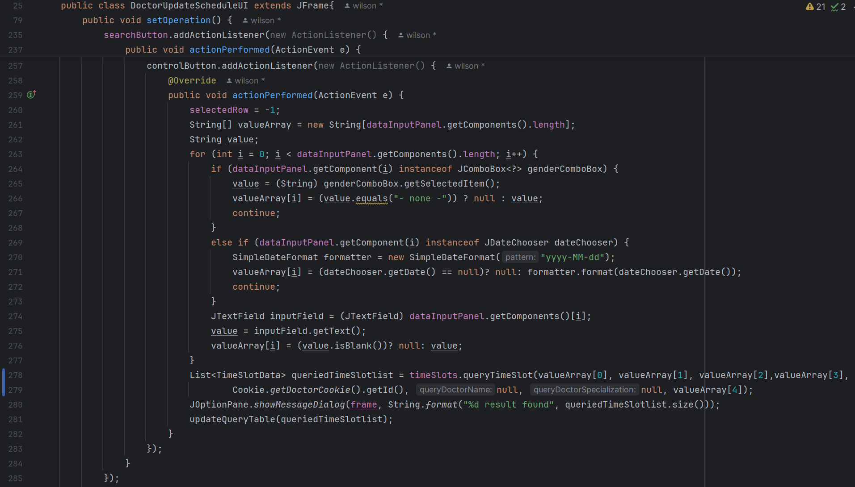

From the other view, the search structure for the patient contains two types of search methods, the multiple selects choice and a search bar. Below is the picture shows the search bar and the multiple select choice panel for patients (Rao, 2015).



The combo box is to search for the doctor's name appointments while the search bar is for filtering results by specialization. The code below, setAllTimeSlotTable() method iterates through the filtered time slot data, checking for matches based on doctor name and specialization, while ensuring the time slot date is after a defined "currentDate". Matching rows are added to "matchingRows", and if no matches are found ("matchFound" is false), all time slot data entries are added to "matchingRows".

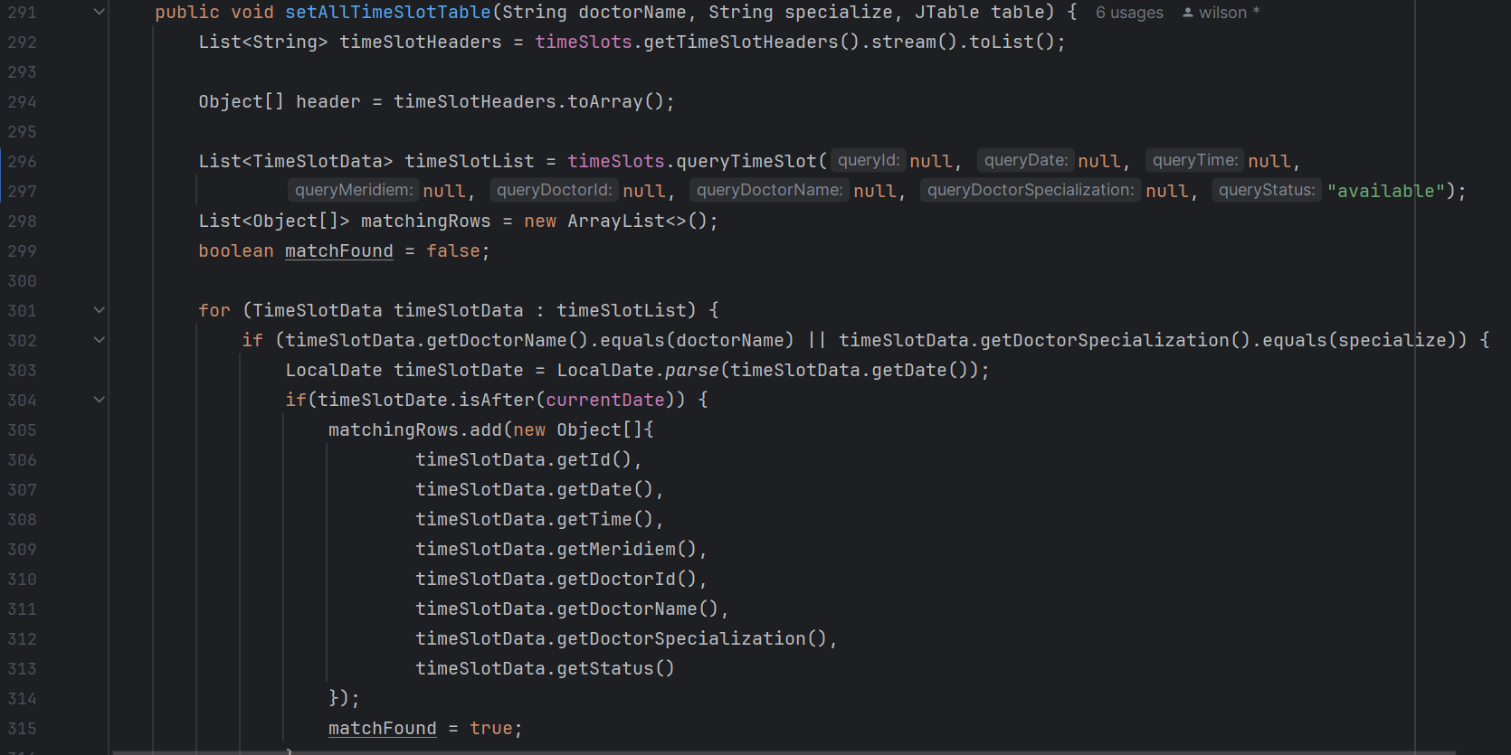

Finally, a DefaultTableModel is created using "matchingRows"and header, and this model is set to the provided JTable (table) to display the filtered time slot data.

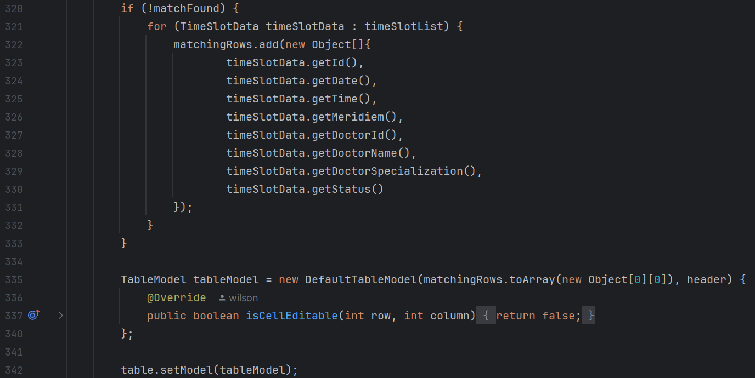

# 6.0 Conclusion

In a nutshell, our team created a simple robust Clinic Management System by utilizing object-oriented programming concepts and Java's GUI user interface features. This system was developed to address requirements of different roles for users in the clinic management system. User Roles such as administrators, doctors, and patients. This is done by including features such user registration, appointment administration, medical record data, and payment data. Through ensuring that all data is kept in text files, our teams have ensured data stability and integrity.

**Limitations**

* **Inventory Management:** Our existing Clinic Management System does not allow inventory management system due to the complexities of the coding required. Implementing an inventory management system involves a wide range of functionality and features to make sure the program run properly. Furthermore, merging inventory management with the user payment function is another challenge of complexity in the code.
* **Appointment Booking:** Our system currently does not limit the number of appointments that a customer may book in a day. This may lead to a situation where the customer may intentionally set many appointments, preventing other customers from making bookings. This limitation raises ethical problems in our program system, since it may result in unethical use of the system. To ensure that all customers have equal access to booking appointment times, we should limit customers to only booking a maximum of three appointments per day.

In future, we will integrate an inventory management system into our clinic management system to provide more service and efficiently coordinate the inflow and outflow of inventory. This improvement can help the administrators to understand the balance amount of each medicine. Besides that, we will add a limitation booking features inside the system. This feature ensures that each patient can only make a maximum of 5 booking slots for a specific day. Consequently, the system can prevent unethical use, for example, a patient reserves all time slots for a day.

# 7.0 References

*Introduction To Java Swing*. (2024). Retrieved from GeeksforGeeks: https://www.geeksforgeeks.org/introduction-to-java-swing/

Kyle Herrity. (2023, February 4). *What Is Object-Oriented Programming (OOP)? A Complete Guid*. Retrieved from indeed: https://www.indeed.com/career-advice/career-development/what-is-object-oriented-programming

NeelumAyub. (2019). *Java SWING JFrame Layouts Example*. Retrieved from Java Tutorial Network: https://javatutorial.net/java-swing-jframe-layouts/

Rao, S. N. (2015). *JList Multiple Selection Example Java Swing*. Retrieved from Way2Java: https://way2java.com/swing/jlist-with-multiple-selection/

Thompson, A. (2012). *Border with rounded corners and transparency*. Retrieved from StackOverflow: https://stackoverflow.com/questions/15025092/border-with-rounded-corners-transparency

Thorben. (2024, February 28). *OOP Concept for Beginners: What is Encapsulation*. Retrieved from Stackify: https://stackify.com/oop-concept-for-beginners-what-is-encapsulation/

Wu, J. (2021). *Java Swing Layouts Example*. Retrieved from Java Code Geeks: https://examples.javacodegeeks.com/java-swing-layouts-example/

# 8.0 Workload Matrix

|  |  |  |  |
| --- | --- | --- | --- |
| Task | LEW WAI HOW | TAN PO YEH | TONG JIA CHUEN |
| **Documentation** |  |  |  |
| Introduction (2%) | 0% | 0% | 100% |
| Explanation Sample Output (15%) | 33% | 33% | 33% |
| Object Oriented Concept (10%) | 100% | 0% | 0% |
| Java Features (10%) | 0% | 0% | 100% |
| Explanation of additional features (10%) | 0% | 100% | 0% |
| Conclusion (2%) | 0% | 0% | 100% |
| Reference (1%) | 100% | 0% | 0% |
|  |  |  |  |
| **Implementation** |  |  |  |
| User Authentication (5%) | 10% | 90% | 0% |
| Admin functions (15%) | 100% | 0% | 0% |
| Doctor functions (15%) | 20% | 0% | 80% |
| Patient functions (15%) | 0% | 100% | 0% |
|  |  |  |  |
| Total percentage | 34.5 | 34.5 | 31 |